What is API Testing

Why we need API

DB layer – > APIlayer → UI Layer

We can detect the bug early in dev stage , No need to wait until UI is developed

We can validate core functionality.

> Rest ( lite weight ) And SOap

Need Swagger doc / API doc/ Swagger link

Http methods ( resource )

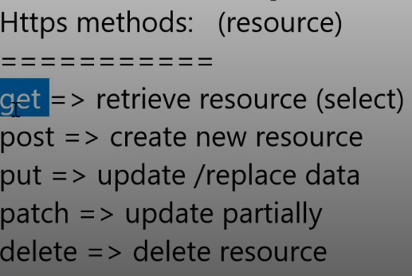

After Base Url → ALl are path parameters

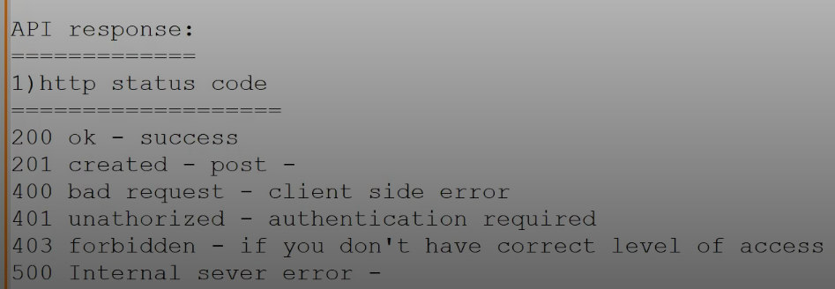 **OAuth 2.0** is an authorization framework that allows third-party applications to access a user's data without sharing their credentials.

It uses access tokens to grant limited, secure access to protected resources on behalf of the user.

**API** - An application programming interface is an interface that defines interactions between multiple software applications or mixed hardware-software intermediaries.

**A Real-world example** :: A real-world example is buying movie tickets online. You go to the movie site; you enter your movie, name and credit card information, and lo-and-behold, you print out your tickets.

But what’s going on between entering your information to receiving your ticket? APIs, that’s what! They are collaborating behind the scenes with other applications.

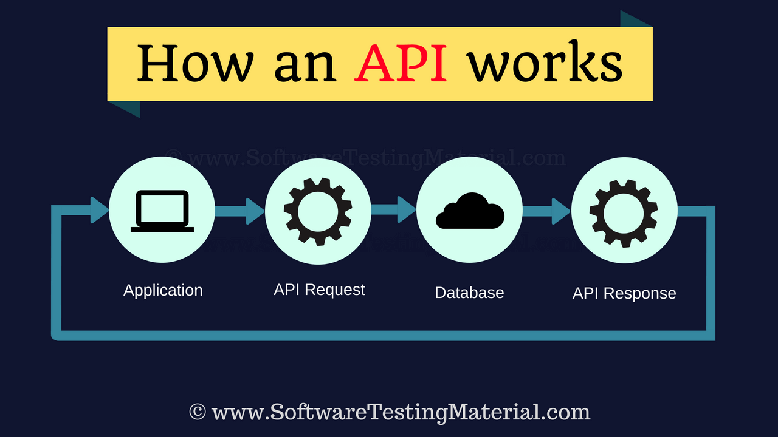

**Differences between API and Web Service?**

* All Web services are APIs but not all APIs are Web services.
* Web services might not contain all the specifications and cannot perform all the tasks that APIs would perform.
* A Web service uses only three styles of use: SOAP, REST and XML-RPC for communication whereas API may be exposed to in multiple ways.
* A Web service always needs a network to operate while APIs don’t need a network for operation.

**What's the difference between HTTP and HTTPS protocols?**

* The HTTP protocol stands for Hypertext Transfer Protocol, whereas the HTTPS stands for Hypertext Transfer Protocol Secure. Security The HTTP protocol is not secure protocol as it does not contain SSL (*Secure Sockets Layer*), which means that the data can be stolen when the data is transmitted from the client to the server.

**Common API Testing Types ::**

1. Validation Testing

2. Functional Testing

3. UI testing

4. Load testing

5. Runtime/ Error Detection

6. Security testing

7. Penetration testing

8. Fuzz testing

9. Interoperability and WS Compliance testing

**What is Rest API (Restful API) – Representational State Transfer API**

You search for something, and you get a list of results back from the service you're requesting from. ... The developer creates the API on the **server** and allows the **client** to talk to it. REST determines how the API looks like. It stands for “Representational State Transfer “.

**Types of Output of an API - An output of API could be**

* Any type of data
* Status (say Pass or Fail)
* Call another API function.

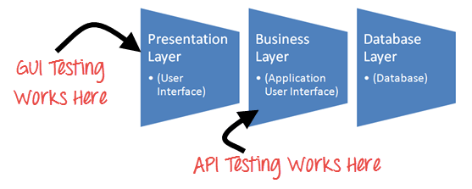 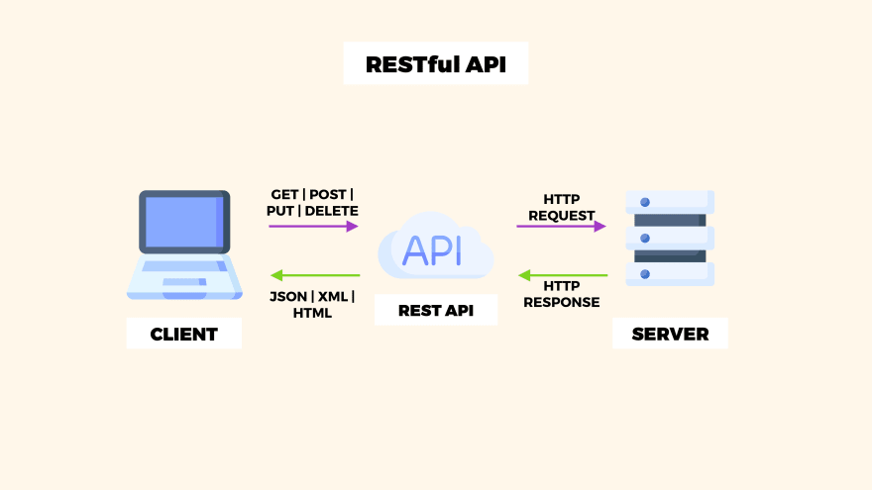

**API Testing Basics ::**

Swagger overview – doc tool for requirement

Service now –

PostMan

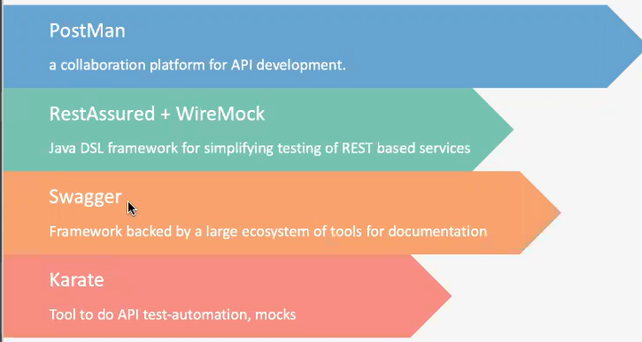

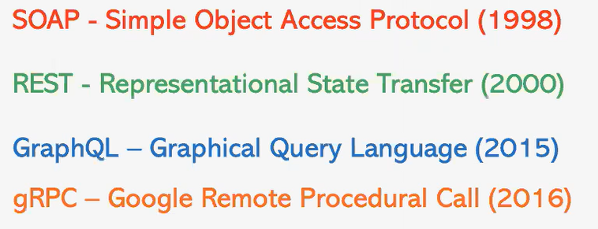

Rest – Architectural

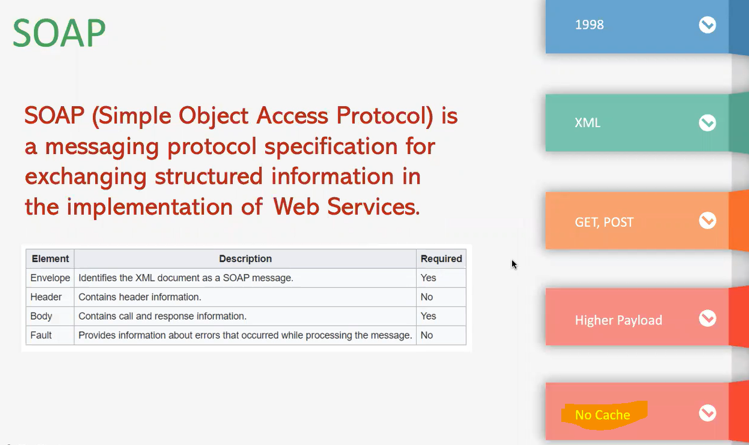

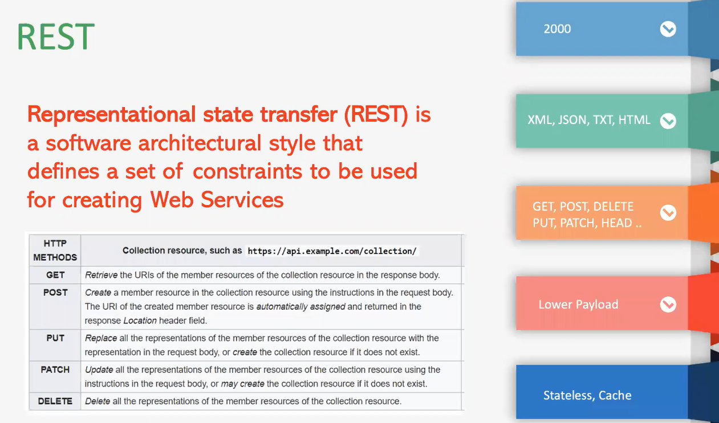

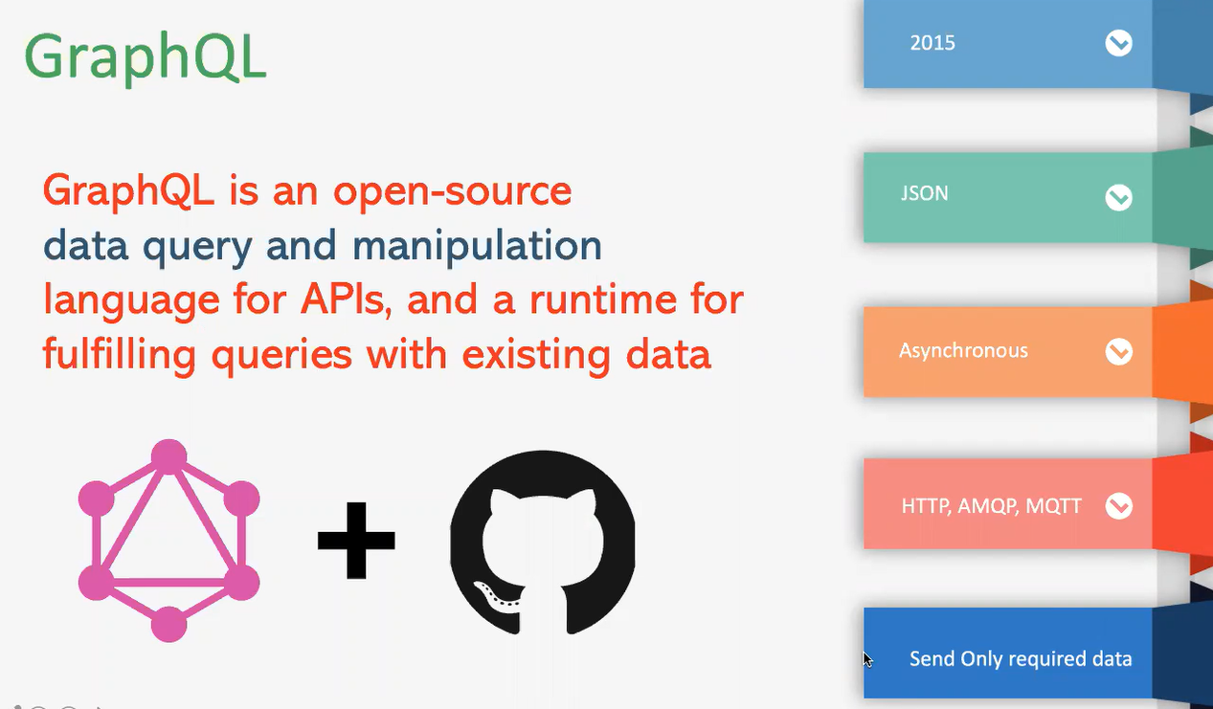

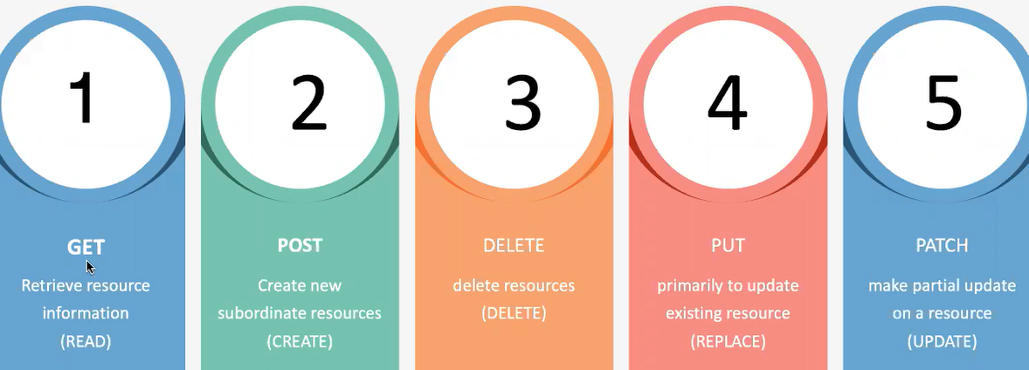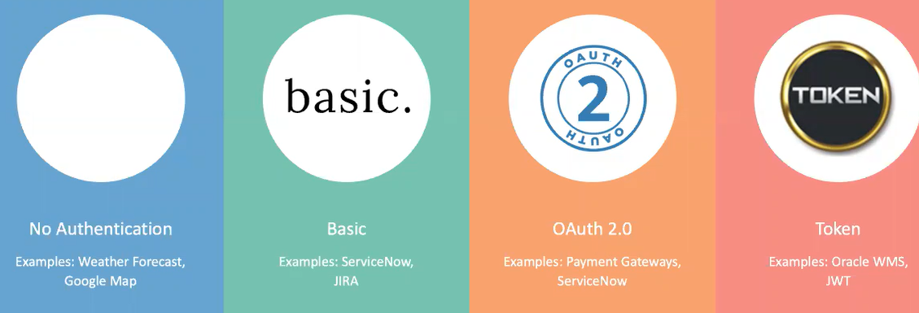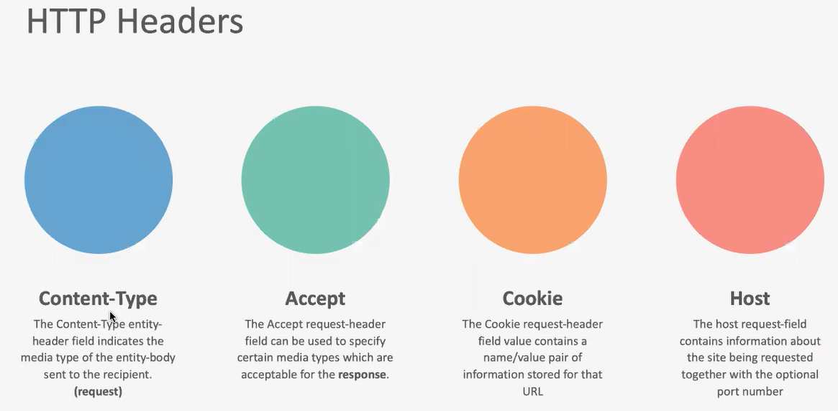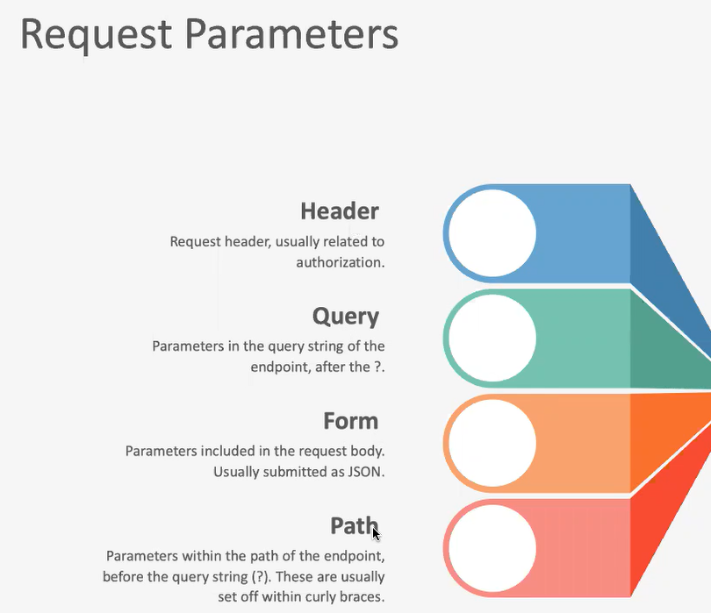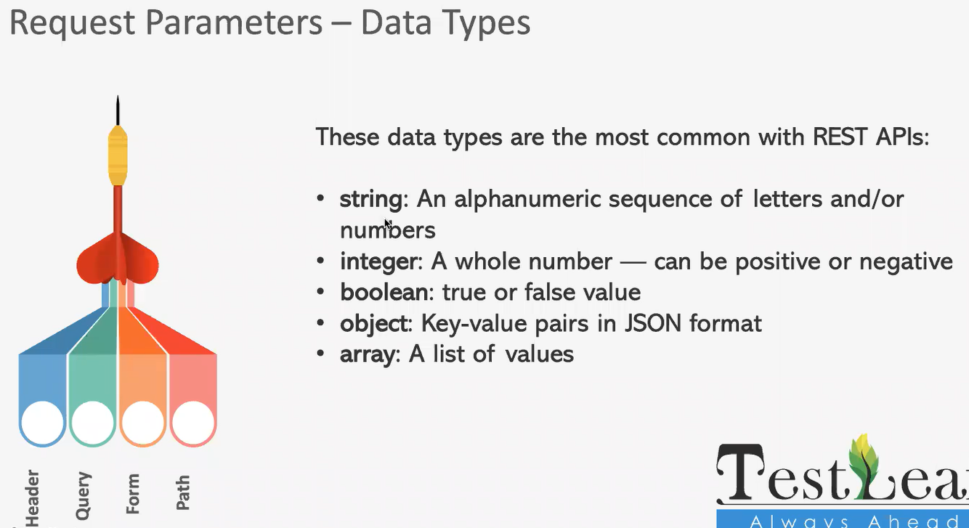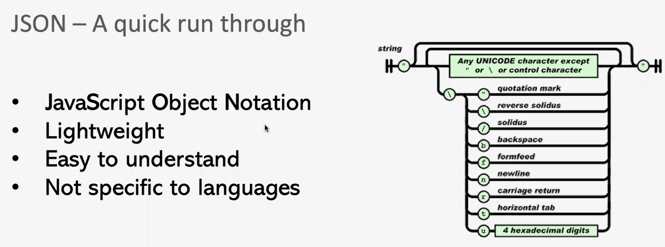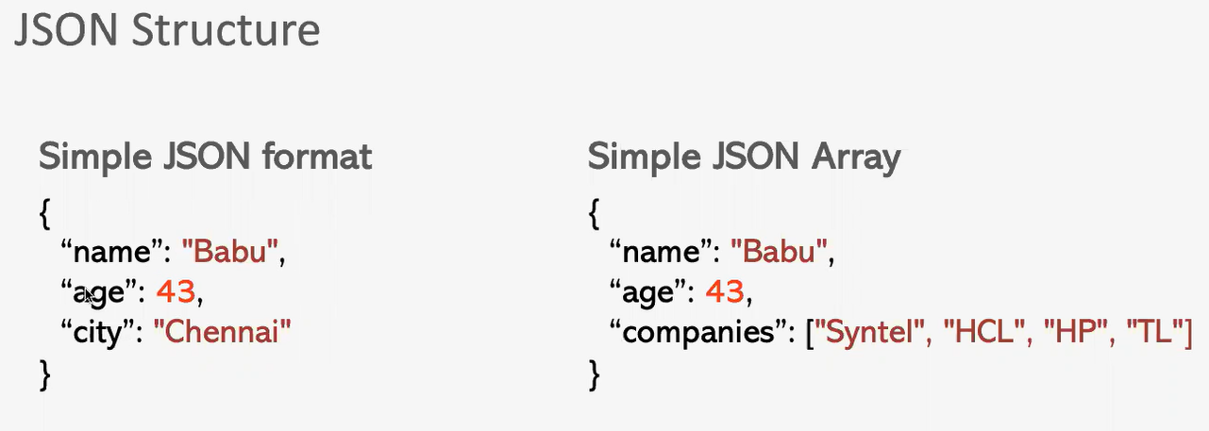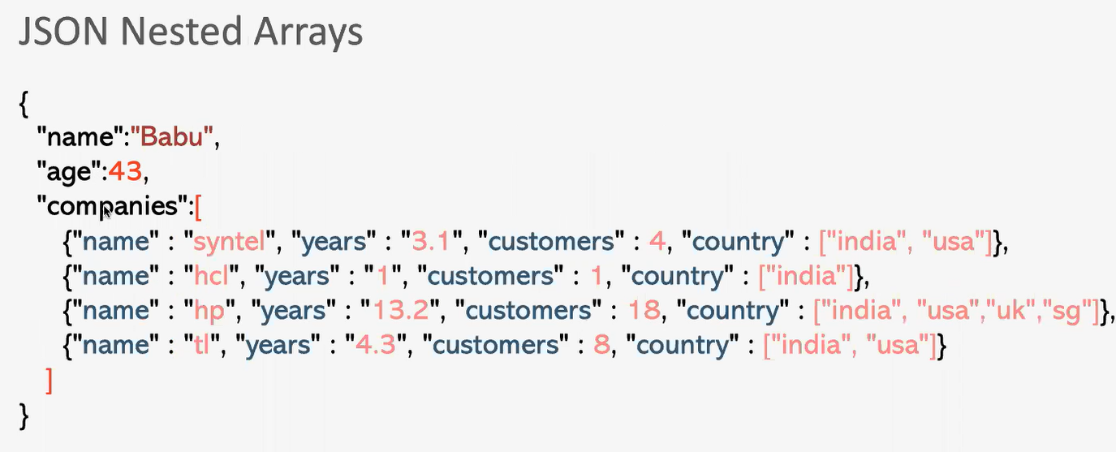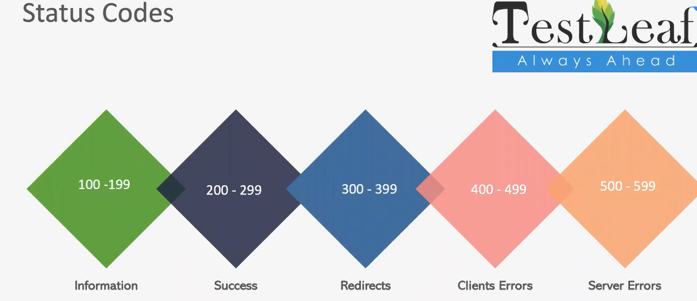

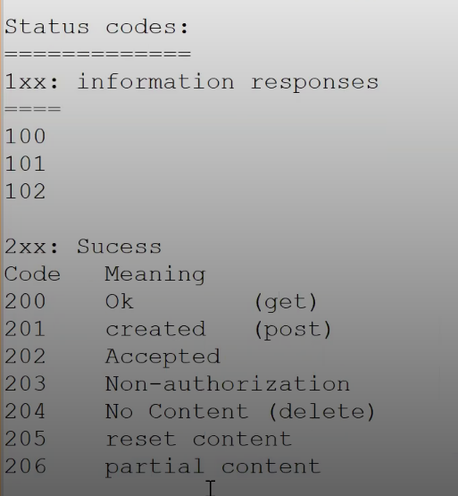

**203**

Non-Authoritative Information indicates that the request was successful, but the meta-information included in the response may have been modified by a proxy or other intermediary. This means the data received might not be the exact representation of the origin server's original response.

**205 status code**, "Reset Content," indicates that the server has successfully processed the request and the user agent (like a web browser) should reset the document view to its initial state, as if it were newly loaded. This is typically used after a form submission to clear the form for a new entry.

HTTP 206 status code, "Partial Content," indicates that the server has successfully fulfilled a range request, meaning it has delivered a portion of a requested resource, as specified in the Range header of the client's request. This is commonly used for efficient data transfer, such as streaming media or resuming interrupted downloads.

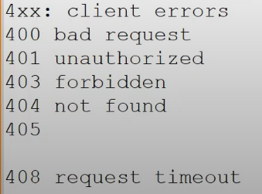

400 error, or "Bad Request" error, means the server can't process the request sent by the client (usually a web browser). It's a client-side error, indicating a problem with the request itself, rather than an issue with the server.

* The server received a request from your browser, but it's malformed, invalid, or too large. The server can't understand or process what you're asking it to do.
* **Incorrect URL:** Typos, missing characters, or invalid syntax in the web address.
* **Corrupted browser data:** Cached files, cookies, or extensions that interfere with the request.
* **Large file uploads:** Sending a file that exceeds the server's size limit.
* **DNS issues:** Outdated or incorrect DNS records that prevent the browser from finding the correct server.

A 401 error, also known as "**Unauthorized**", is an HTTP status code that indicates the client's request is missing valid authentication credentials, or the credentials provided are not authorized to access the requested resource.

A 403 Forbidden error code signifies that the server understands the request but refuses to authorize it, indicating a lack of permission to access the requested resource. This is a client-side error, meaning the problem often lies with the website's configuration or security settings rather than the user's browser.

A 404 error, also known as "404 Not Found," is a standard HTTP status code that indicates the web server could not find the requested resource (usually a webpage). It essentially means the page you're trying to access doesn't exist or can't be located on the server.

HTTP 408 error, or "**Request Timeout**" error, indicates that the server did not receive a complete request from the client within the expected time frame. Essentially, the server is waiting for the client to finish sending the request, but the client takes too long, leading to the server closing the connection and returning the 408 error.

401 and 403 lies in whether the client needs to authenticate or if the client is authenticated but lacks the necessary authorization.

A 401 Unauthorized indicates that the client needs to provide valid credentials (like a username and password) to access the resource.

403 Forbidden, on the other hand, means the client is authenticated, but the server has denied access due to lack of permission, even with valid credentials.

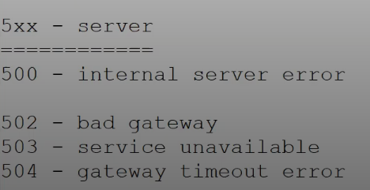

500 status code, or "Internal Server Error," indicates that the server encountered an unexpected condition that prevented it from fulfilling the client's request. It's a generic error message, meaning the server doesn't know exactly what went wrong but knows that something did. This error is on the server-side, and the client has no way to resolve it directly.

The HTTP status code 501, "Not Implemented", indicates that the server does not support the functionality required to fulfill the request. This means the server recognizes the request method but doesn't have the capability to handle it. It's a server-side error, distinct from client errors like 404 (Not Found).

502 Bad Gateway error is an HTTP status code indicating that a server acting as a gateway or proxy received an invalid response from an upstream server. Essentially, it means the server couldn't complete the request because it failed to get a valid response from another server it was relying on.

The HTTP 503 status code, "Service Unavailable," indicates that the server is temporarily unable to handle the request. This is often due to the server being overloaded, undergoing maintenance, or experiencing other temporary issues. It implies that the issue is likely temporary and the service should become available again after some time.

A 504 HTTP status code, or "Gateway Timeout", indicates that one server, acting as a gateway or proxy, didn't receive a timely response from another server it needed to complete a request. This often happens when a website relies on multiple servers, and one or more of them are experiencing issues.

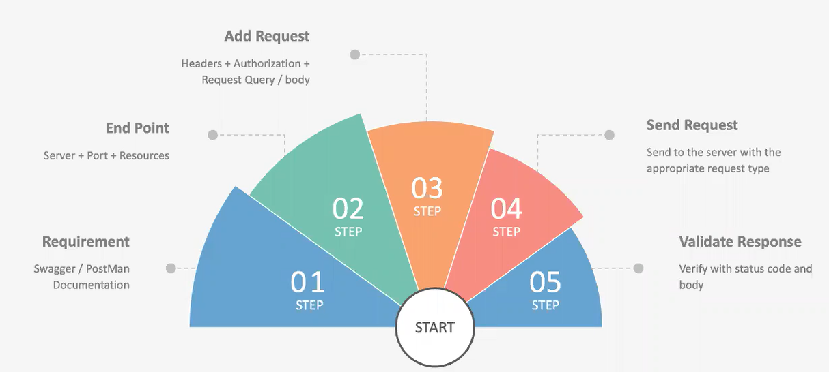

1. Accessibility - To use Postman tool, one would just need to log-in to their own accounts making it easy to access files anytime, anywhere as long as a Postman application is installed on the computer.
2. Use of Collections - Postman lets users create collections for their Postman API calls. Each collection can create subfolders and multiple requests. This helps in organizing your test suites.
3. Collaboration - Collections and environments can be imported or exported making it easy to share files. A direct link can also be used to share collections.
4. Creating Environments - Having multiple environments aids in less repetition of tests as one can use the same collection but for a different environment. This is where parameterization will take place which we will discuss in further lessons.
5. Creation of Tests - Test checkpoints such as verifying for successful HTTP response status can be added to each Postman API calls which help ensure [test coverage](https://www.guru99.com/test-coverage-in-software-testing.html).
6. Automation Testing - Through the use of the Collection Runner or Newman, tests can be run in multiple iterations saving time for repetitive tests.
7. Debugging - Postman console helps to check what data has been retrieved making it easy to debug tests.
8. Continuous Integration - With its ability to support continuous integration, development practices are maintained.

<https://dev.to/duomly/rest-api-vs-graphql-comparison-3j6g>

Host examples in header

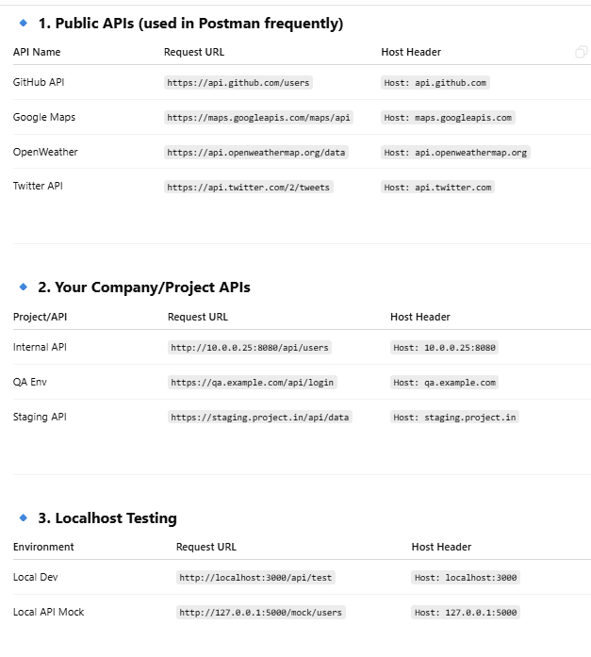

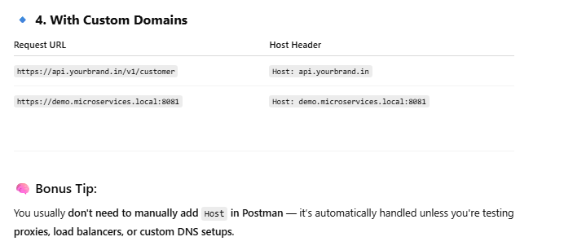

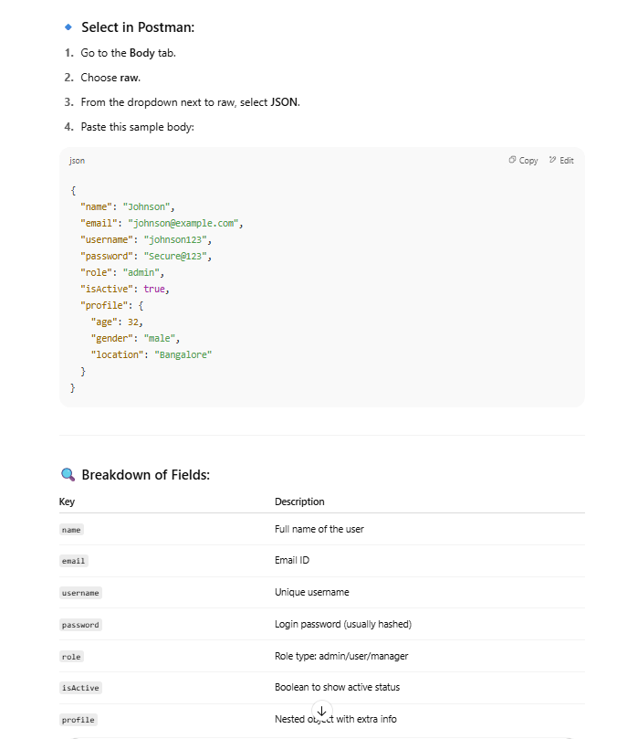

**Script**

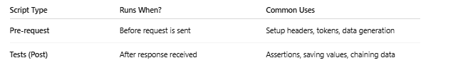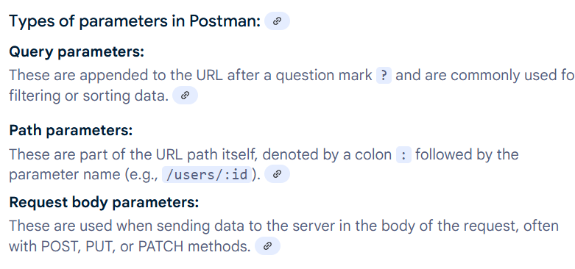

**oAuth ::** 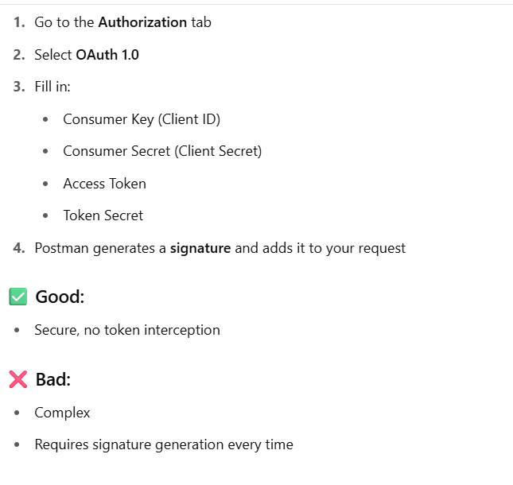

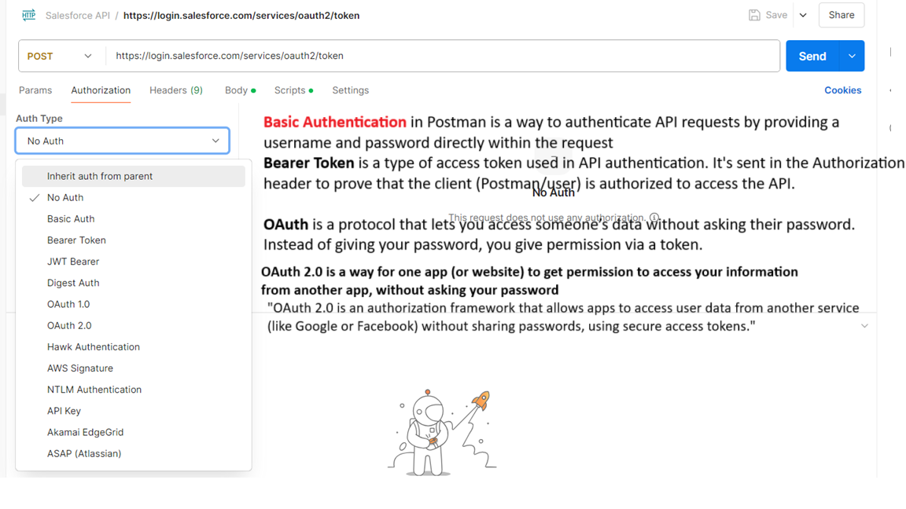

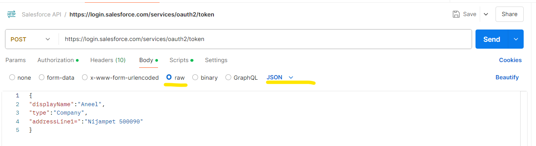

**Content type ( Request ) , Accept ( Response ) , cookies , User-Agent Scrpi**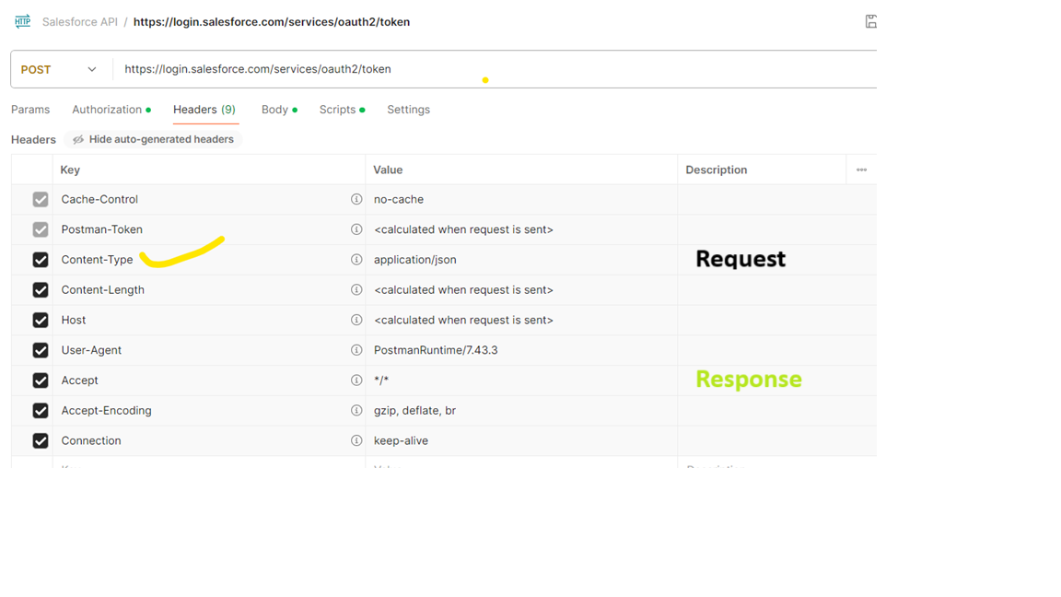

**Scripts**  :: Pre request and post response .

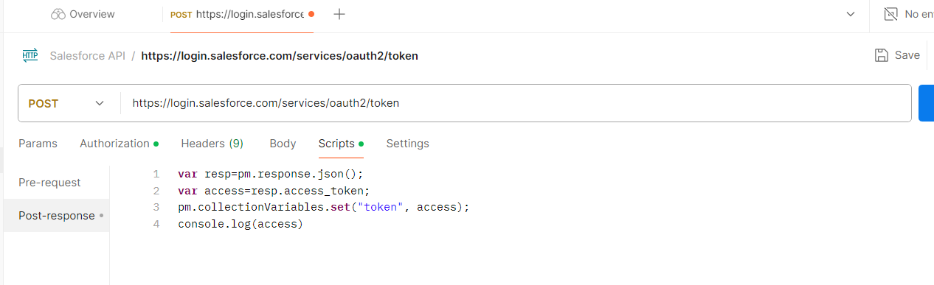

In Postman, Pre-request scripts run before the request — useful for setting dynamic data like tokens.

Test scripts run after the response — used to validate status codes, content, or response time.

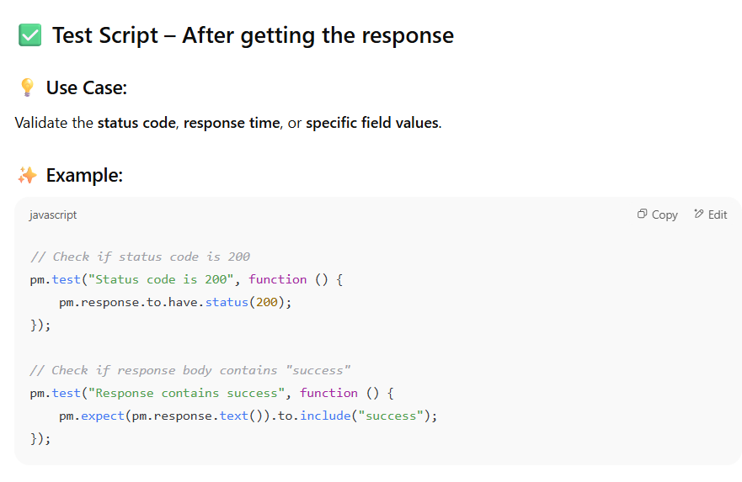

# PostMan ::

Postman is one of the most popular software testing tools which is used for API testing. With the help of this tool, developers can easily create, test, share, and document APIs.

Introduction to Postman

* Postman is a standalone software testing API (Application Programming Interface) platform to build, test, design, modify, and document APIs. It is a simple Graphic User Interface for sending and viewing HTTP requests and responses.
* While using Postman, for testing purposes, one doesn't need to write any HTTP client network code. Instead, we build test suites called collections and let Postman interact with the API.
* In this tool, nearly any functionality that any developer may need is embedded. This tool has the ability to make various types of HTTP requests like GET, POST, PUT, PATCH, and convert the API to code for languages like JavaScript and Python.

### API

Application Programming Interface (API) is software that acts as an intermediary for two apps to communicate with each other. We use APIs whenever we use an application like Twitter, Facebook, sending text messages, or checking the weather over the phone.

### HTTP

HTTP (Hypertext Transfer Protocol) is the collection of rules for the transmission of data on the World Wide Web, like graphic images, text, video, sound, and other multimedia data. The Web users implicitly make use of HTTP as soon as they open their Web browser.

Example: A user or browser enters the HTTP request to the server; the server then returns the user response. This response includes the request status information and may consist of the requested material as well.

Why use Postman?

Postman is based on a wide range of extremely user-friendly power tools. For more than 8 million users, Postman has become a tool of convenience. Following are the reasons why Postman is used:

1. **Accessibility-** One can use it anywhere after installing Postman into the device by simply logging in to the account.
2. **Use Collections**-Postman allows users to build collections for their API-calls. Every set can create multiple requests and subfolders. It will help to organize the test suites.
3. **Test development-** To test checkpoints, verification of successful HTTP response status shall be added to every API- calls.
4. **Automation Testing-**Tests can be performed in several repetitions or iterations by using the Collection Runner or Newman, which saves time for repeated tests.
5. **Creating Environments-** The design of multiple environments results in less replication of tests as one can use the same collection but for a different setting.
6. **Debugging-** To effectively debug the tests, the postman console helps to track what data is being retrieved.
7. **Collaboration-** You can import or export collections and environments to enhance the sharing of files. You may also use a direct connection to share the collections.
8. **Continuous integration-**It can support continuous integration.
9. New - This is where you will create a new request, collection or environment.
10. Import - This is used to import a collection or environment. There are options such as import from file, folder, link or paste raw text.
11. Runner - Automation tests can be executed through the Collection Runner. This will be discussed further in the next lesson.
12. Open New - Open a new tab, Postman Window or Runner Window by clicking this button.
13. My Workspace - You can create a new workspace individually or as a team.
14. Invite - Collaborate on a workspace by inviting team members.
15. History - Past requests that you have sent will be displayed in History. This makes it easy to track actions that you have done.
16. Collections - Organize your test suite by creating collections. Each collection may have subfolders and multiple requests. A request or folder can also be duplicated as well.
17. Request tab - This displays the title of the request you are working on. By default, "Untitled Request" would be displayed for requests without titles.
18. HTTP Request - Clicking this would display a dropdown list of different requests such as GET, POST, COPY, DELETE, etc. In Postman API testing, the most commonly used requests are GET and POST.
19. Request URL - Also known as an endpoint, this is where you will identify the link to where the API will communicate with.
20. Save - If there are changes to a request, clicking save is a must so that new changes will not be lost or overwritten.
21. Params - This is where you will write parameters needed for a request such as key values.
22. Authorization - In order to access APIs, proper authorization is needed. It may be in the form of a username and password, bearer token, etc.
23. Headers - You can set headers such as content type JSON depending on the needs of the organization.
24. Body - This is where one can customize details in a request commonly used in POST request.
25. Pre-request Script - These are scripts that will be executed before the request. Usually, pre-request scripts for the setting environment are used to ensure that tests will be run in the correct environment.
26. Tests - These are scripts executed during the request. It is important to have tests as it sets up checkpoints to verify if response status is ok, retrieved data is as expected and other tests.

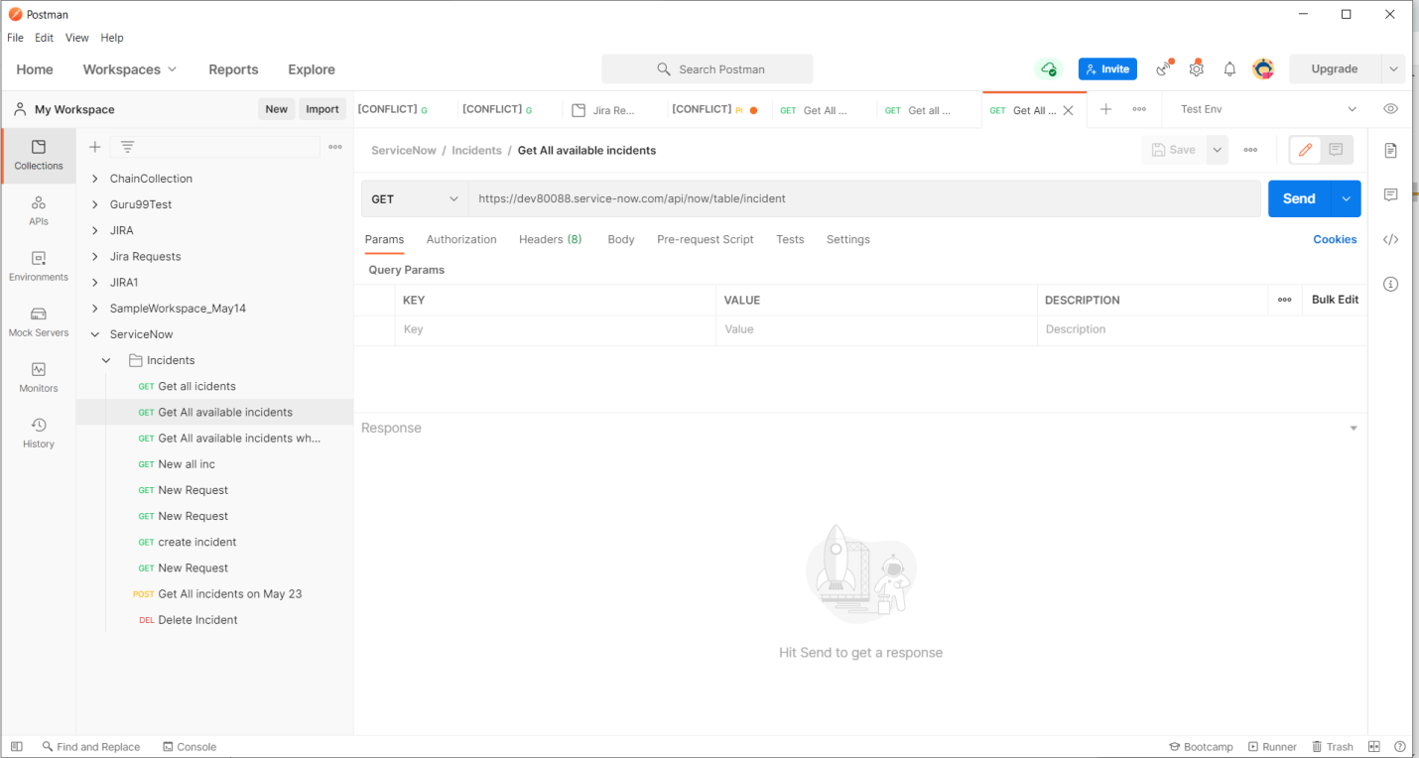

Stripe API

The Stripe API is organized around [REST](http://en.wikipedia.org/wiki/Representational_State_Transfer). Our API has predictable resource-oriented URLs, accepts [form-encoded](https://en.wikipedia.org/wiki/POST_(HTTP)#Use_for_submitting_web_forms) request bodies, returns [JSON-encoded](http://www.json.org/) responses, and uses standard HTTP response codes, authentication, and verbs.

Service Now ::

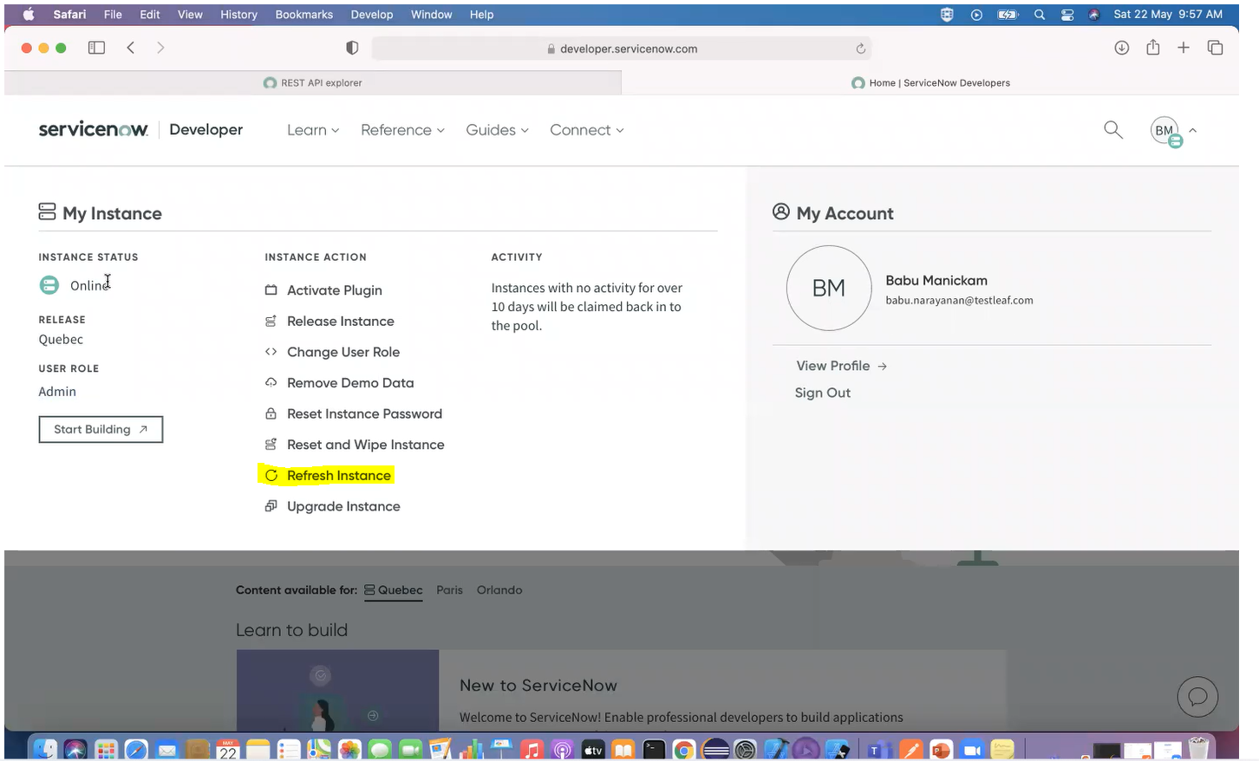

**Create Instance ::**

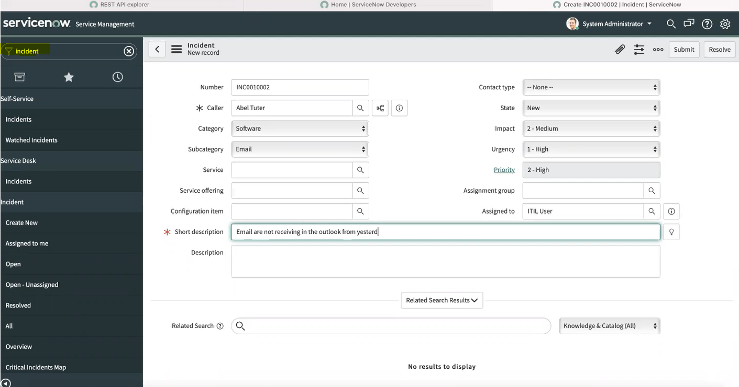

**Create Change Request ::**

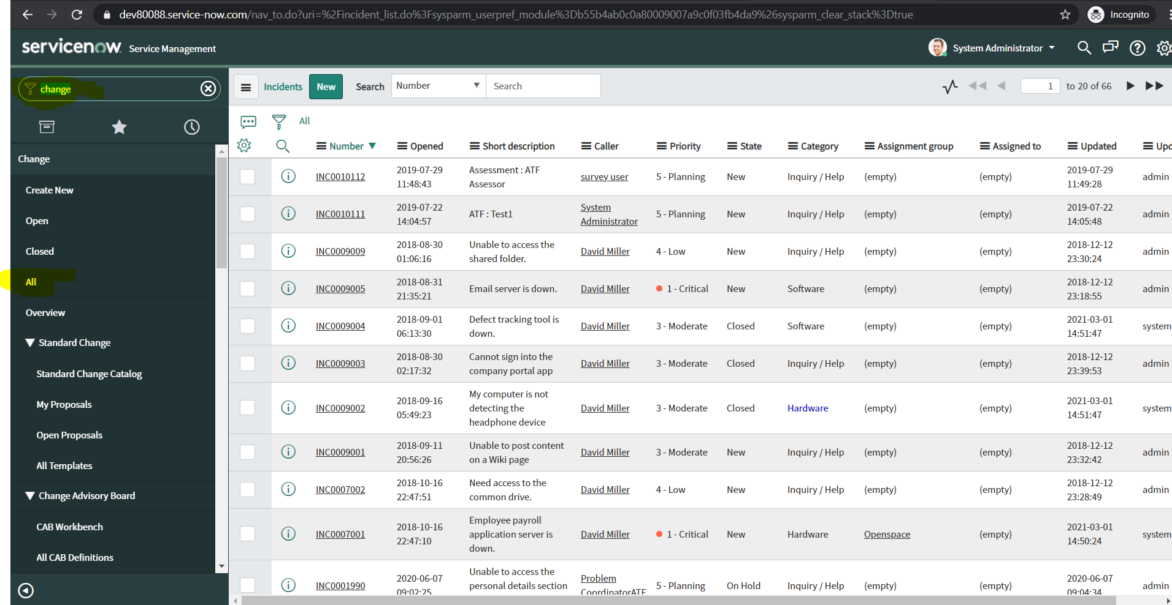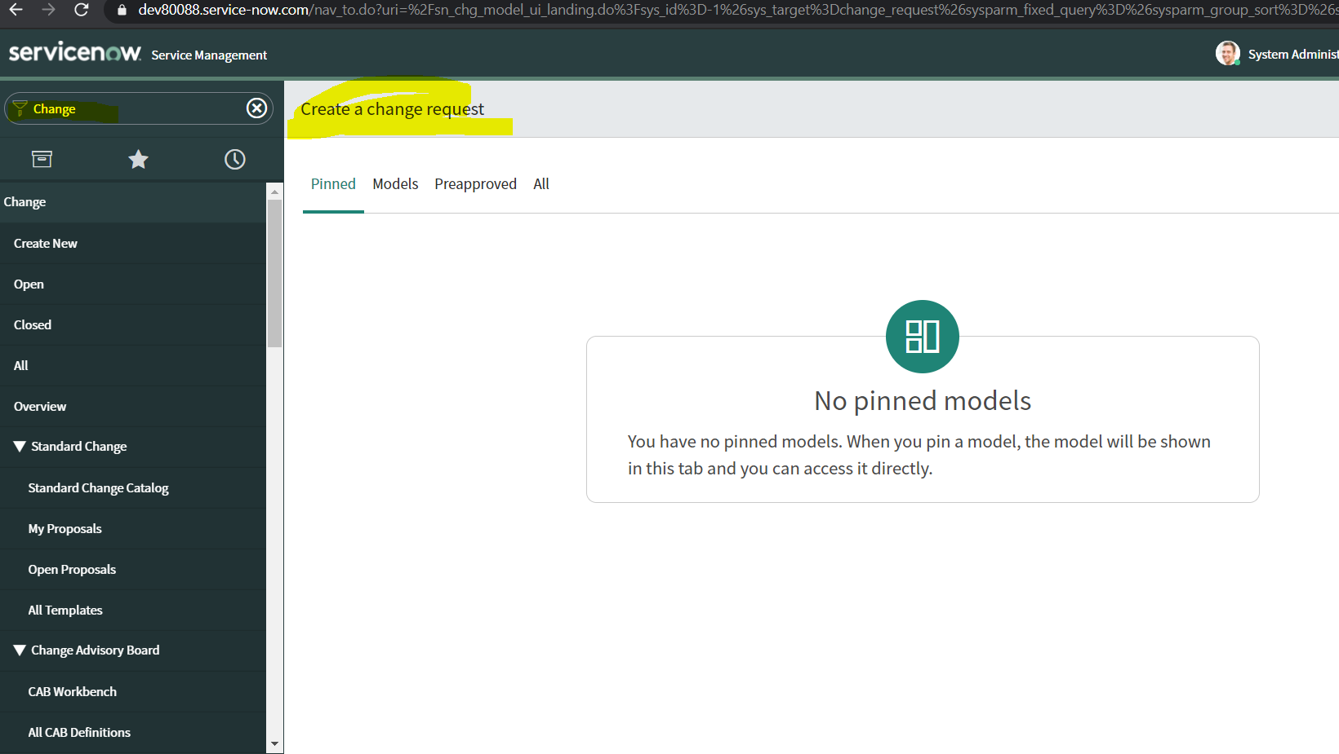

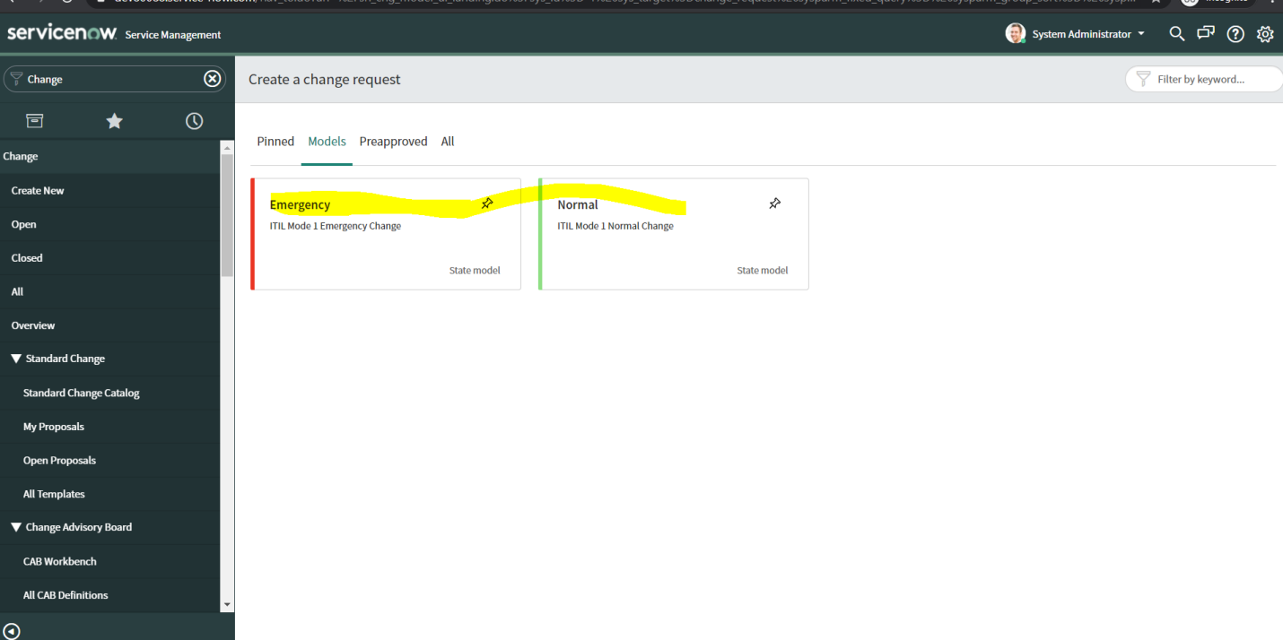

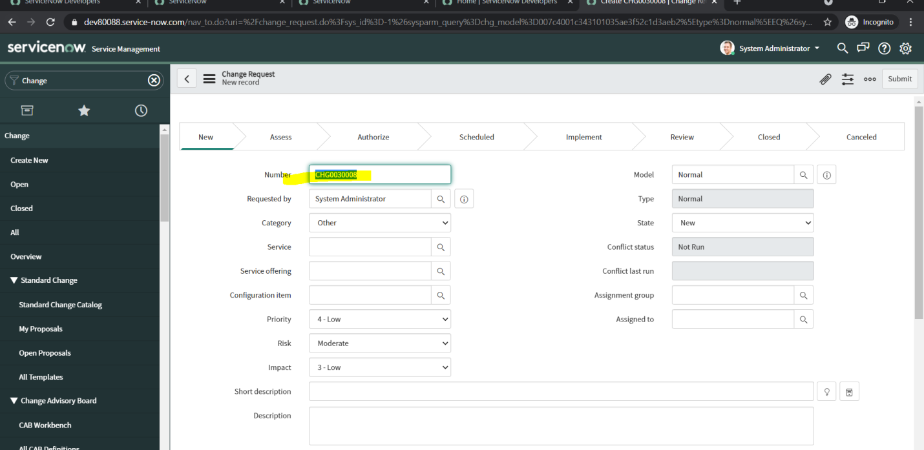

To get all instances

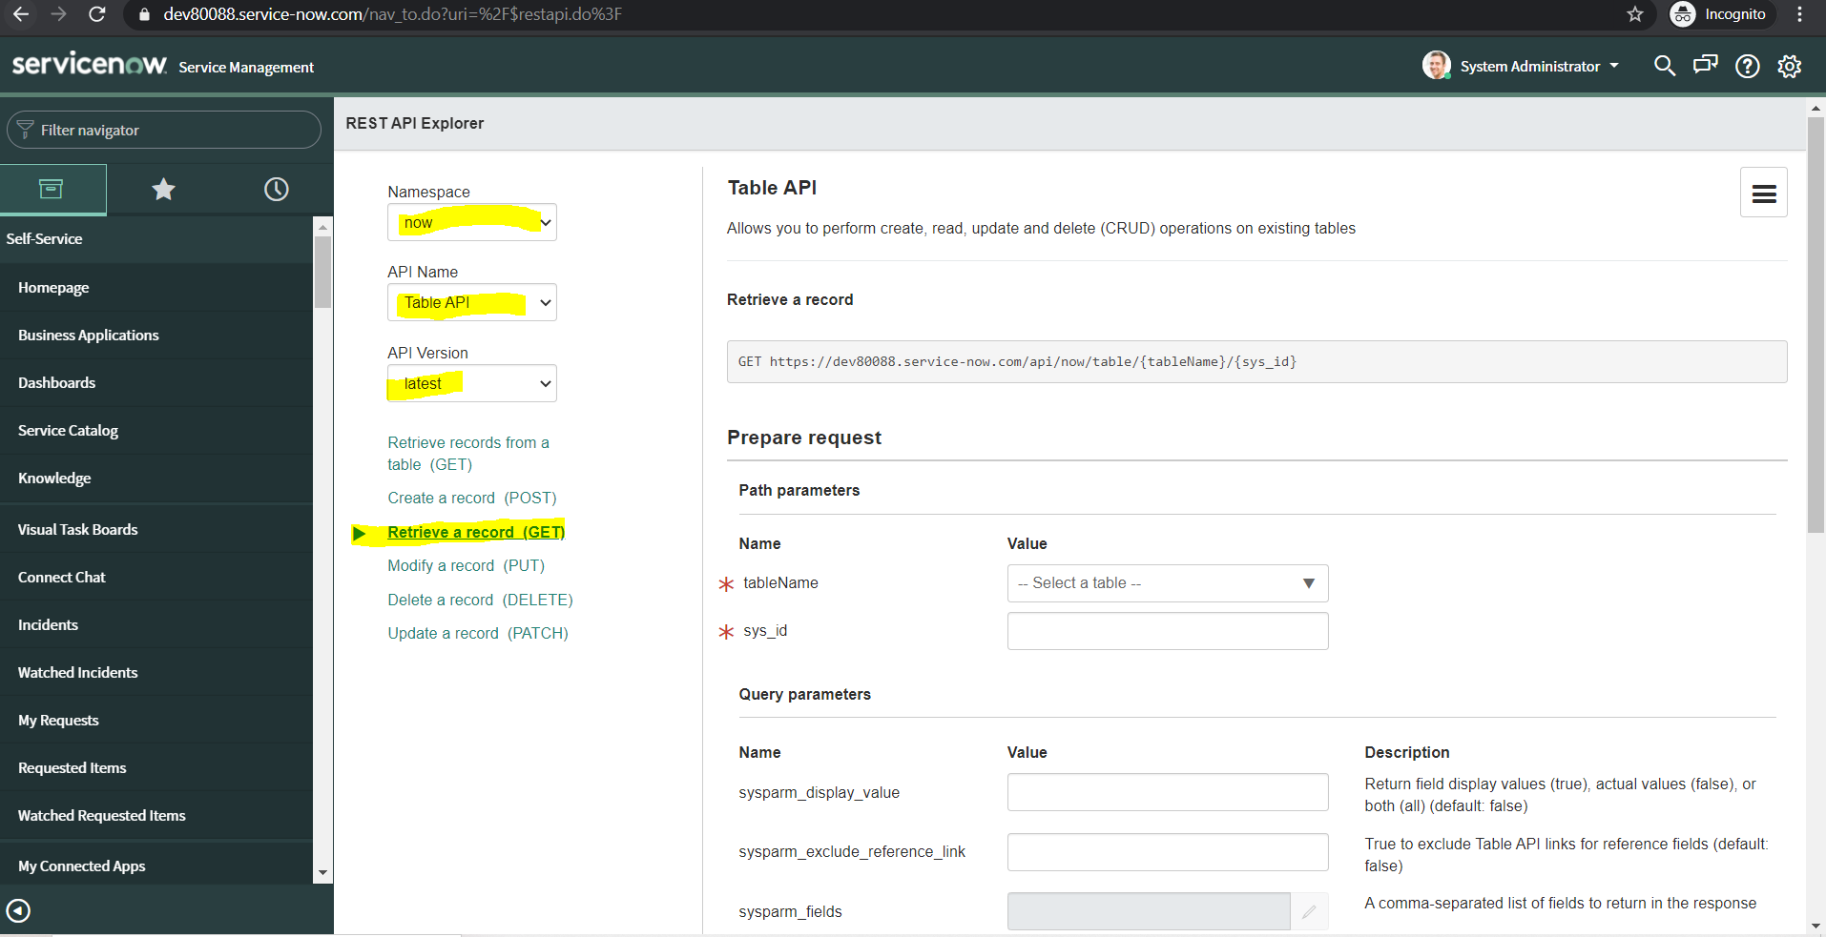

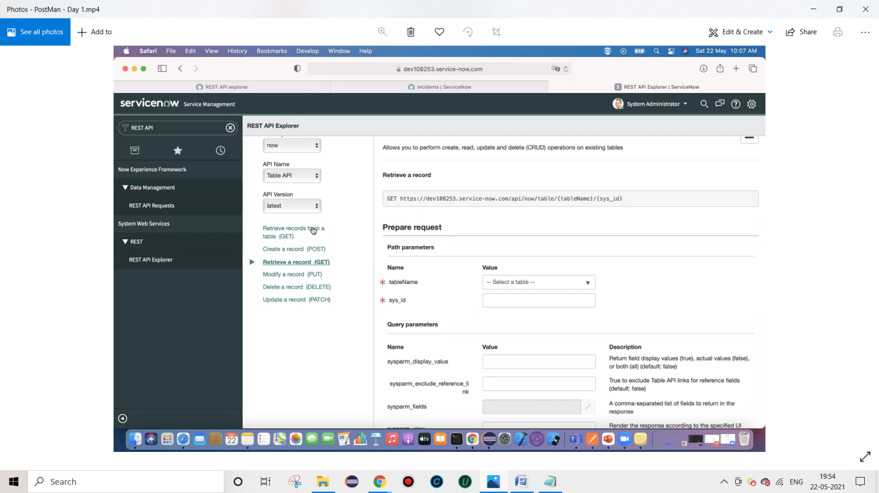

Don’t pass sys_id if we want all details from Table

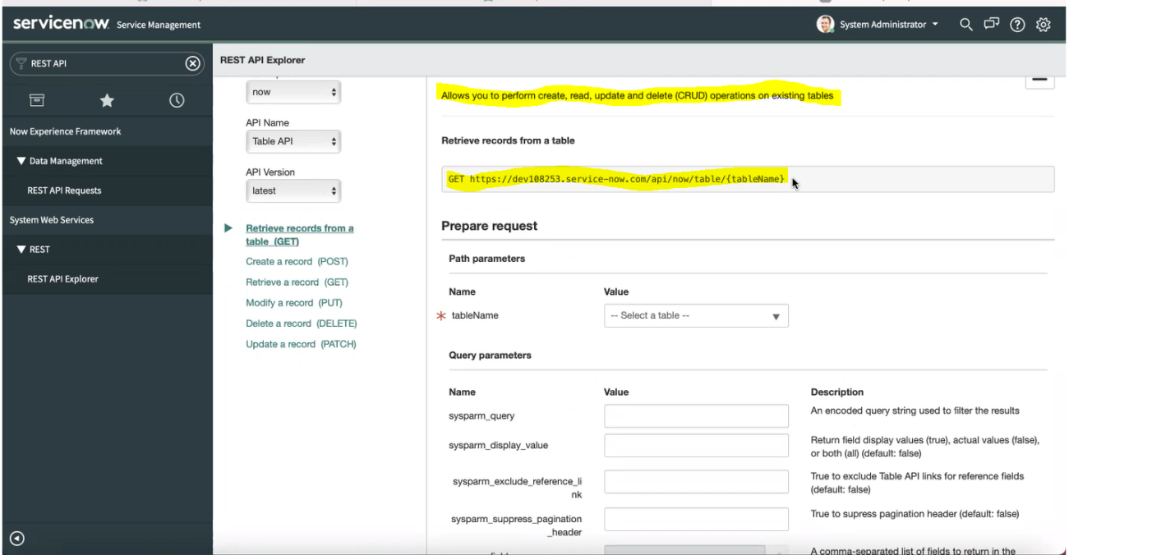

We can send request from JSON and get response from JSON or XML

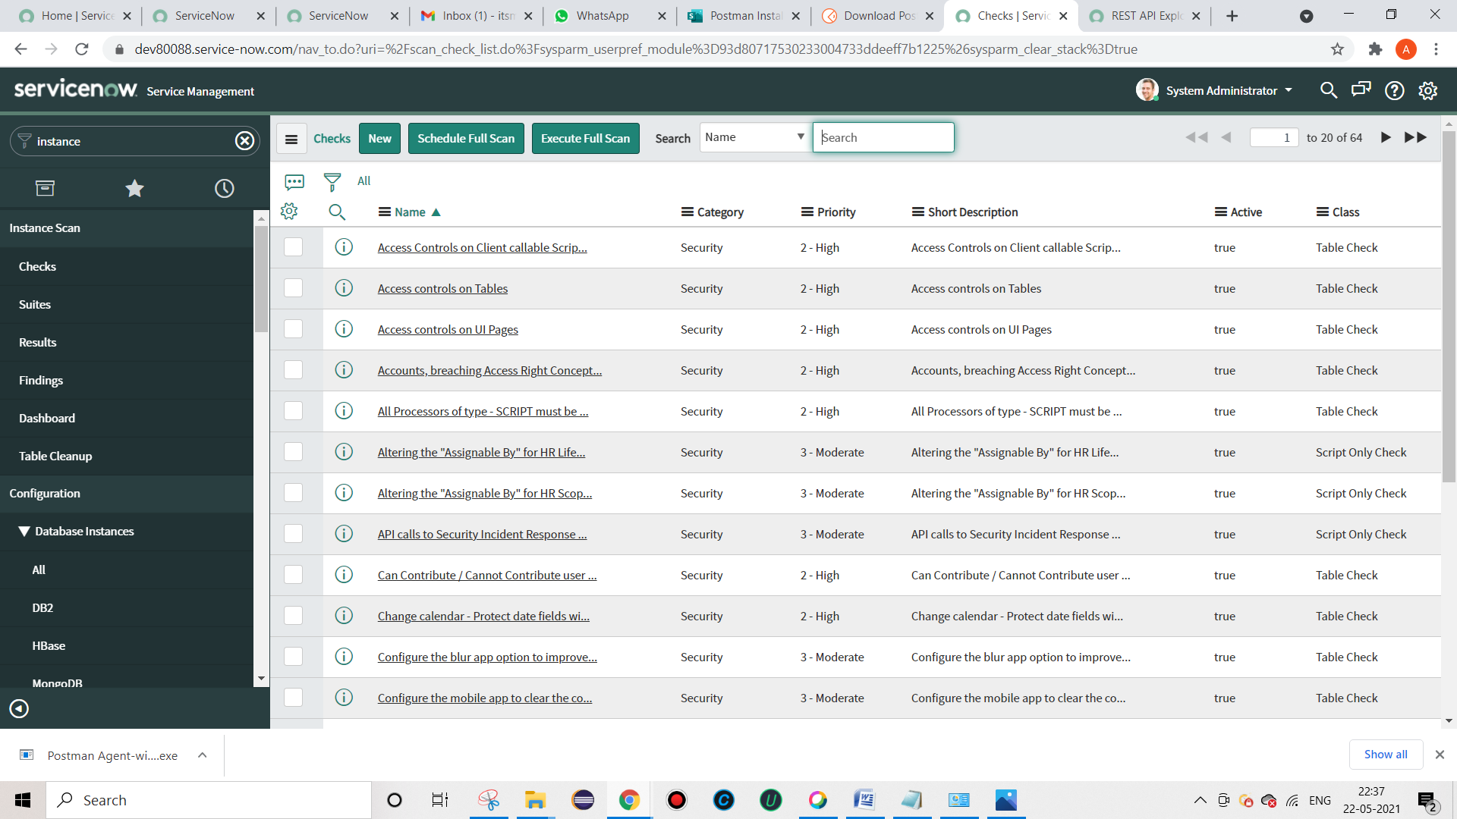

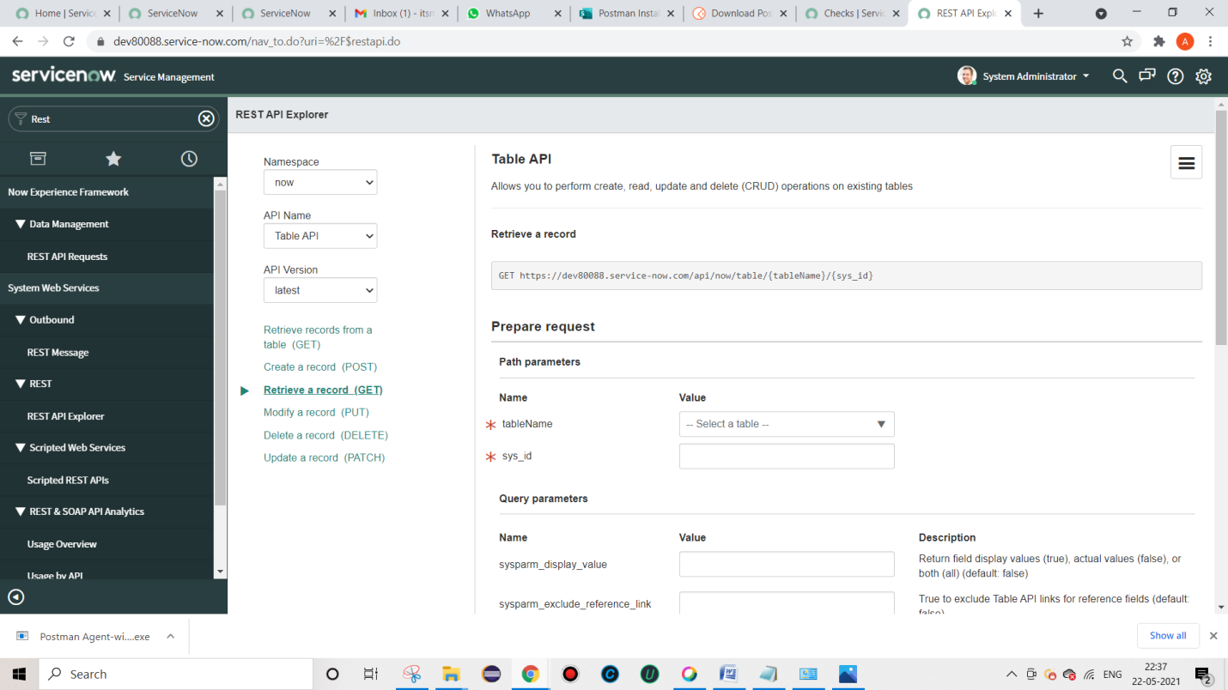Create req

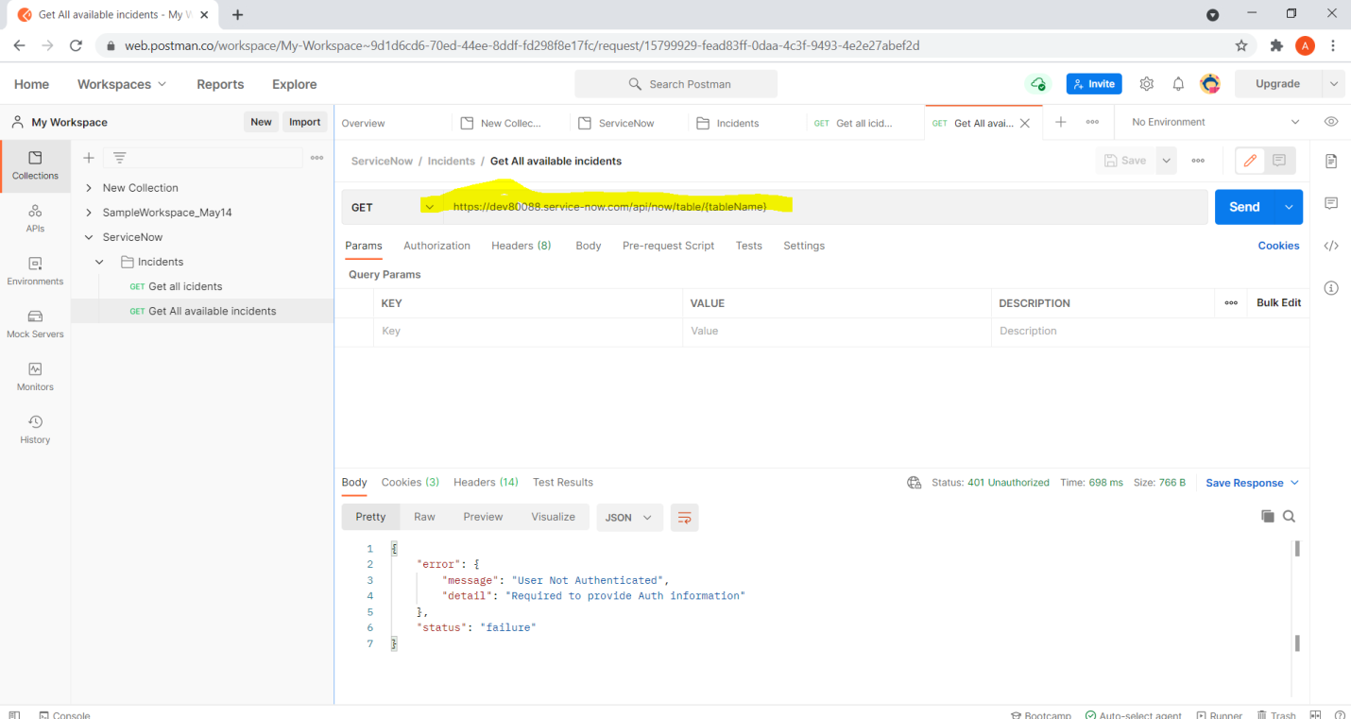

Incidents from service now

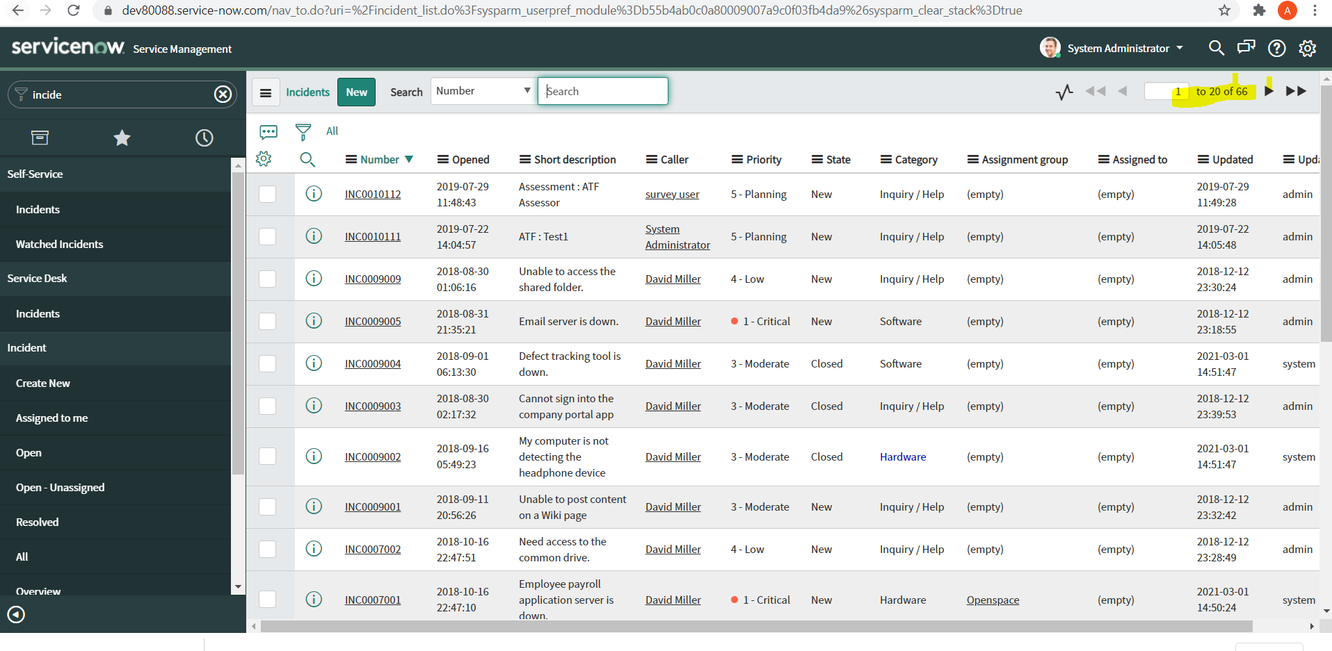

Incidents from Postman

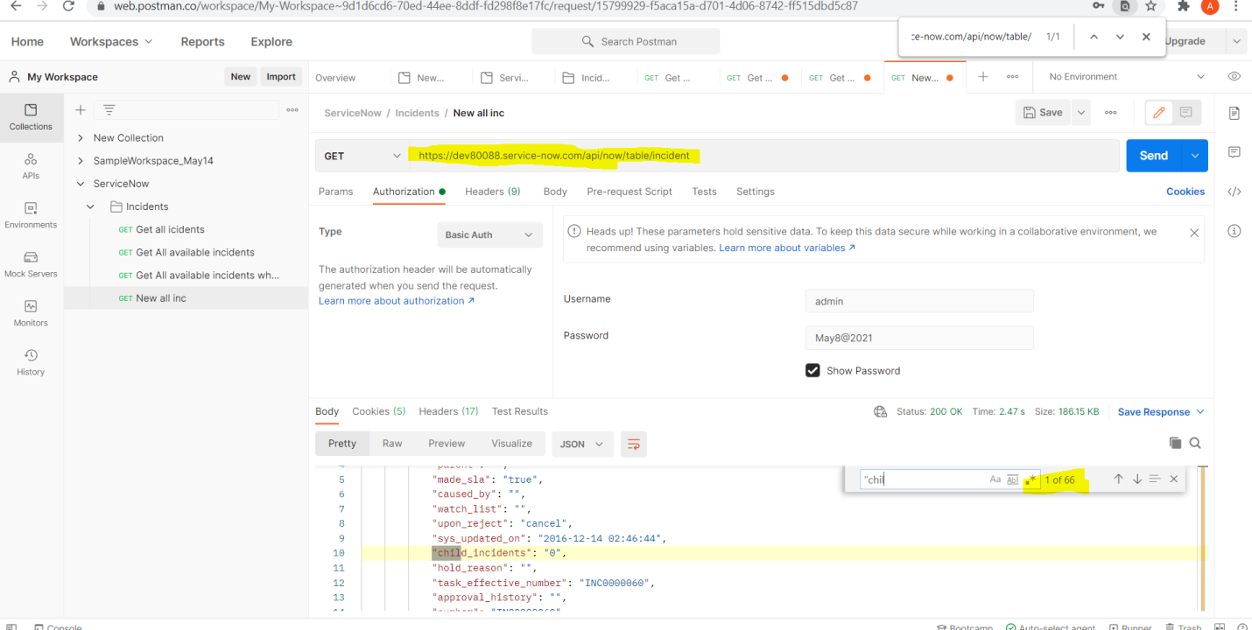

With query – Priority -2 High

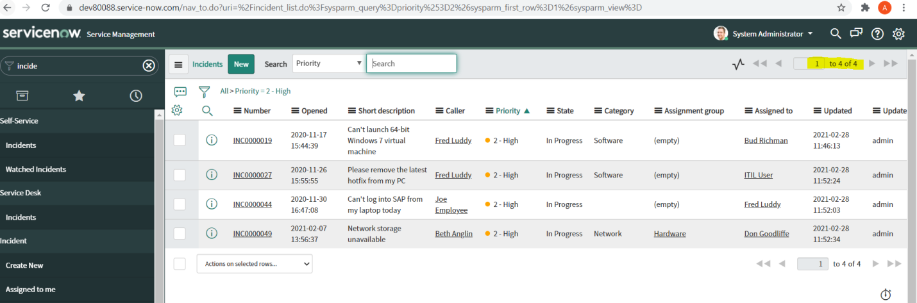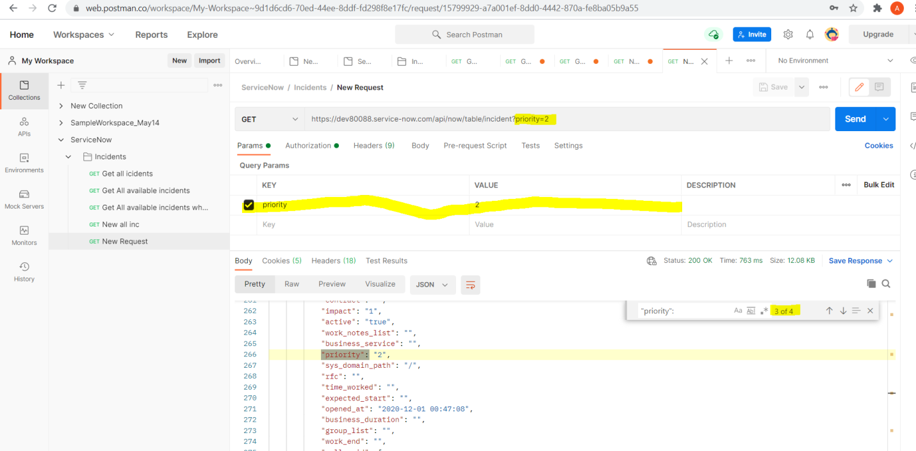

Requirement document ::

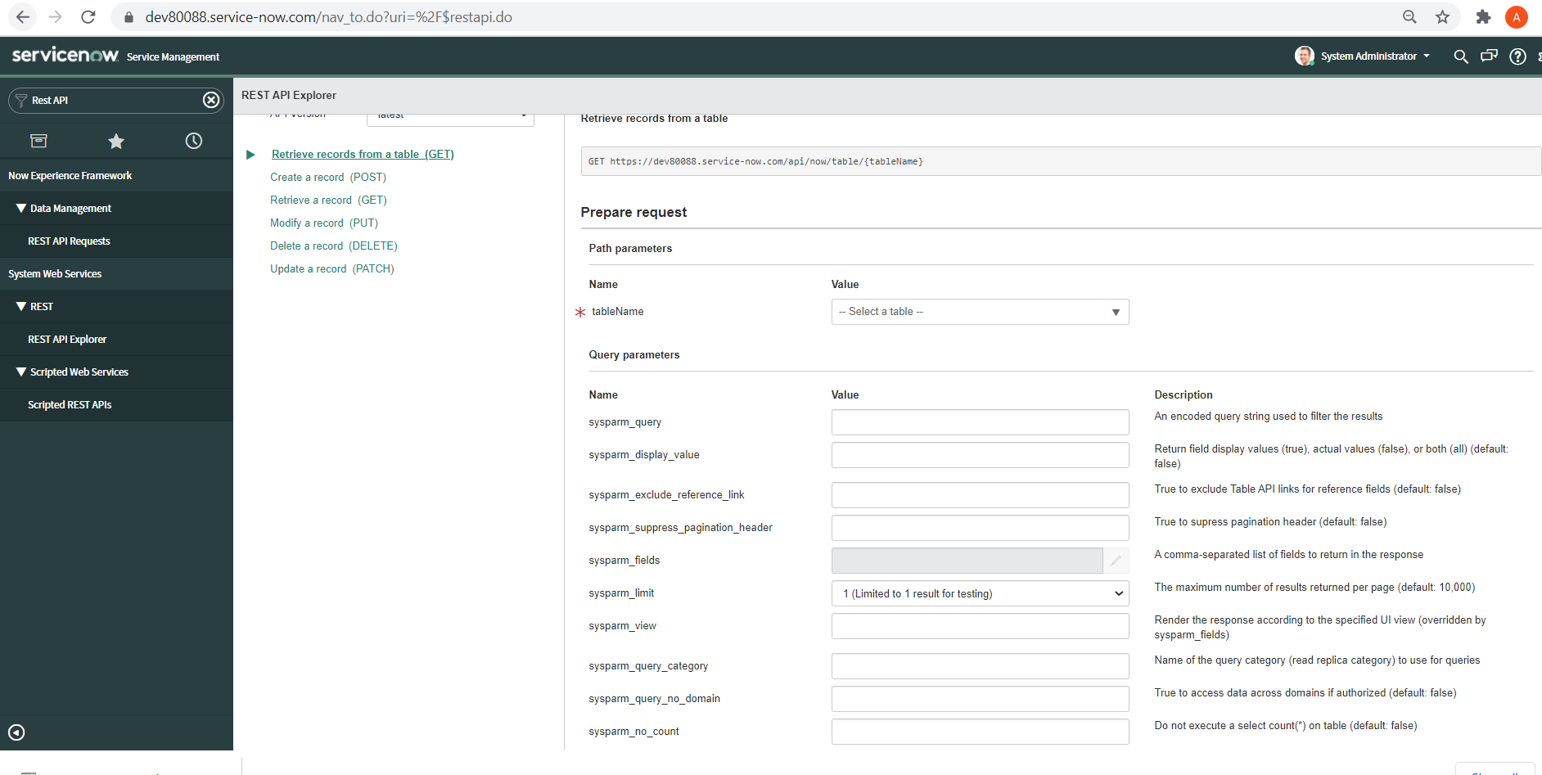

How to get only particular values ::

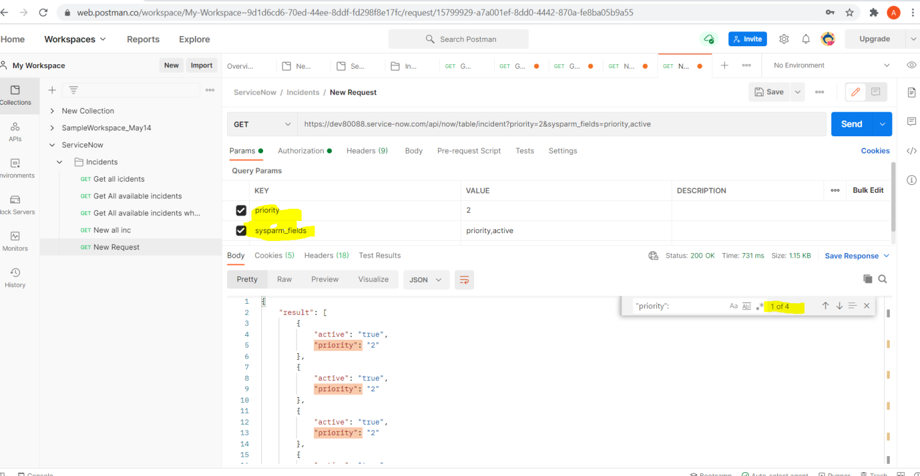

We can give authentication details from collection itself

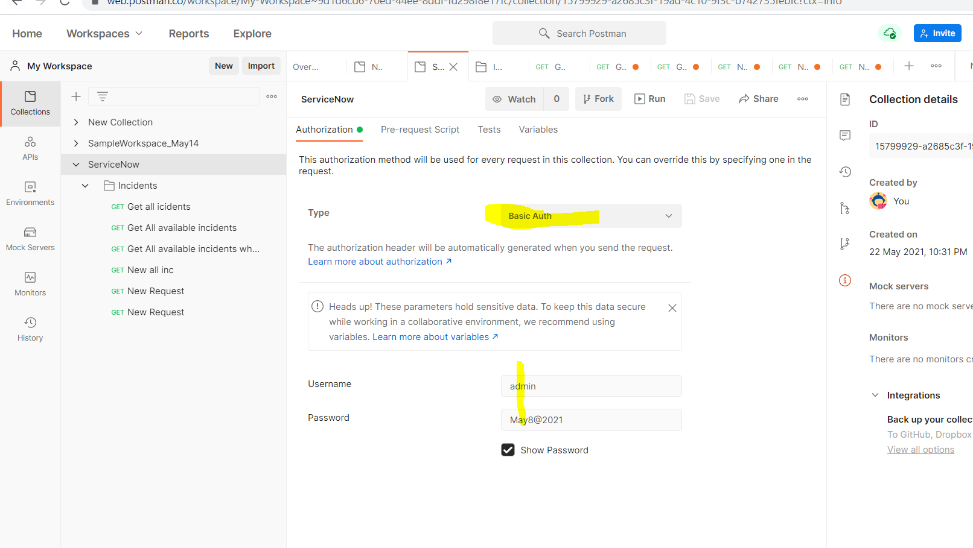

So that we will get like below for child requests.

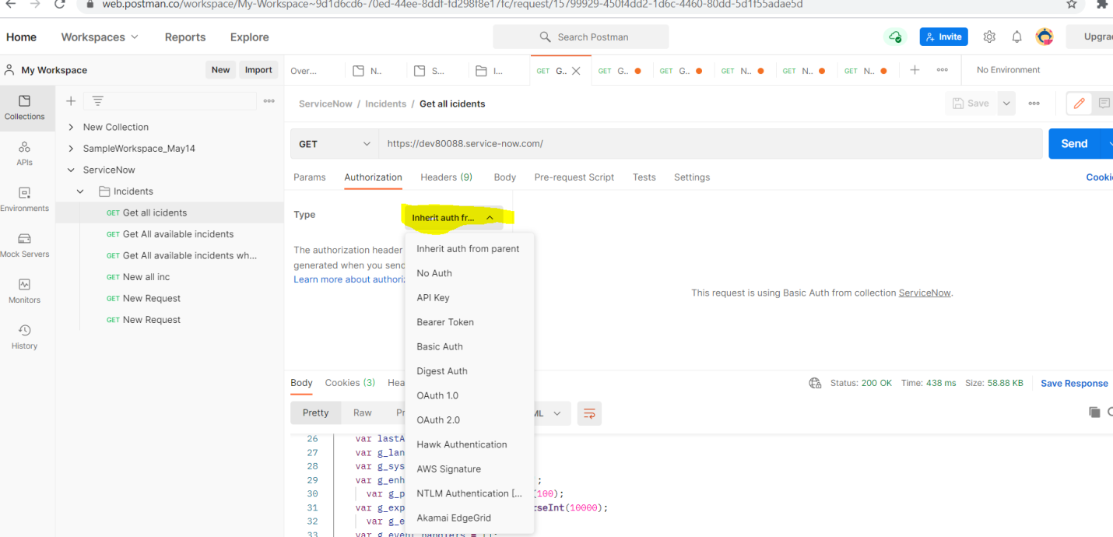

Sys id -

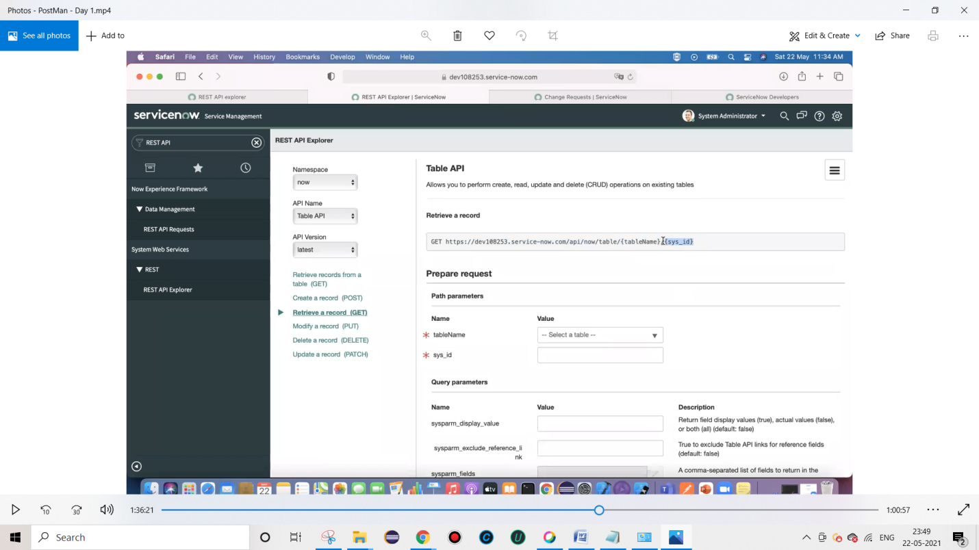

To Export :: 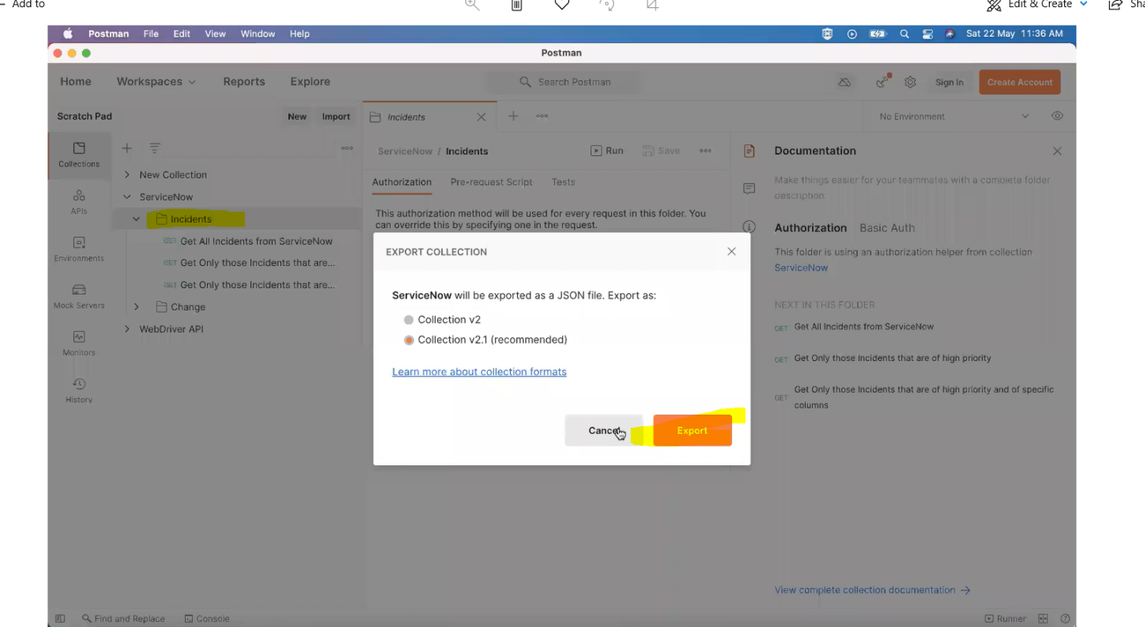

Create new Record –Manually

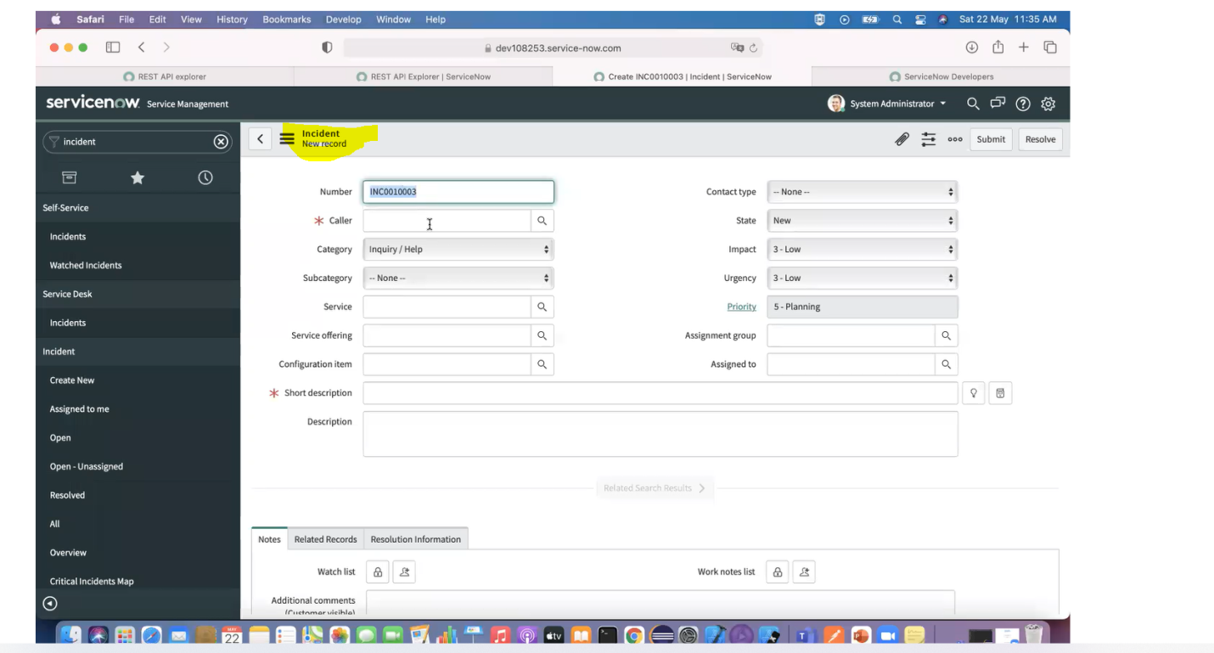

Create Instance using Postman

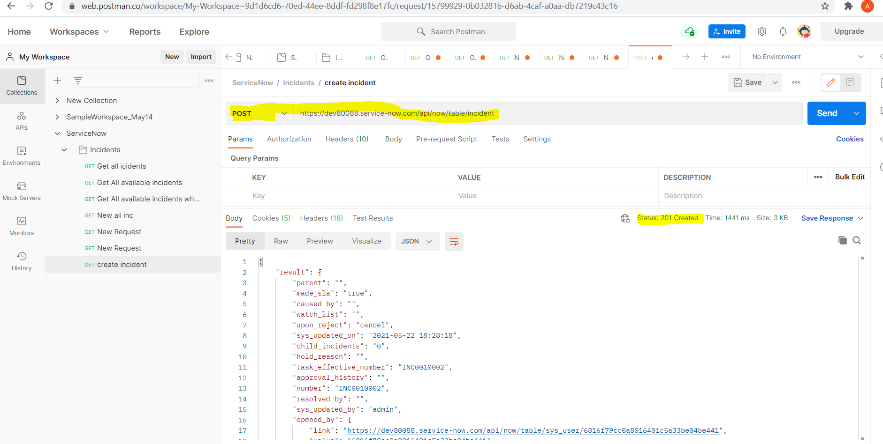

POST -201 – Successfully created

GDT – 200 - Successfully created 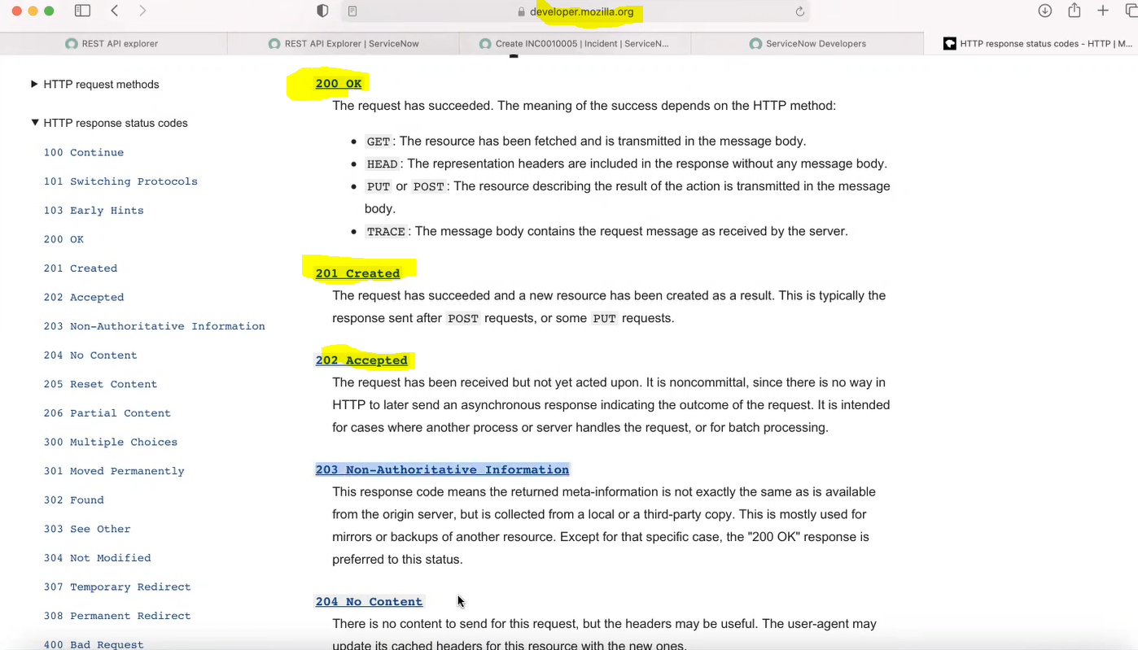

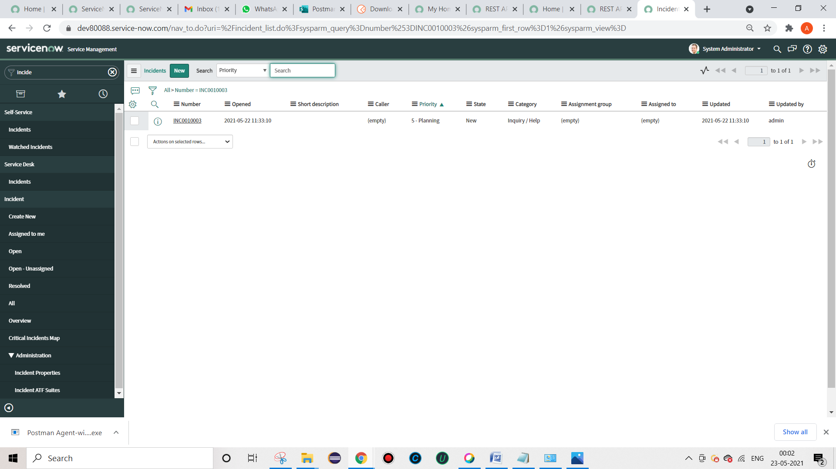 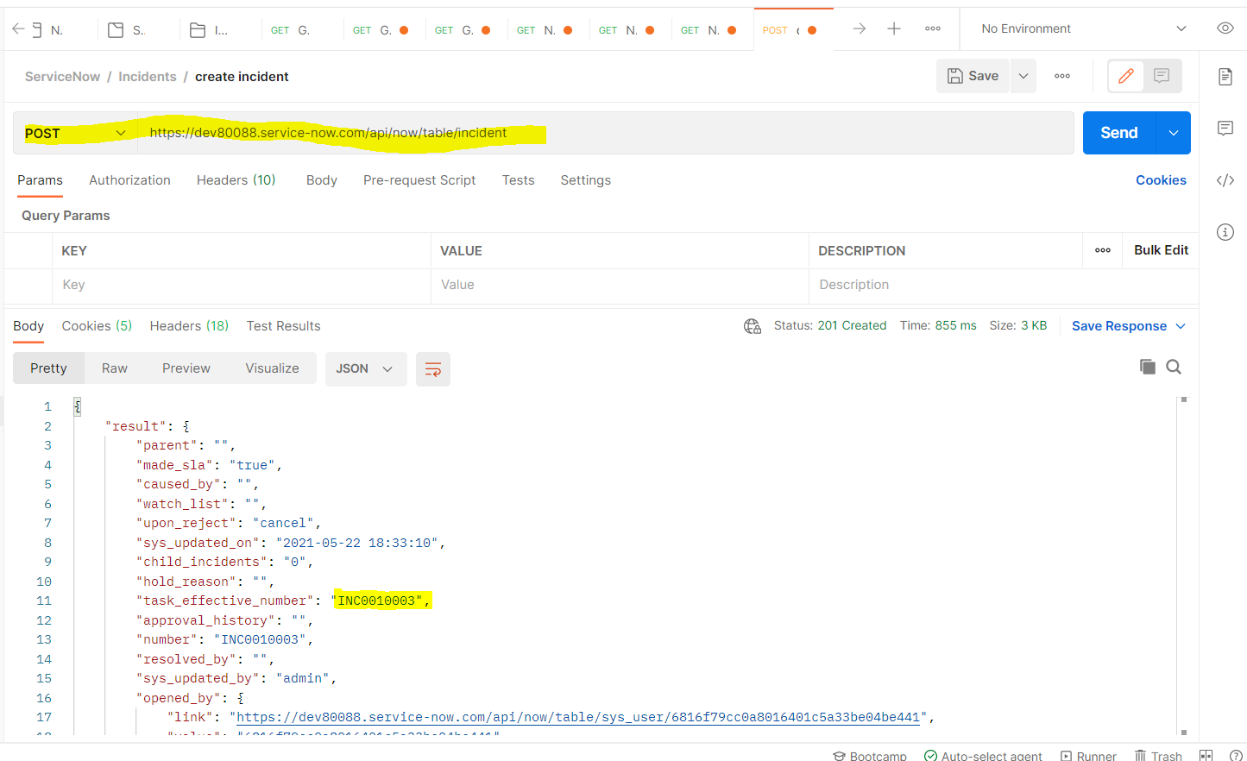 While creating (POST), if we want the response in XML format –

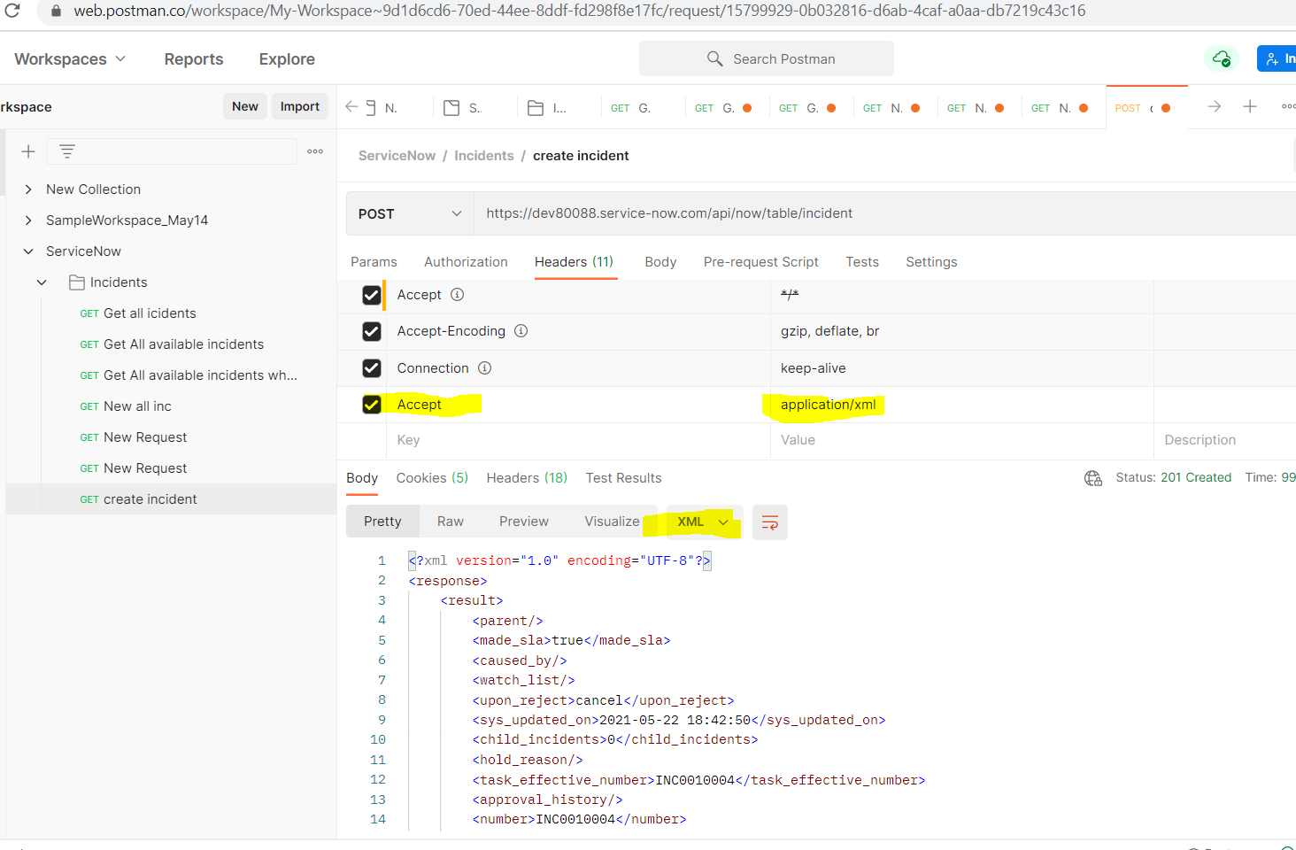

While creating (POST), if we want only particular values -

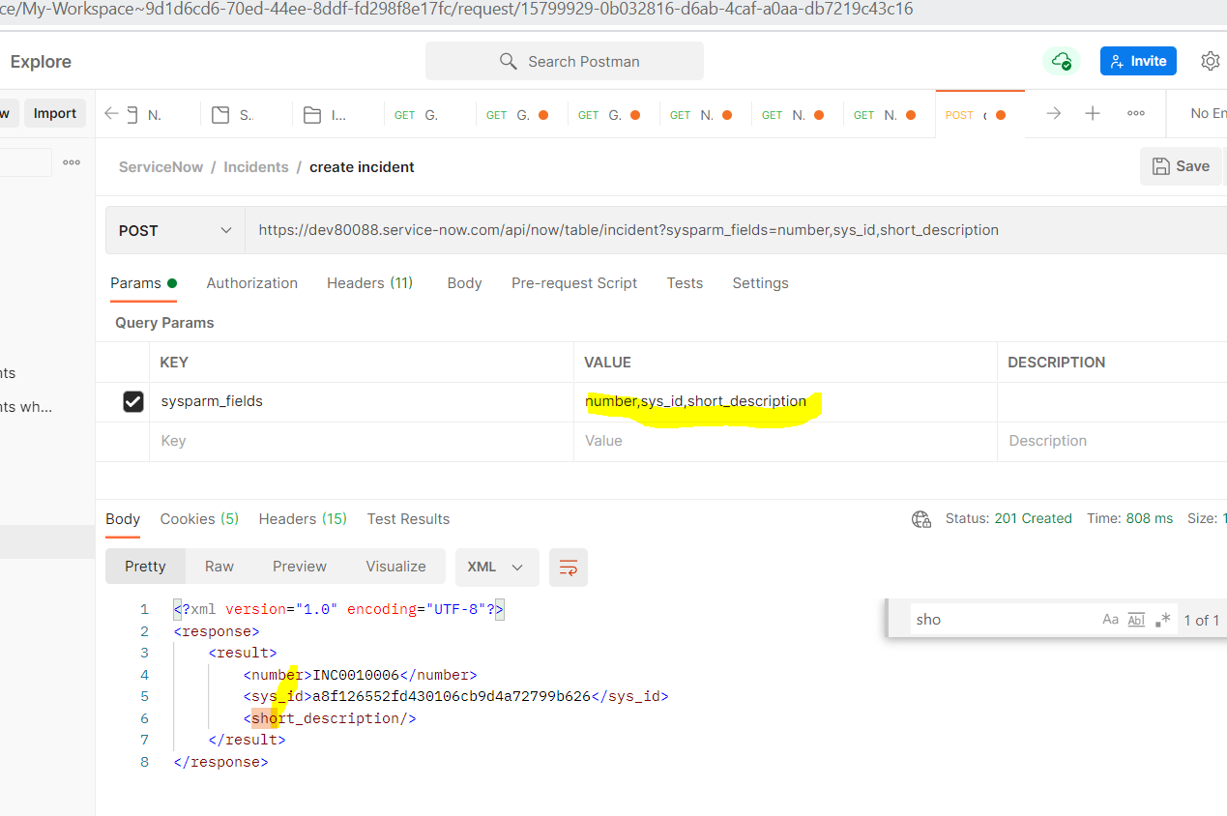



Delete Incident ::

Can’t delete All at same time.

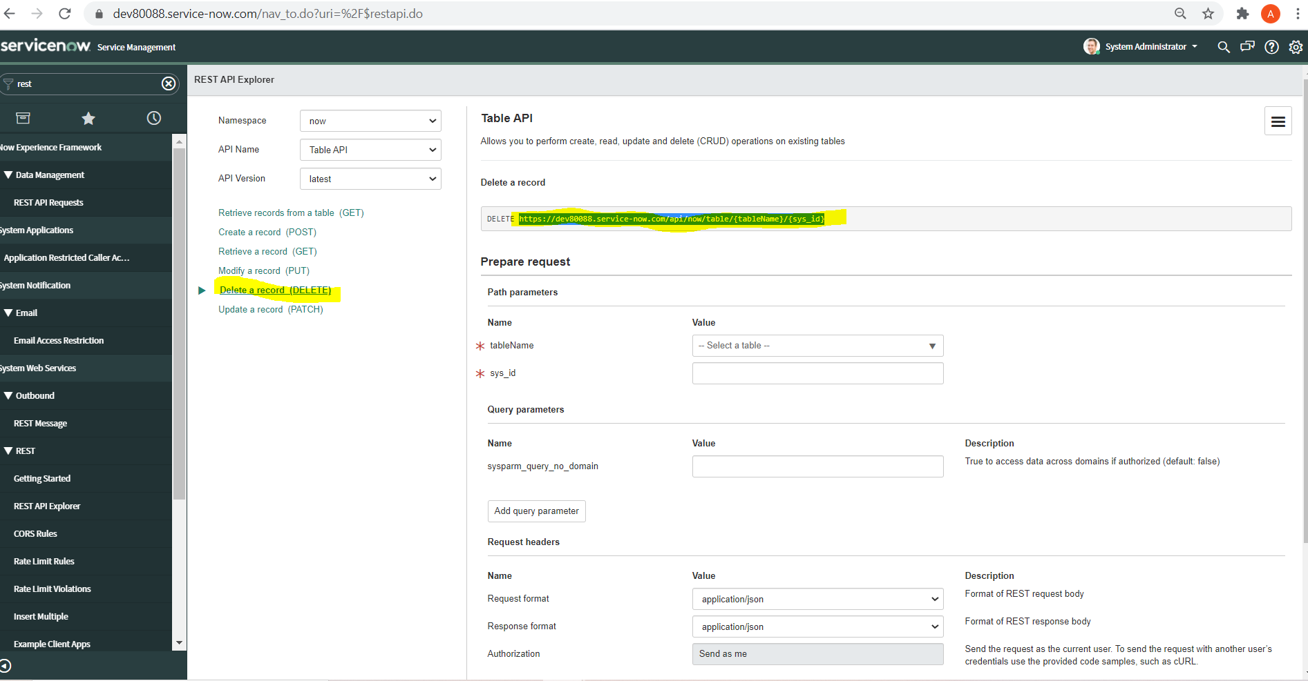

Even PUT and PATCH

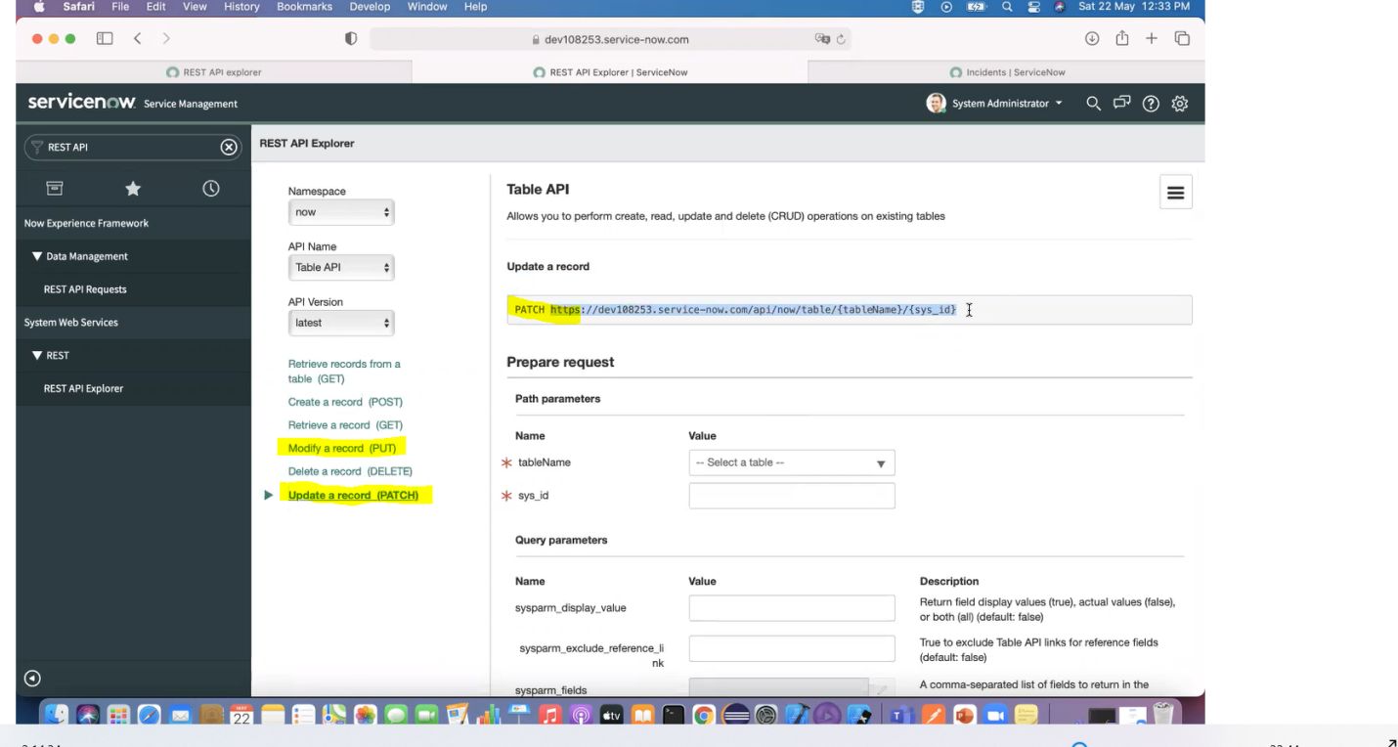

Delete Record from Postman :: 402

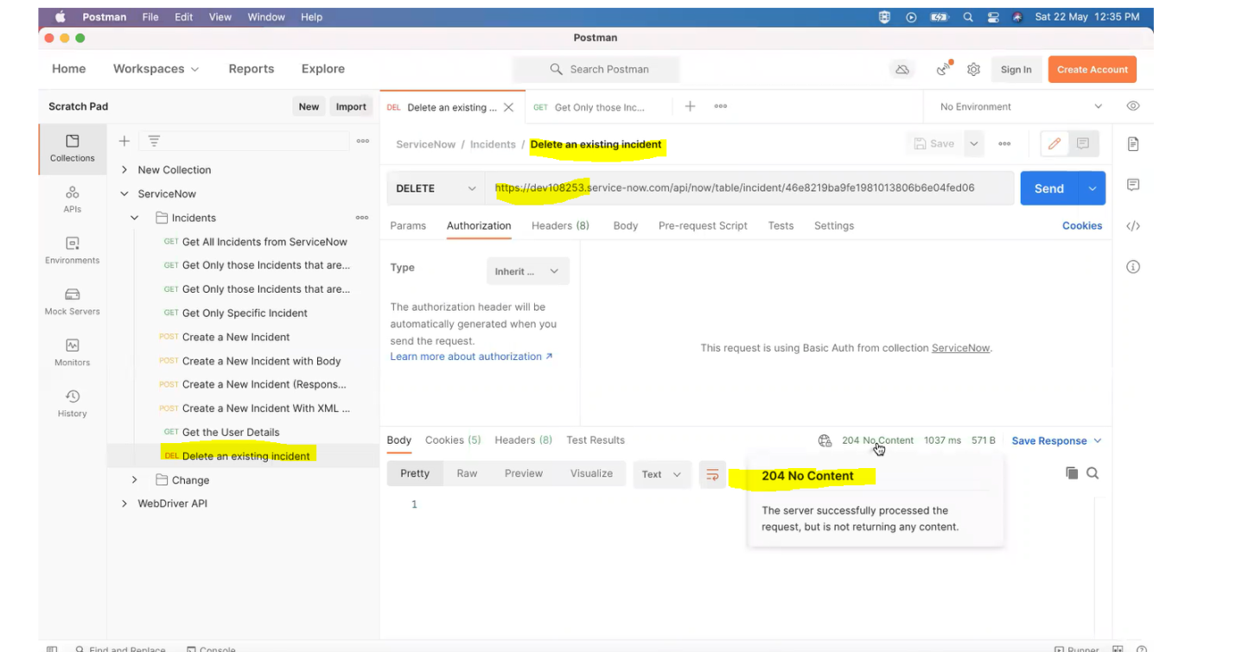

PATCH :: Updating short description

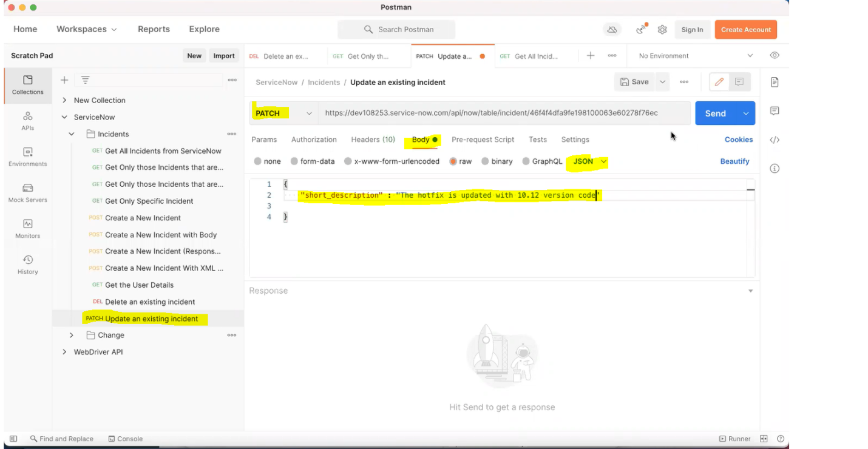

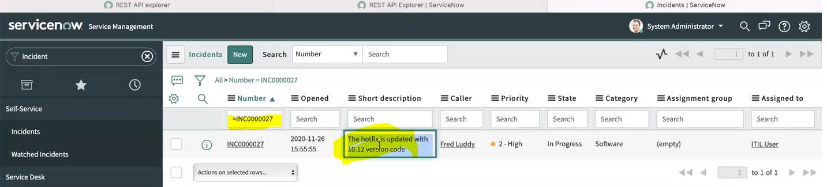

**JIRA :: Search All issues**

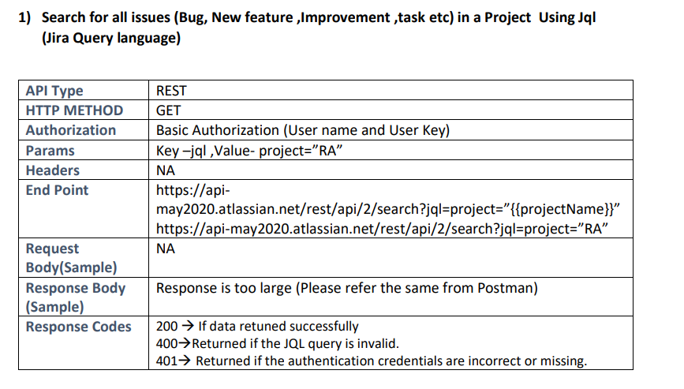

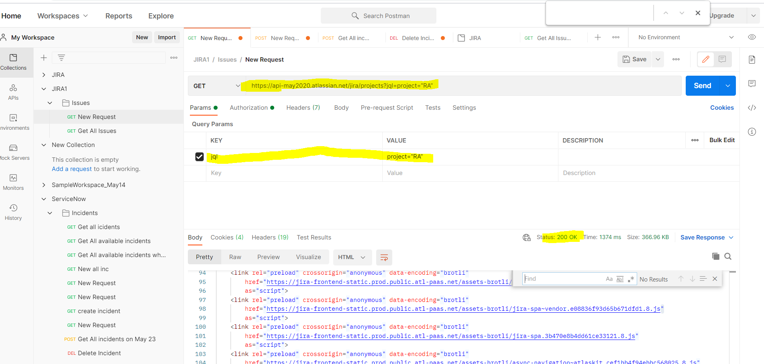

2. Create issue Manually and Delete the same from Postman

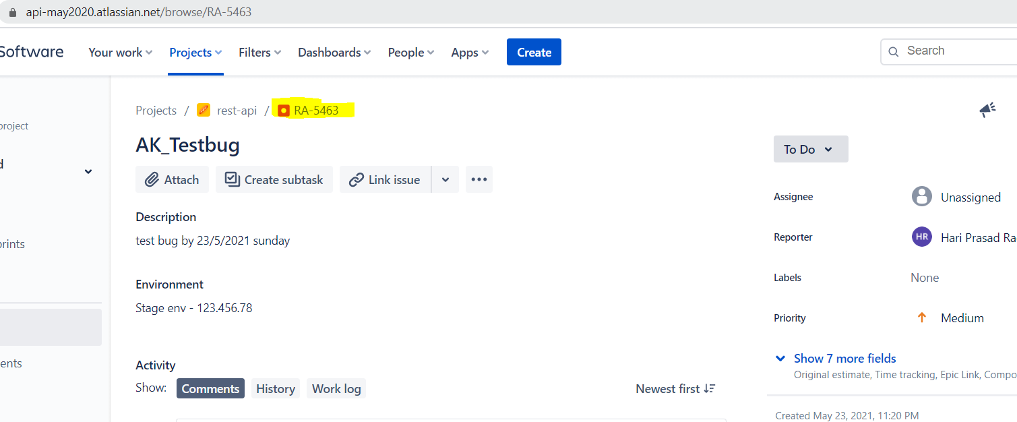

1. Get that Issue and Delete the same

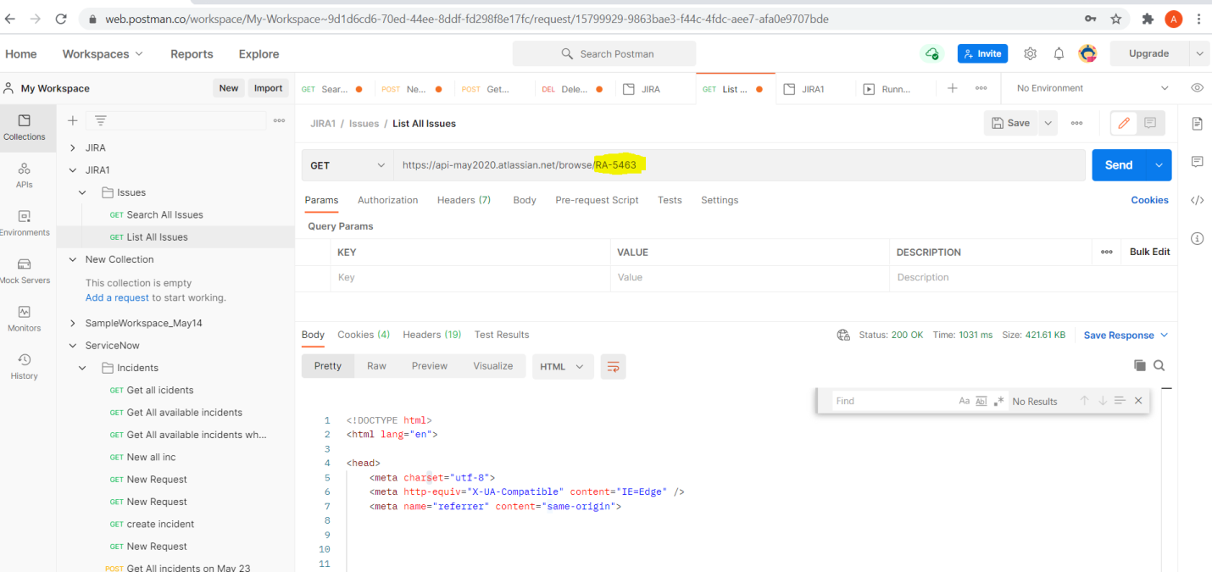

1. delete

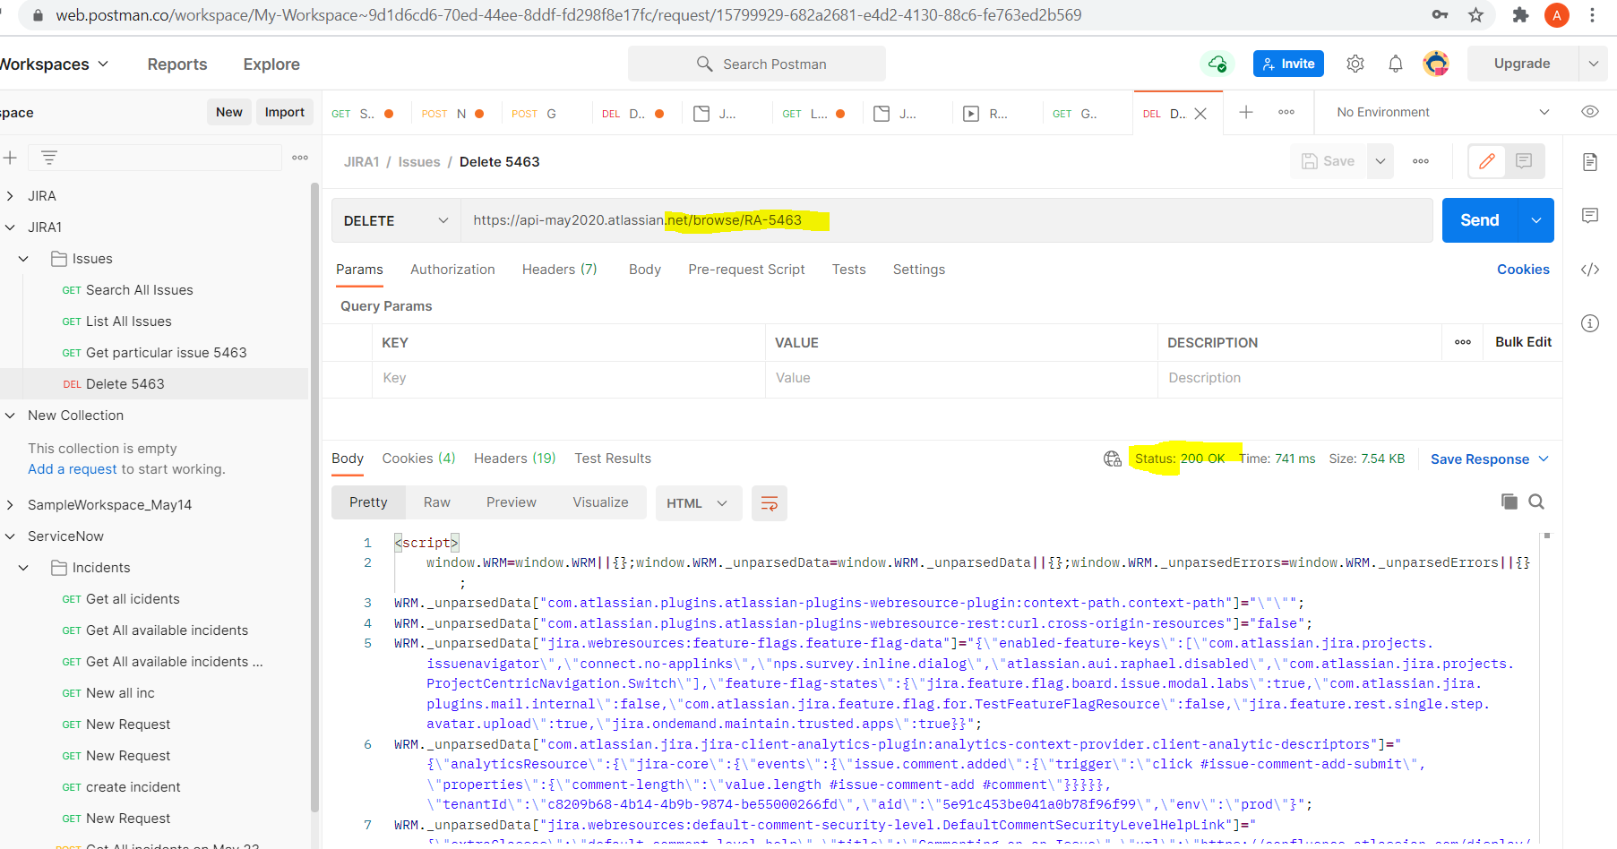

PATCH – Modify /update

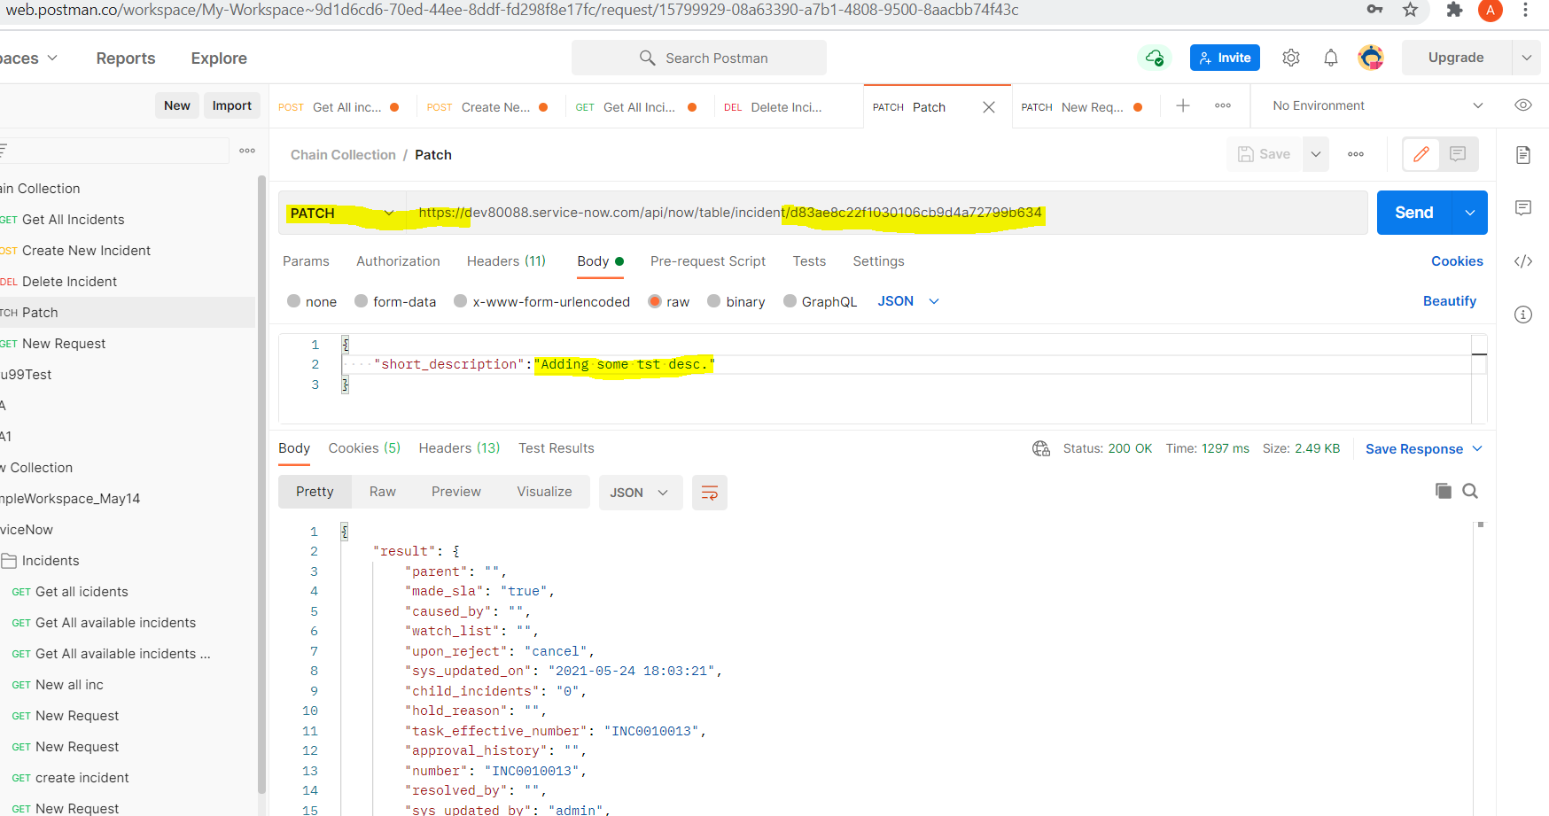

**Delete** :: 204 - Successfully processed request, but not returning any content .

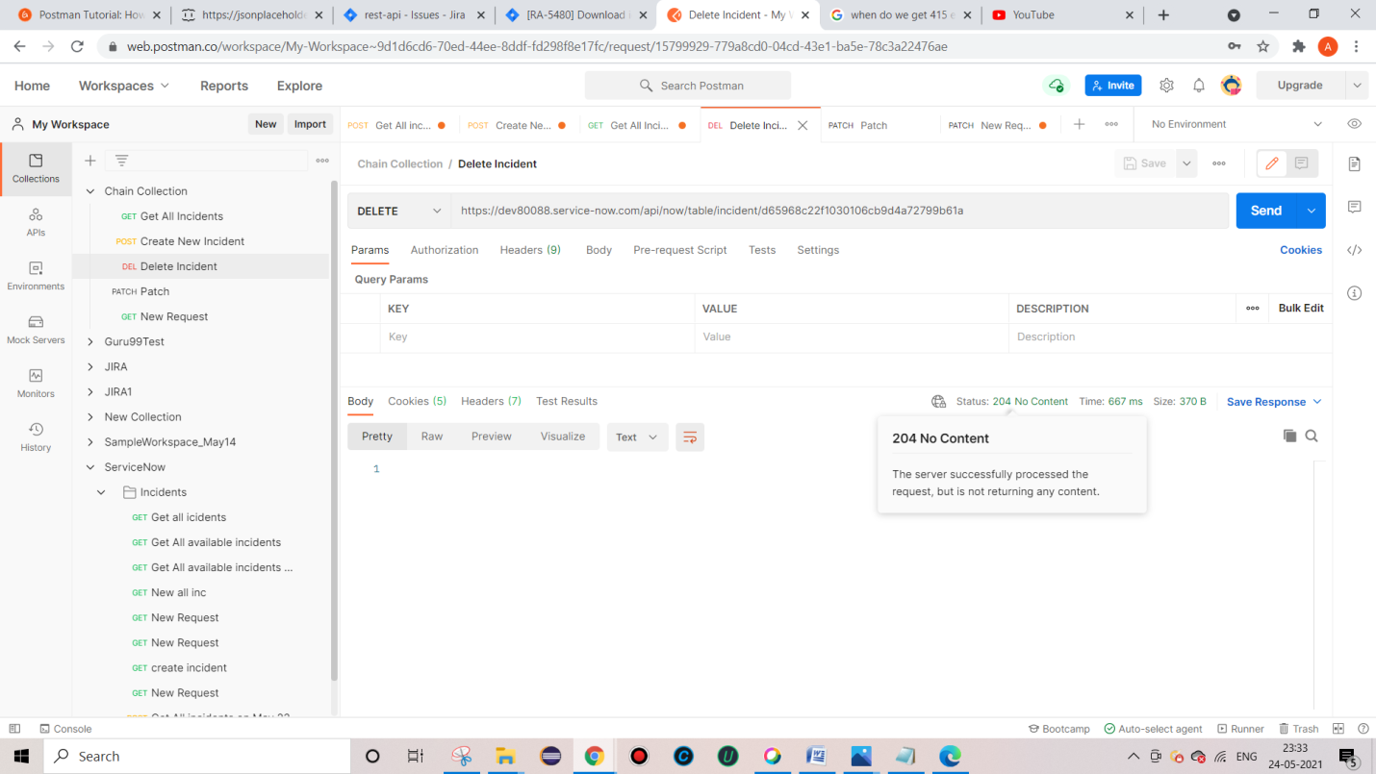

**New Man** – command line based postman , especially if we want to integrate with Jenkins or any CI / CD Devopps tool.

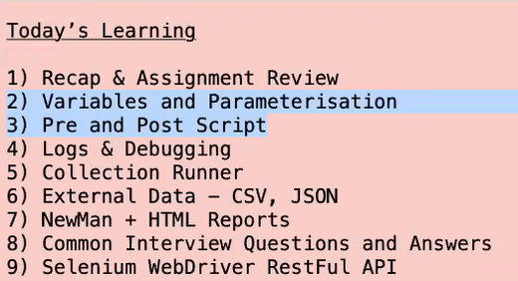

**Variables and Parameterization :: To create and delete at same time**

**Variables ::** 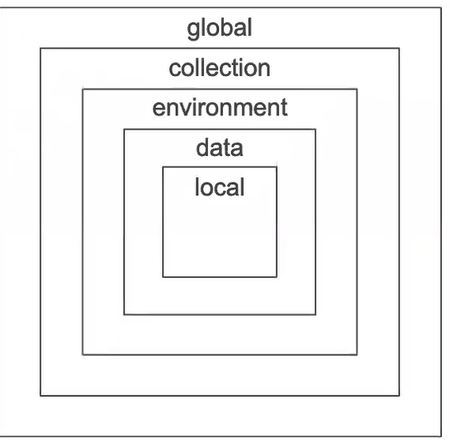

**Global** – It is applicable for all different requests in postman (For multiple collections like – Service now collection, JIRA collection / Smoke collection / sanity etc).

**Collection** – Common variable for All request for specific collection

**Environment** – common for all requests for specific env – Test/ stage /dev, pre production

(When data is changing with respect to your environment)

**Data -** external file coming from csv or JSON

**Local –** locally created , with in Request

Setting Global variable :: - **Settings To export data**

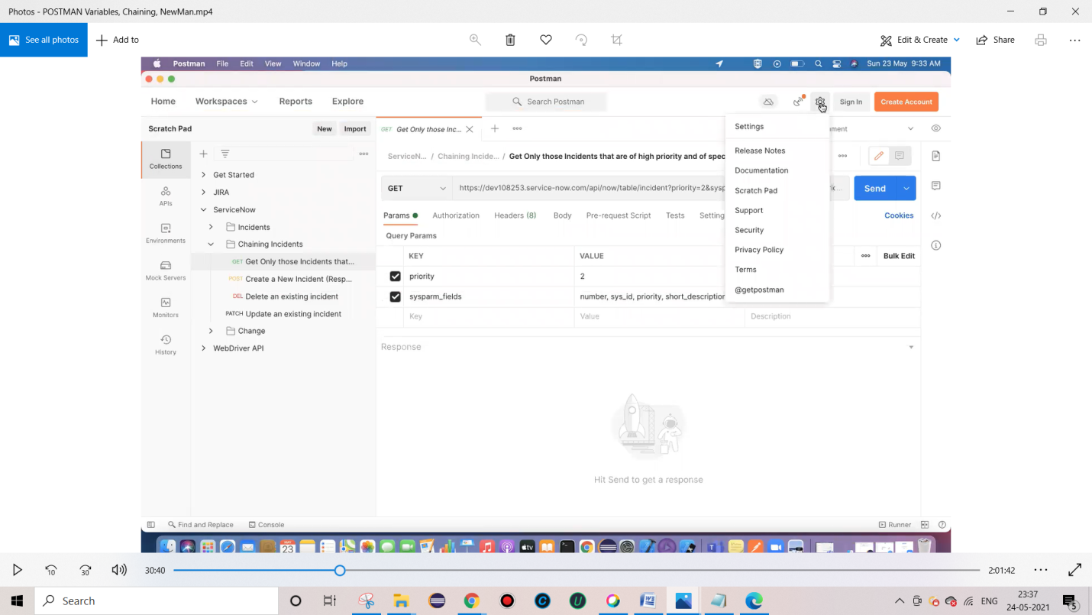

View icon – To set variable

Creating Global variable

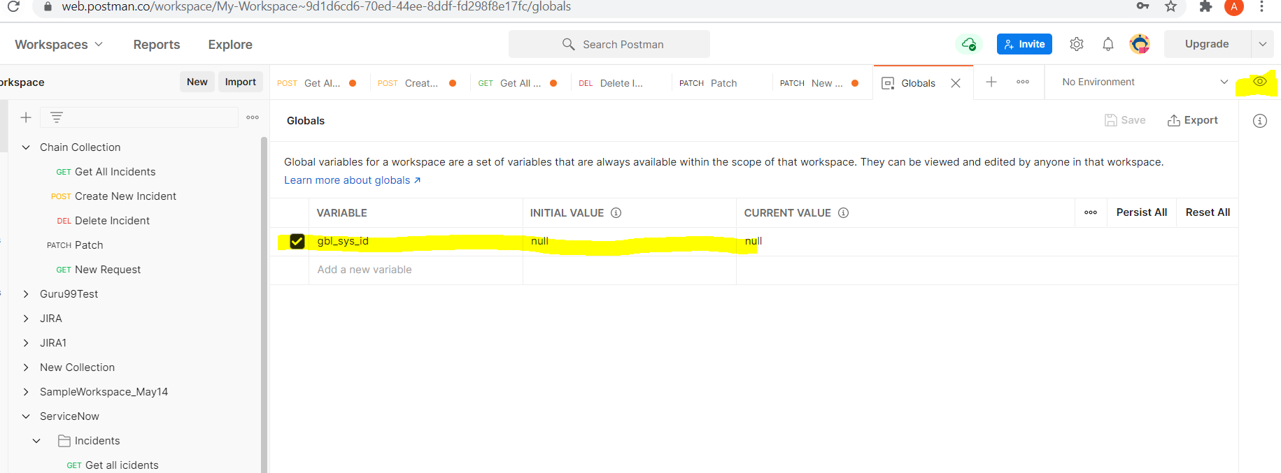

Collection var –

Click on Edit for selected collection

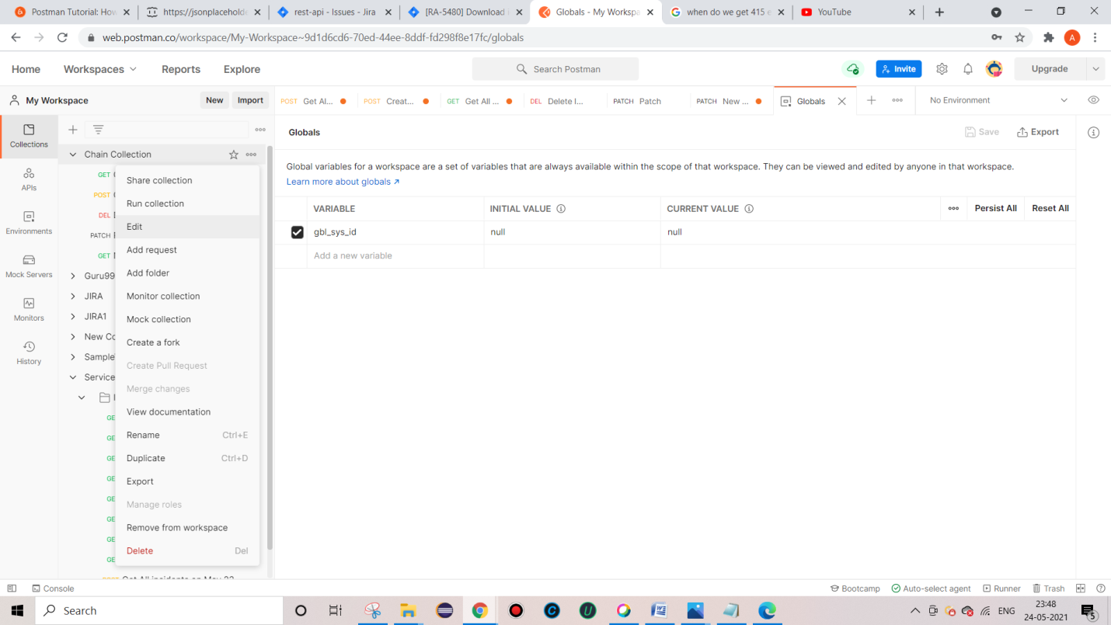

Env variable and global var ::

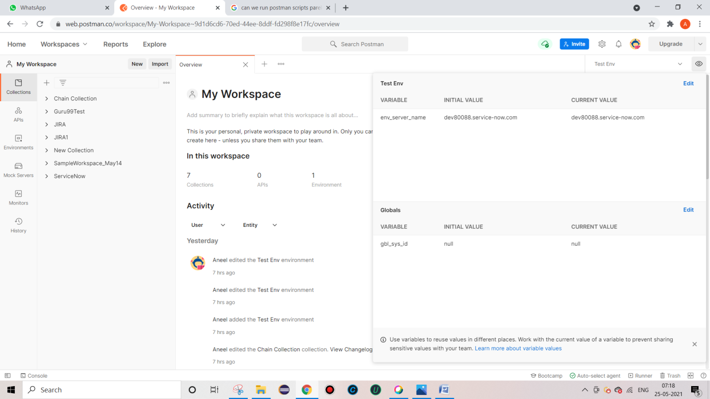

Collection variable restricted to collection

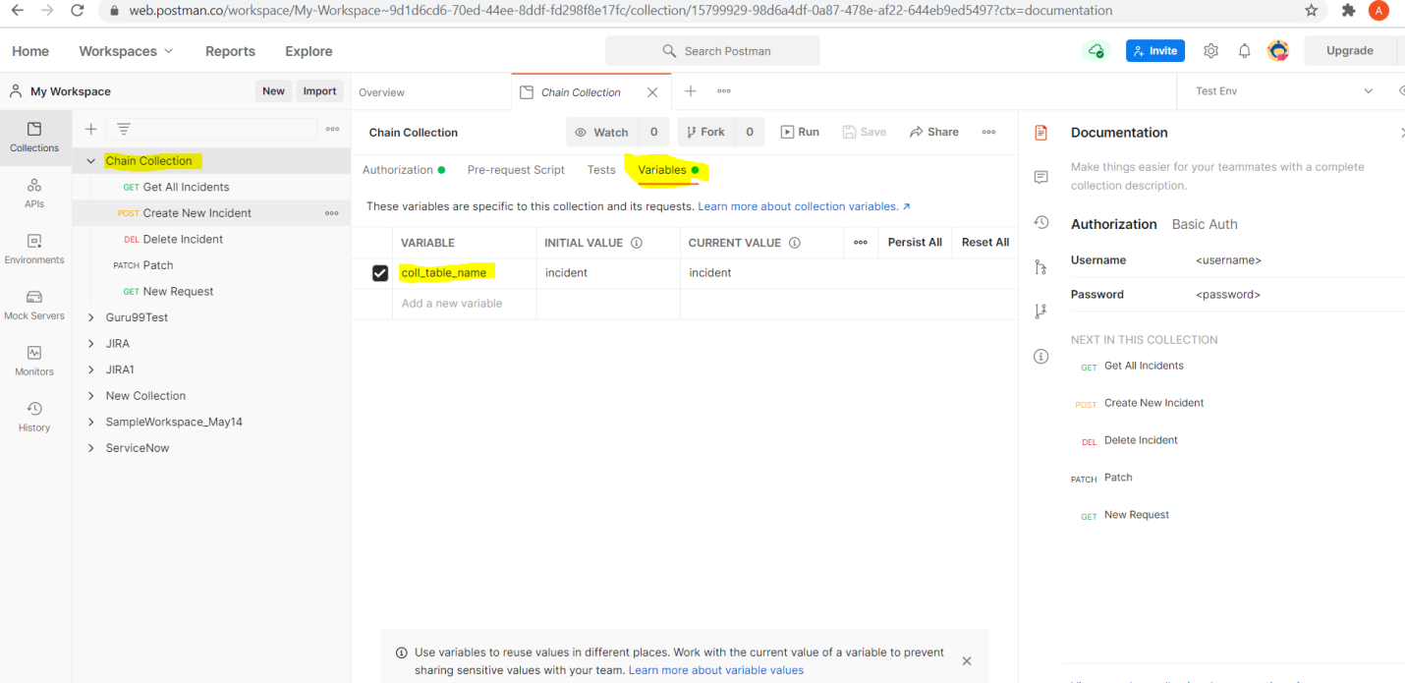

***We can’t Run scripts/requests in parallelly in Postman, we can achieve this thru Newman and able to generate Allure Reports.***

**How to use Env variables in Request**

**Env var which we saved -** dev80088.service-now.com

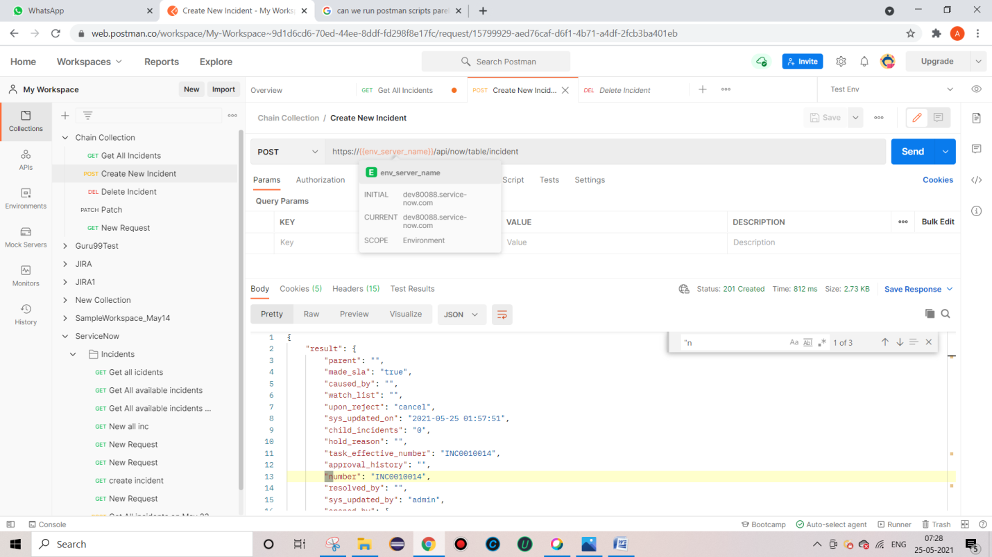

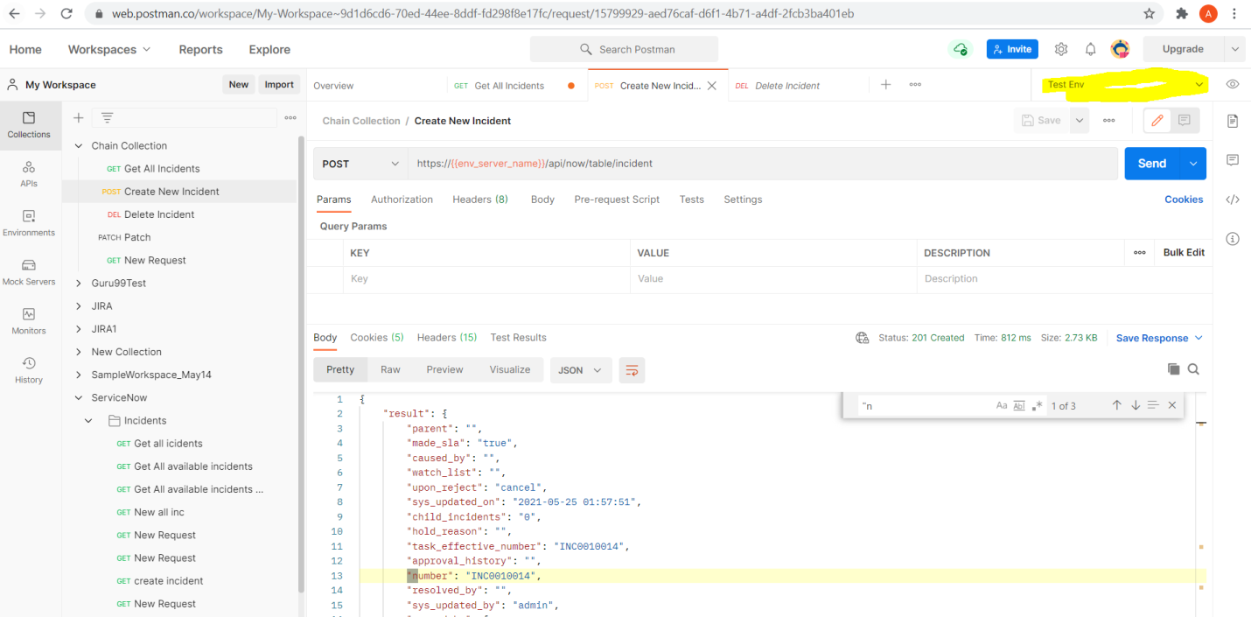

**After using all vars - GET**

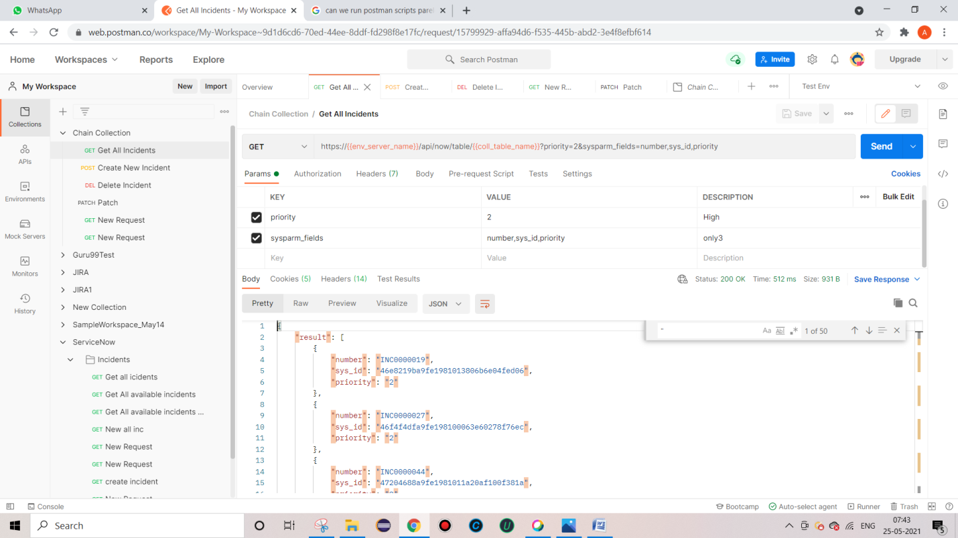

**POST**

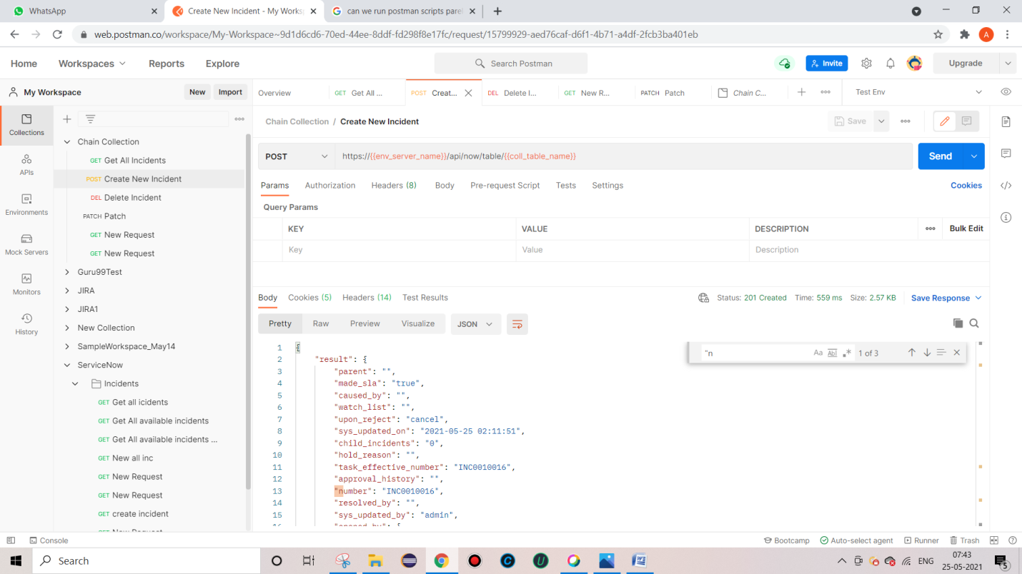

Delete

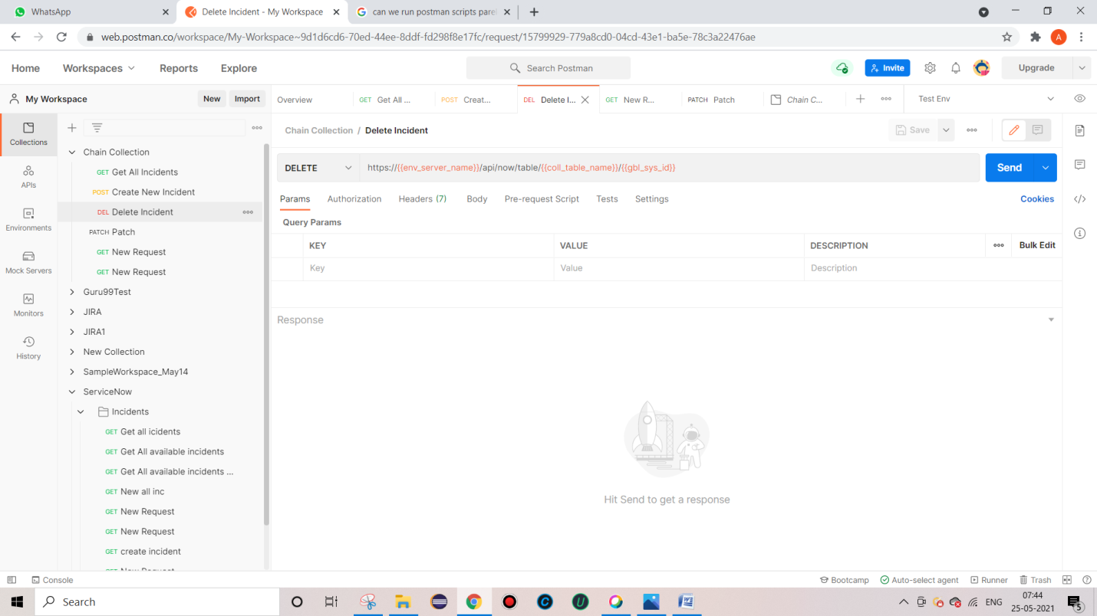

**PATCH ::**

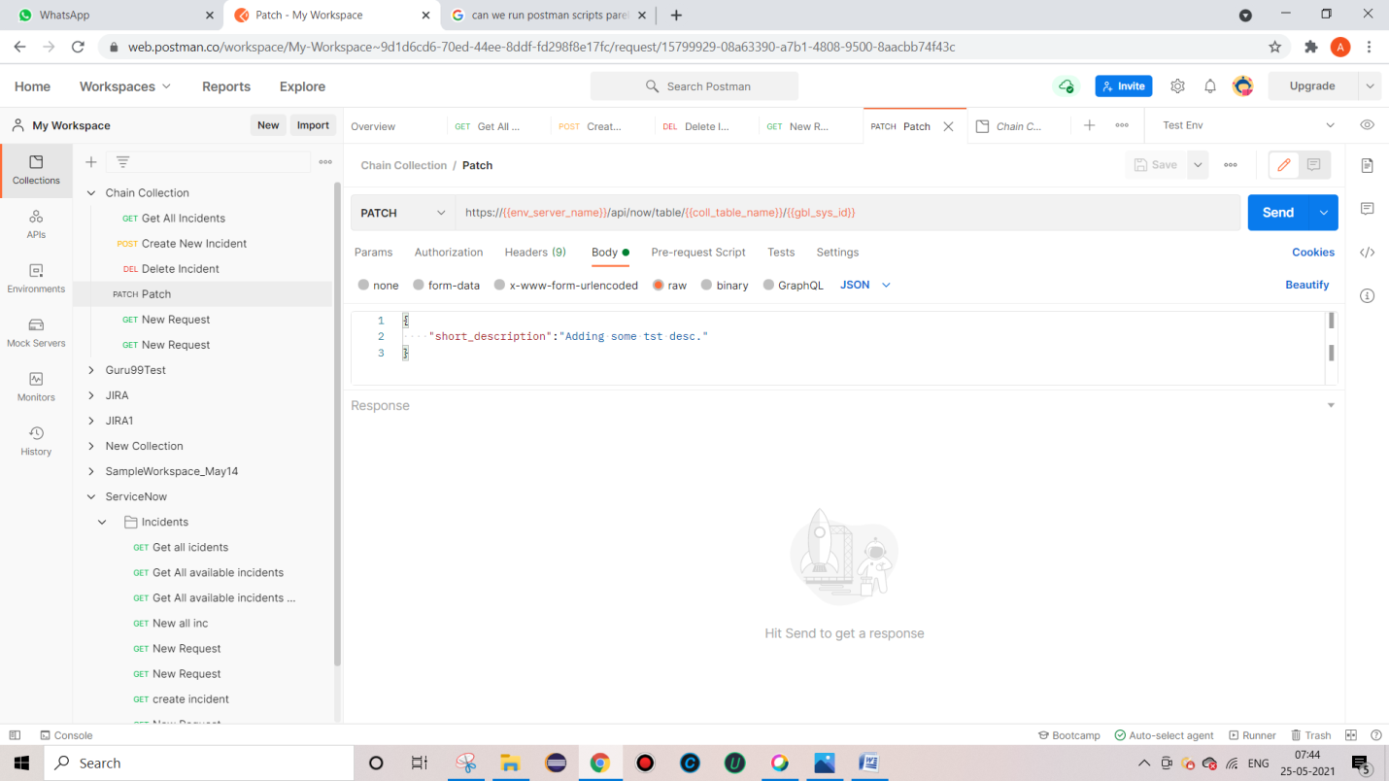

**To check logs ::**

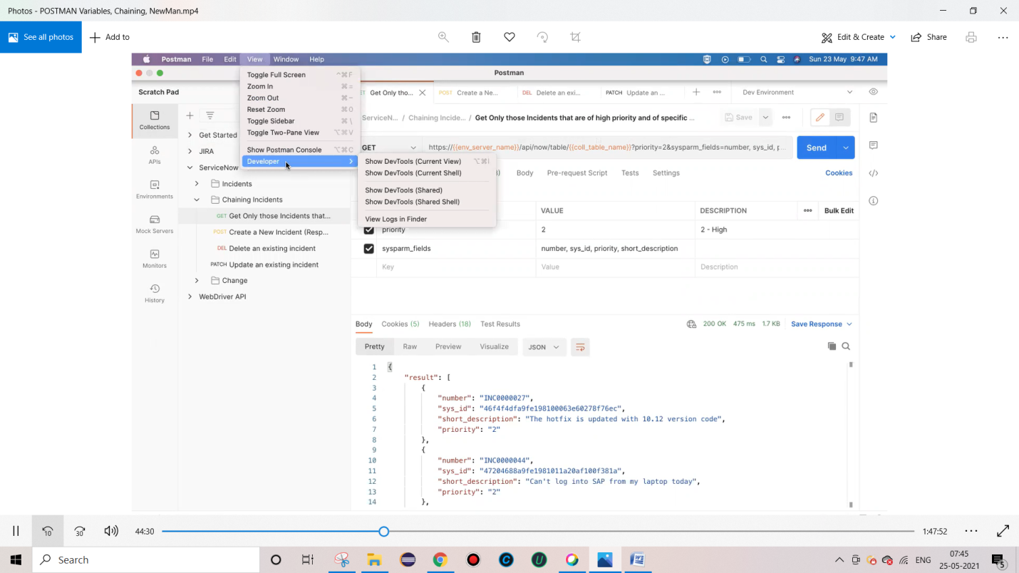

**To pass sys_id which is generated using POST, e need to pass it for some other requests to delete or update (PATCH) the same.**

**Pm – post man library , java script based library which is available in postman.**

**Test – function – tets and confirm whether postman is working fine or not .**

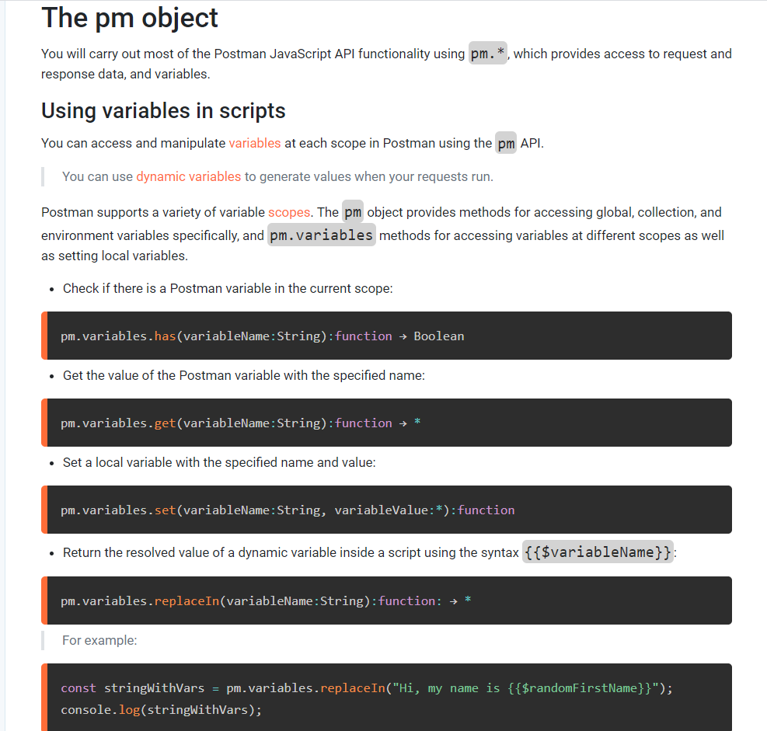

Writing test assertions

The **pm** object provides most of the functionality for **testing** your request and response data.

You can use pm.test to write test specifications inside either the **Pre-request** or **Tests** scripts. Tests include a name and assertion—Postman will output test results as part of the response.

The pm.test method returns the pm object, making the call chainable. The following sample test checks that a response is valid to proceed.

pm.test("response should be okay to process", function () {

pm.response.to.not.be.error;

pm.response.to.have.jsonBody('');

pm.response.to.not.have.jsonBody('error');

})

JavaScript Object Notation (**JSON**) is a standard text-based format for representing structured data based on JavaScript object syntax. It is commonly used for transmitting data in web applications (e.g., sending some data from the server to the client, so it can be displayed on a web page, or vice versa

I have set of Requests like POST, GET and DELETE

For each **POST** request, one record will be generated and **sys_id** will be generated for those record.

And if we want to DELTE the record we can use the **sys_id** as a parameter.

//confirm status of the code

Pm.test(“xxxxxxxx”,function()

{pm.response.to.have.status(200)}

)

//Get response (json) - (since we cant get in XML format we can use json format)

// Will use var or let to save response

var json= pm.response.jsosn();

var local_sys_id = json.result.sys_id;

**// set id value as global var**

**Pm.globals.set(“()global_sys_id”,** local_sys_id**);**

**After creating record using POST Request**

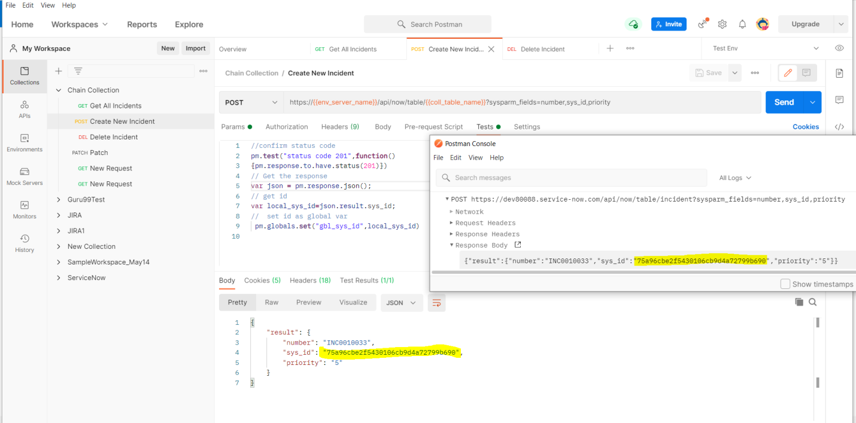

**Verify the sys_id is passed into DELETE Request**

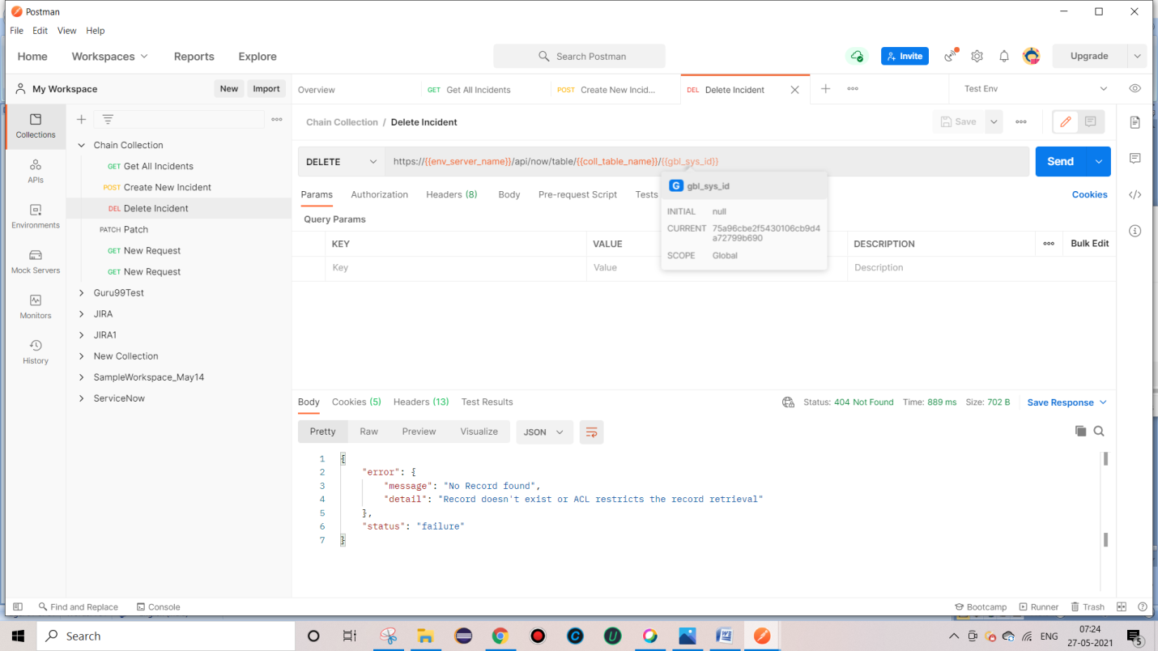

**POST – create :: 201 SUCCESS , created.**

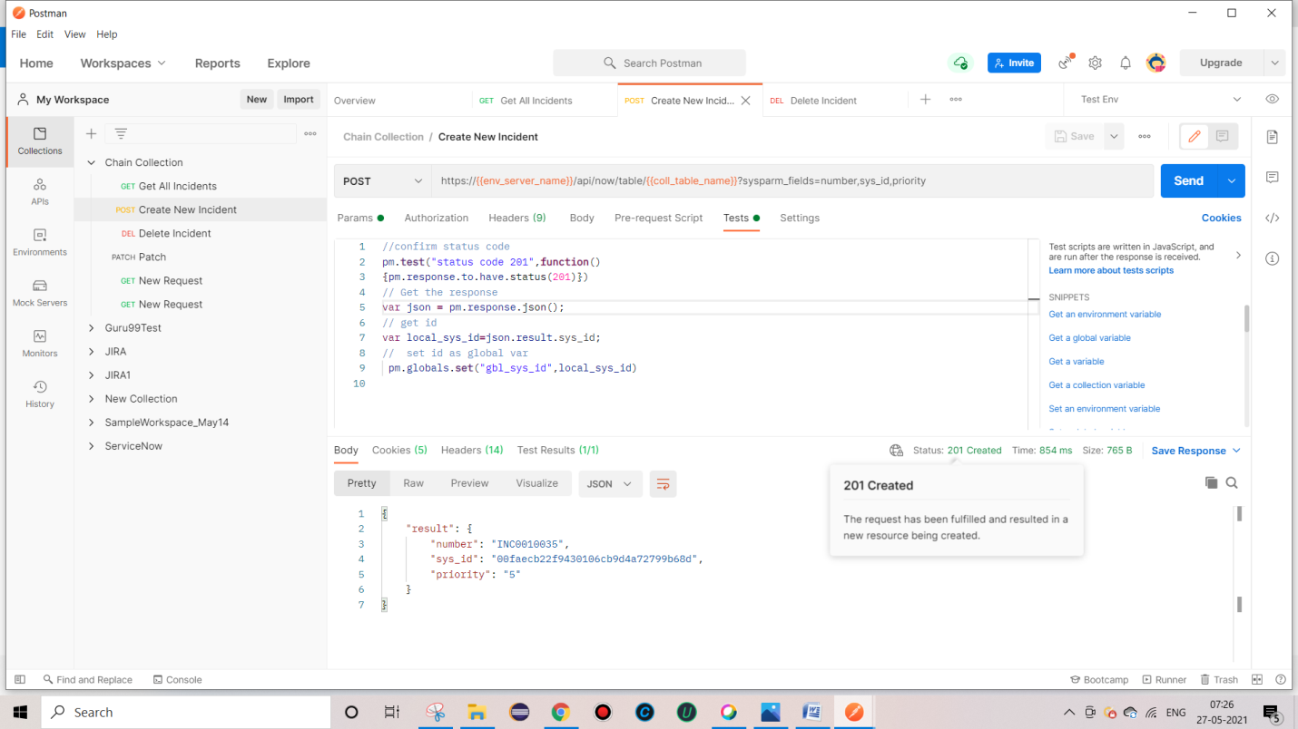

**DELETE Record – 204 , Successful but not returning anything**

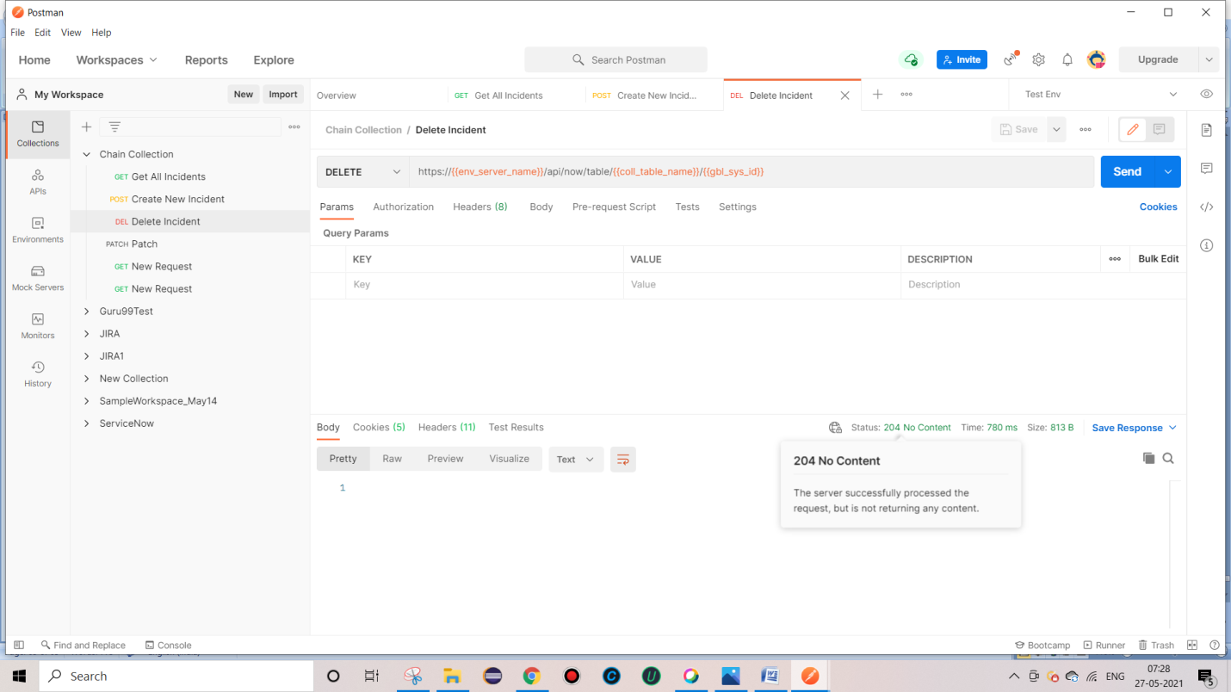

**Try DELETE after deleting Record – 404 – Not Found since it is already deleted in previous request**

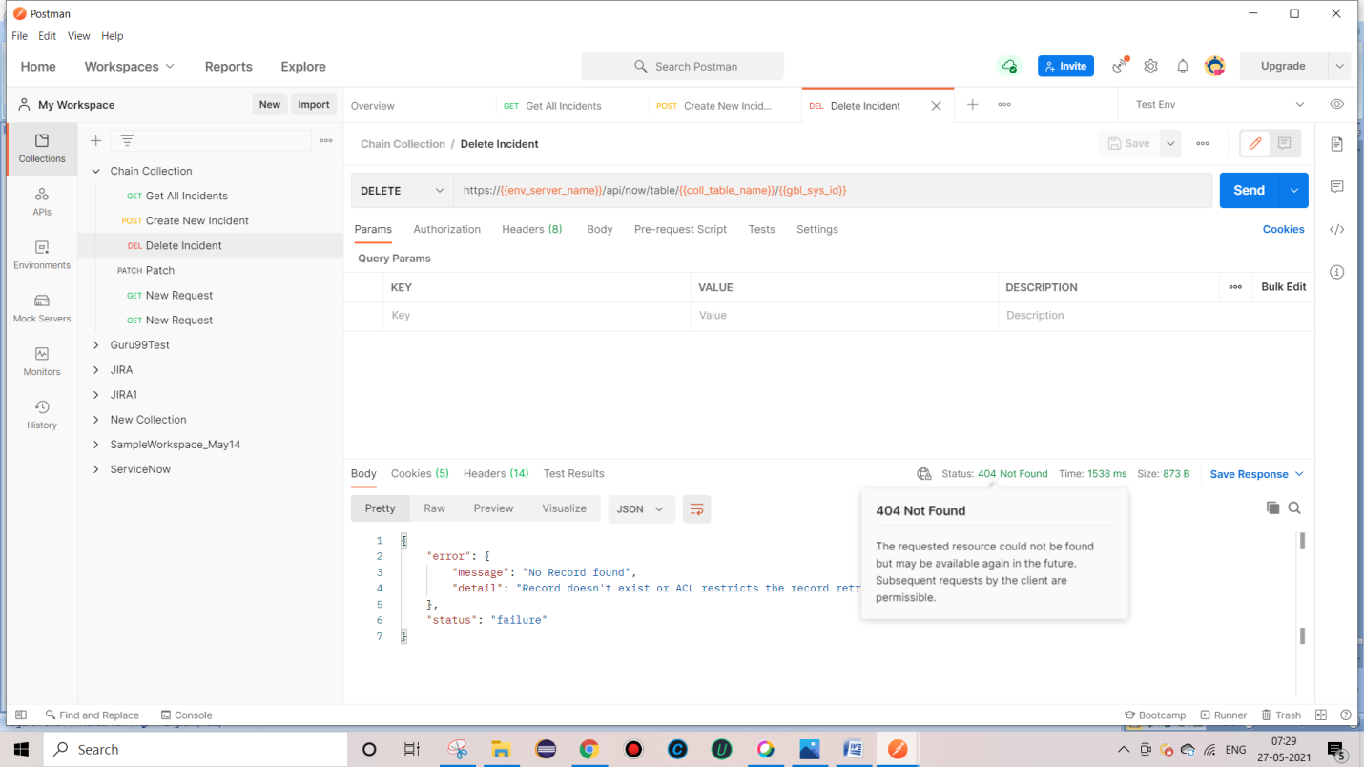

**In some scenarios, Get might get multiple records.**

**Here we got 94 records .**

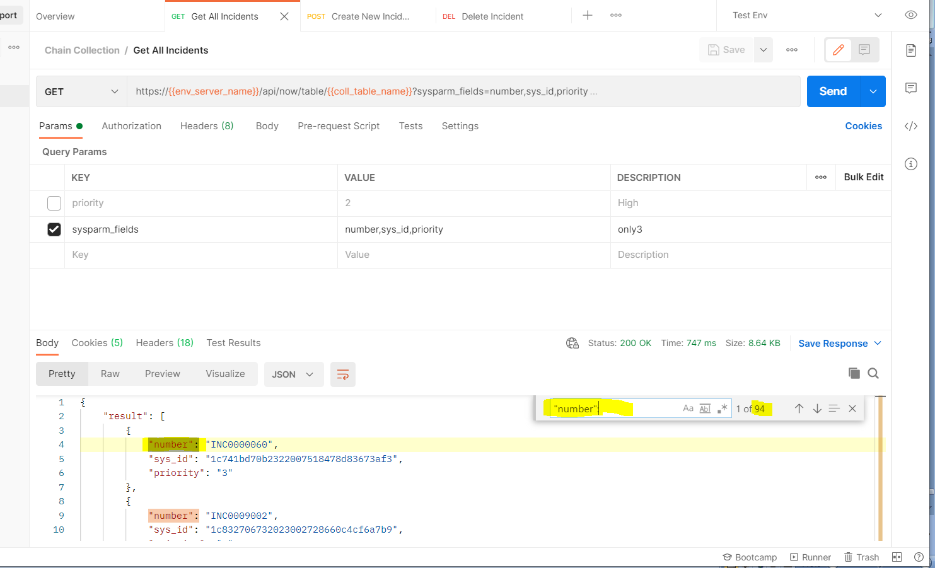 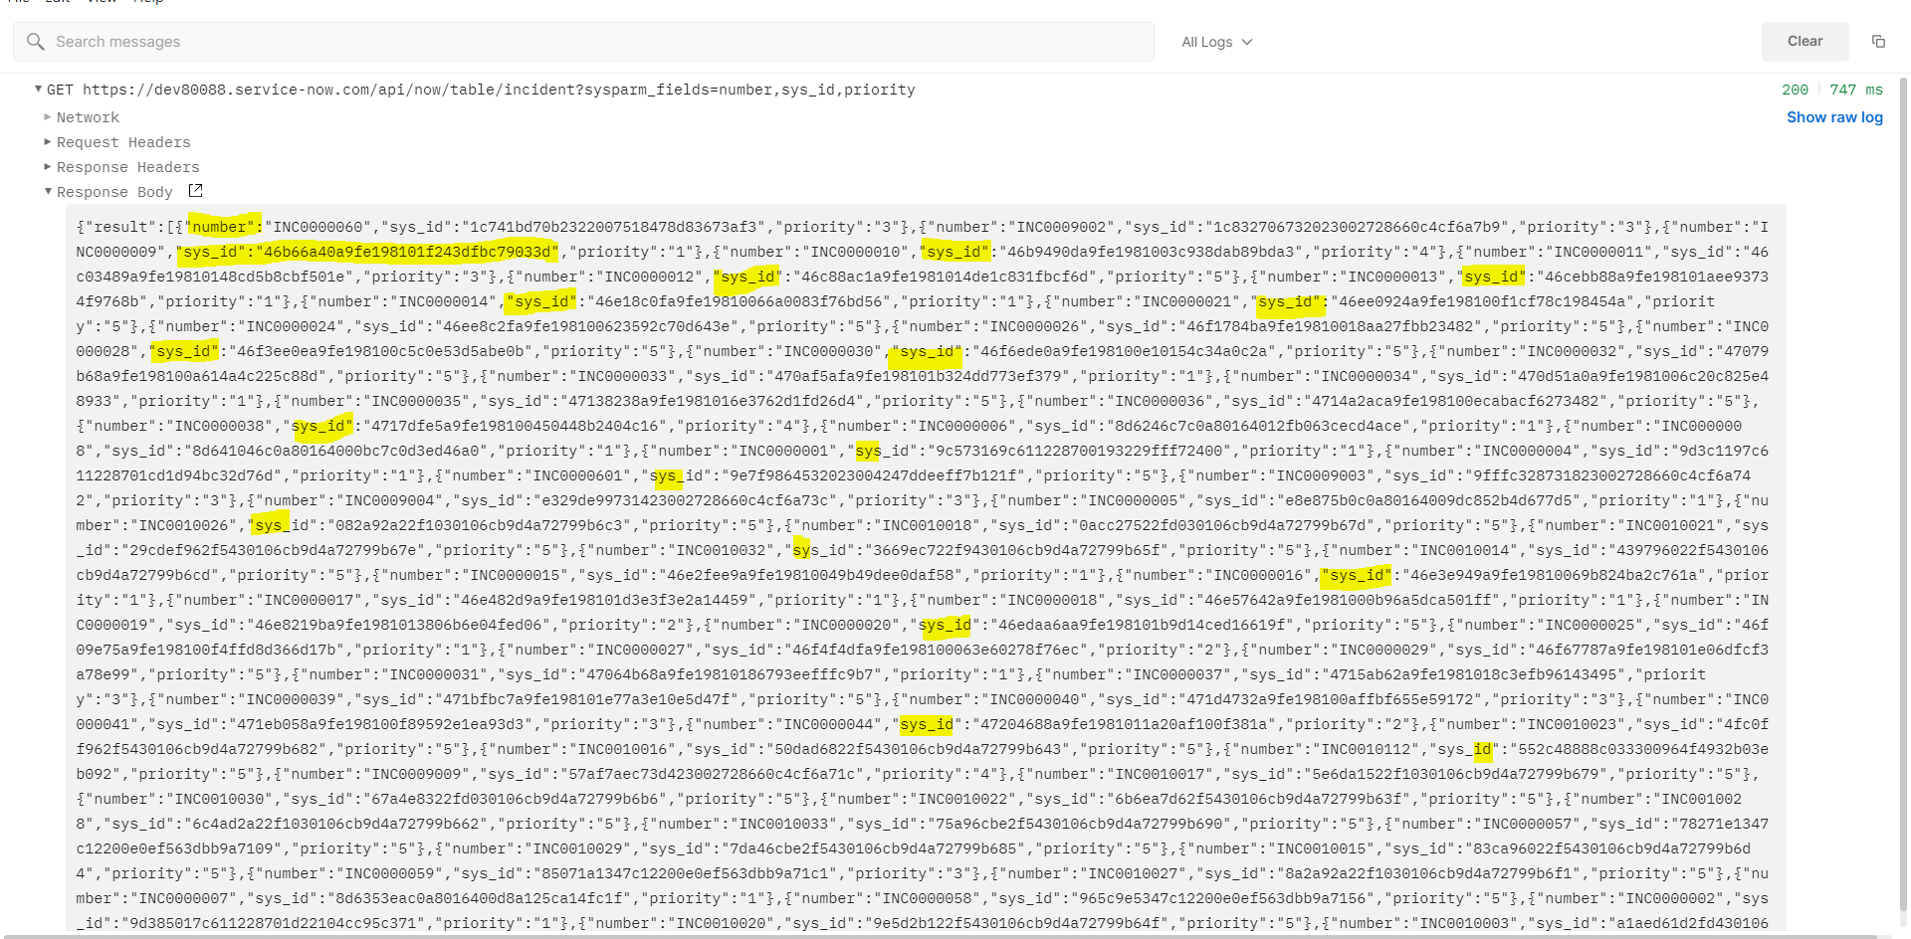

**Java script does not show any exception like java, it throw only undefined**

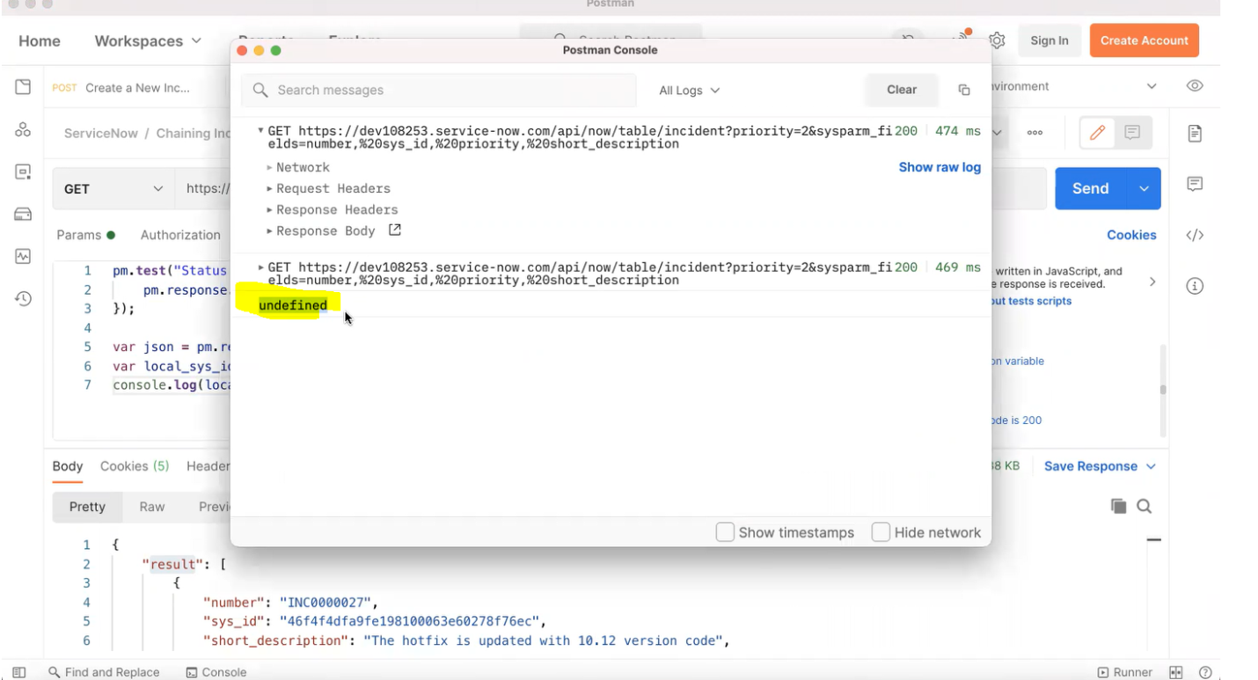

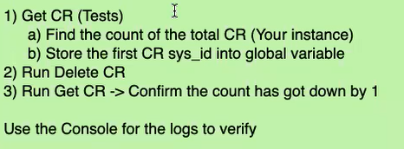

**To Run chain collections**

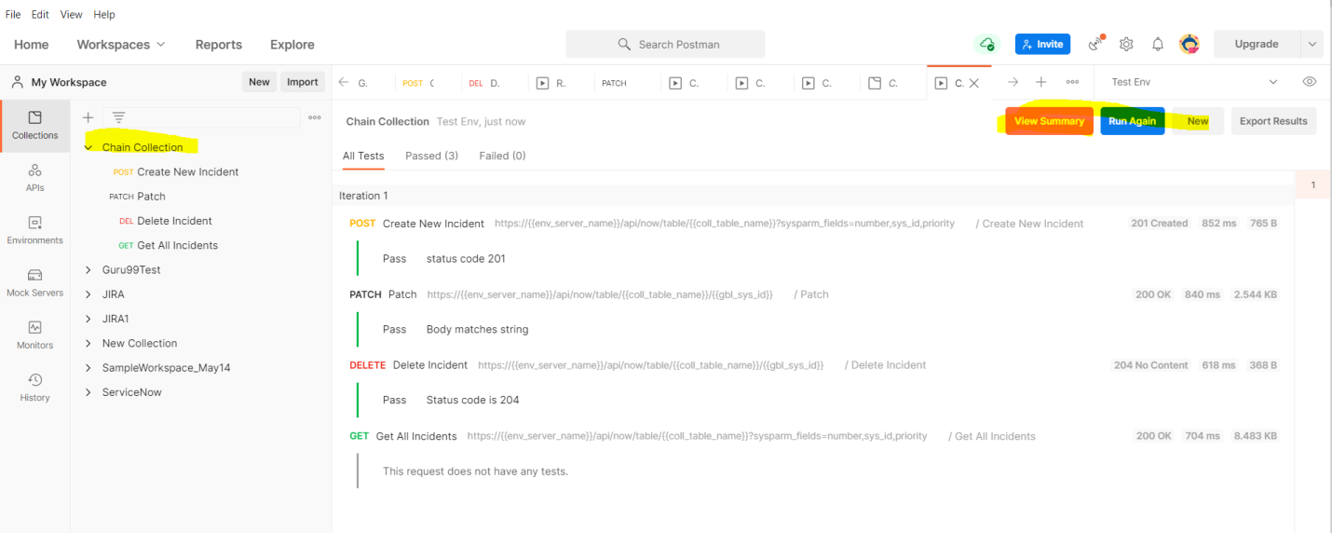

**Sometimes we may need to work with diff data , To pass that data , We can use .csv or .json file**

**So that we can create multiple records with multiple data passed from .csv or .json file.**

1. **Go to Collection and click on “Run”**

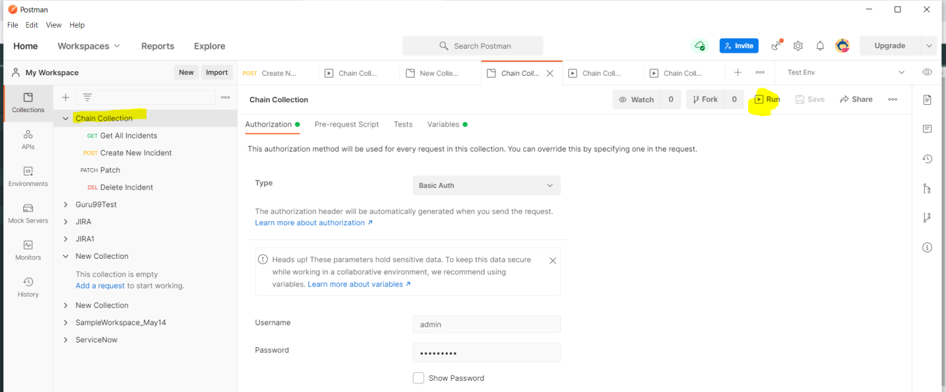

1. **Add this under “ Body ” tab**

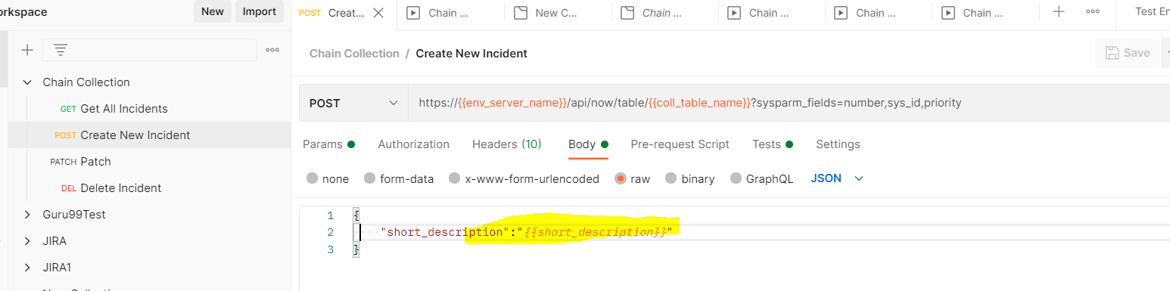

**3. Select the Request which we want o Run multiple times using csv file and since my csv file having 5 set of data ,Iterations showing as “5” .**

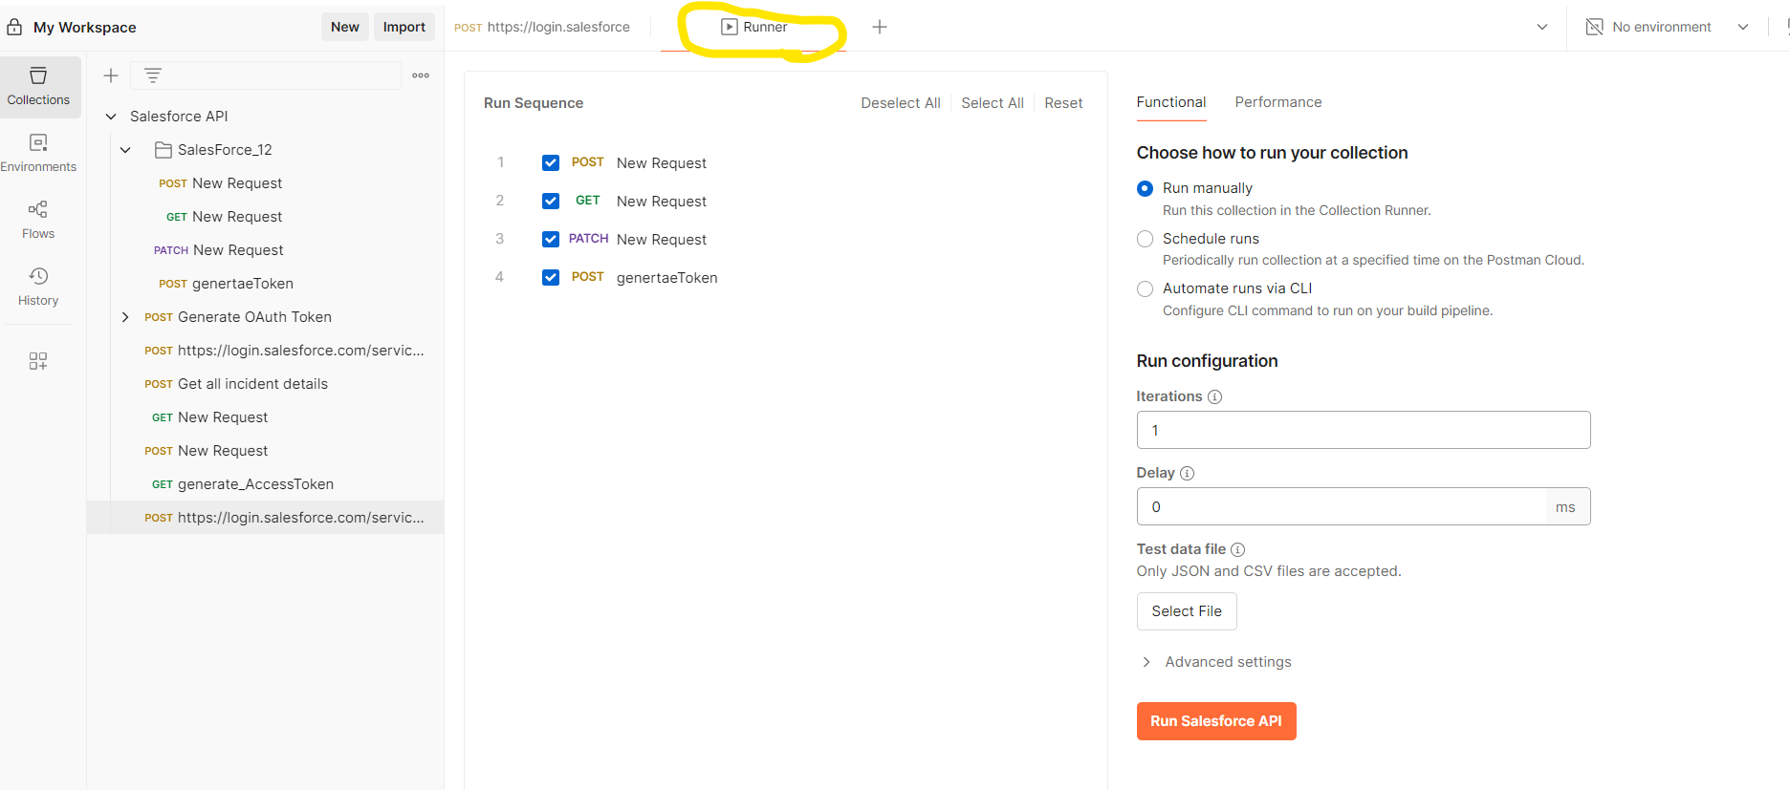

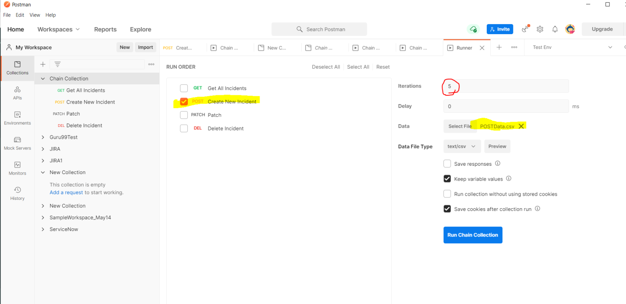

**Csv File**

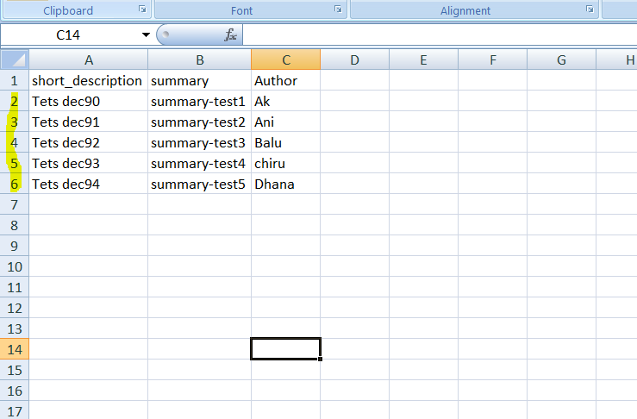

**Click on ”Run Chain” collection**

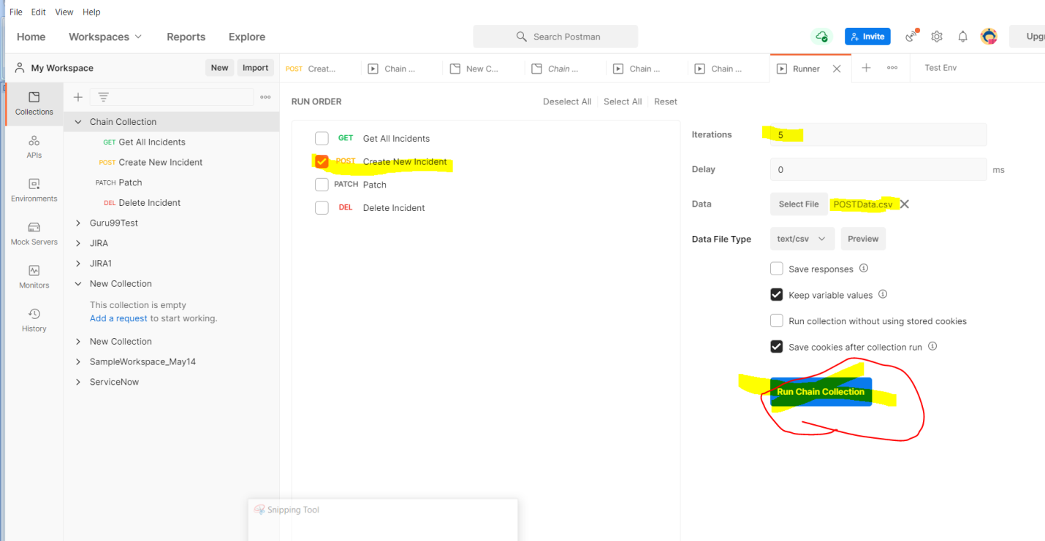

**We even see the csv/ json file data by click on Preview button**

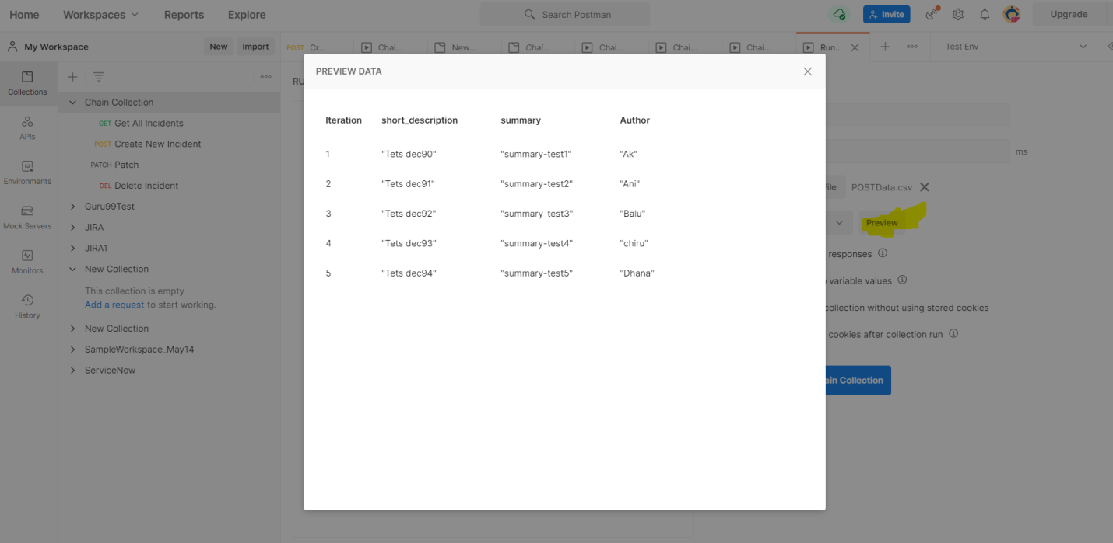

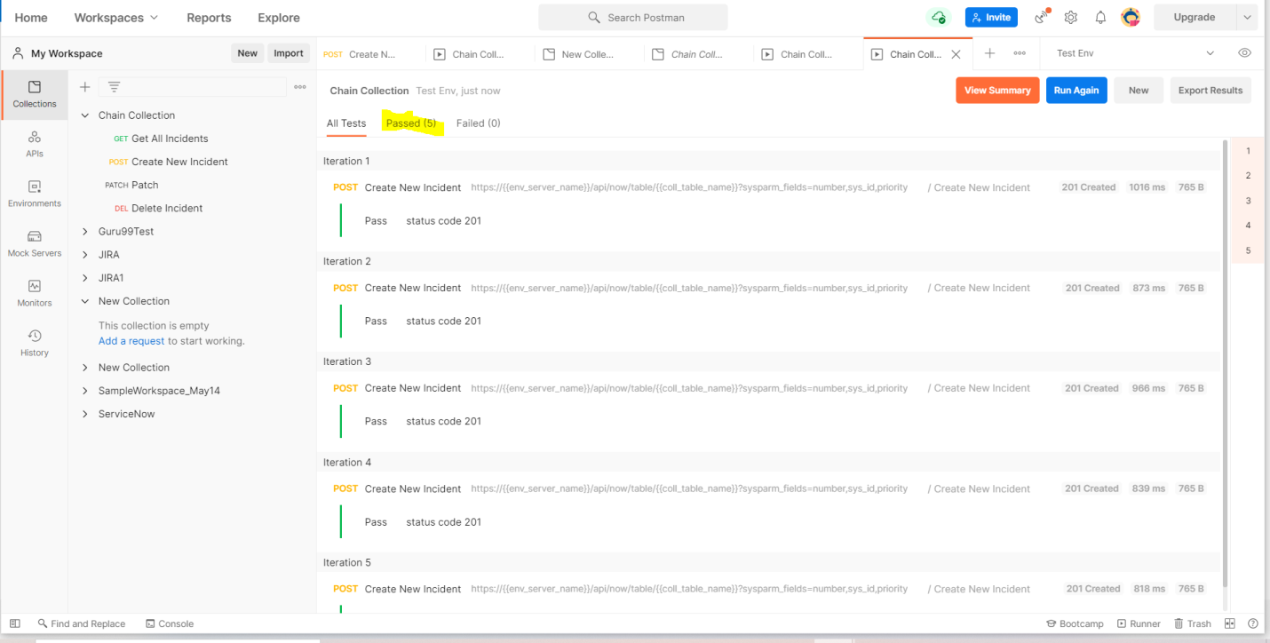

**And if we want to print data, we can add like this**

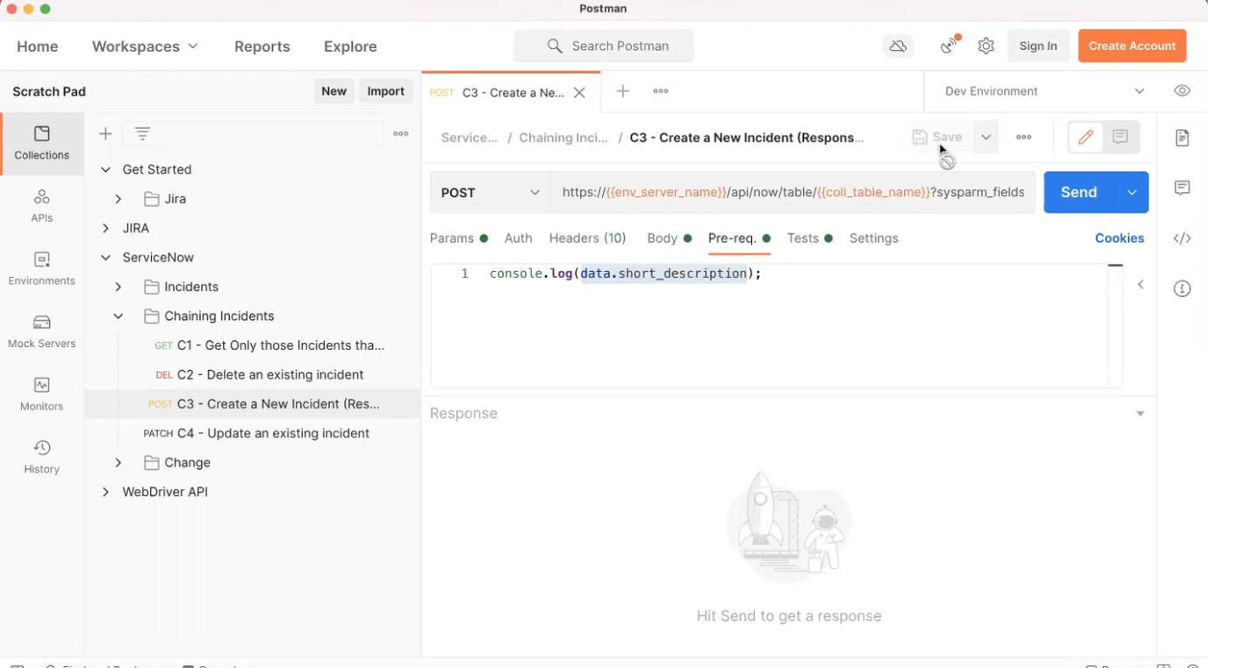**1**

**Runner – only at collection level**

**View icon 🡪Edit**

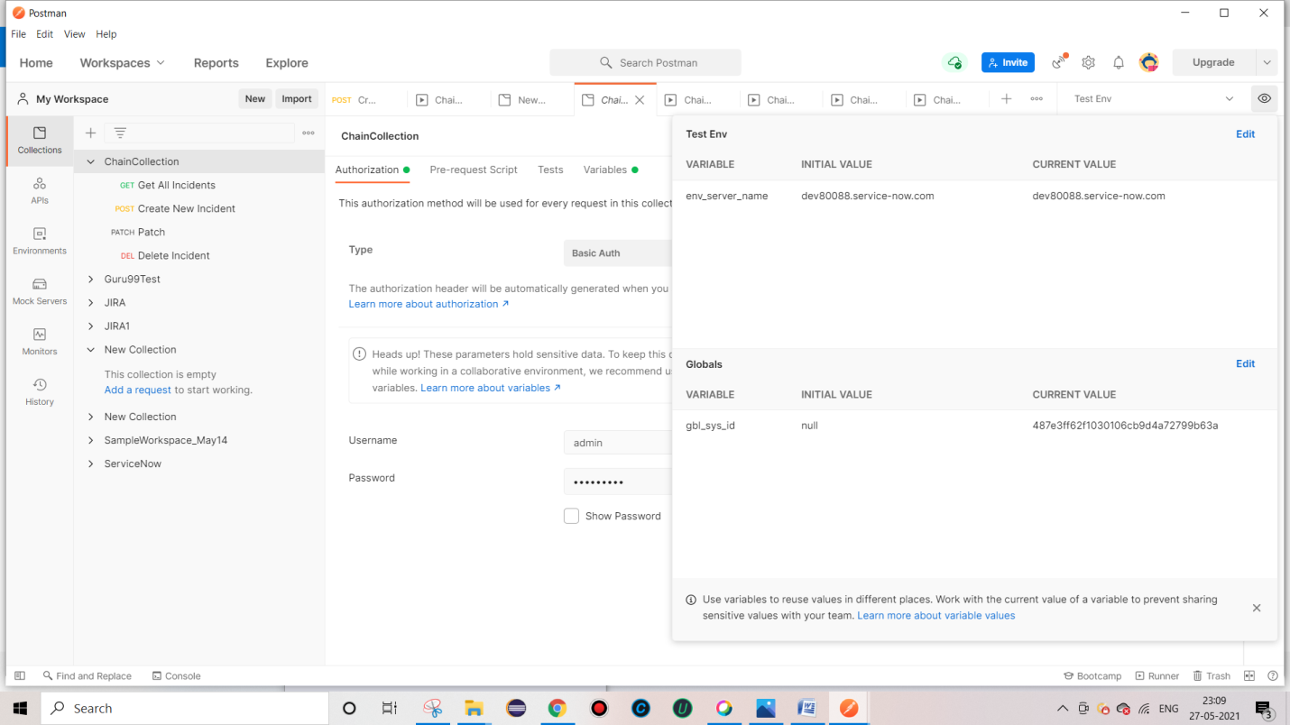**Export**

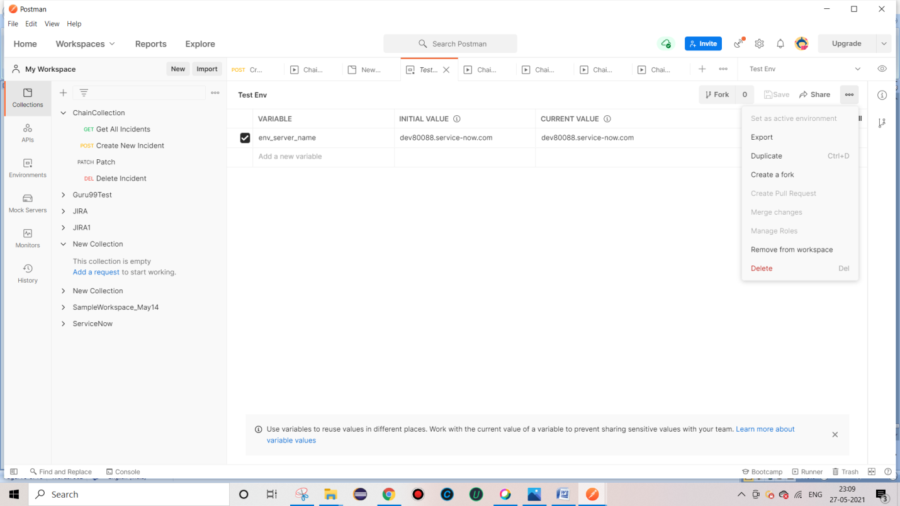

**Working with Newman – Newman built on node**

1. **Make sure All ur files in .json format**

**Export**

1. **Collection**
2. **Env variable**
3. **Global variable**

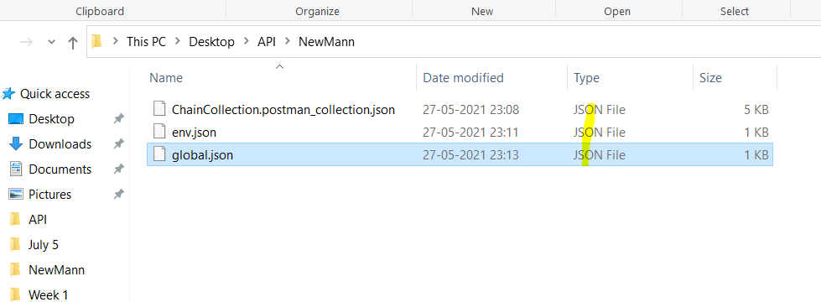

**Steps to work with Newman**

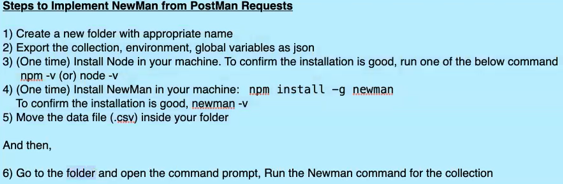

**Verify node and**

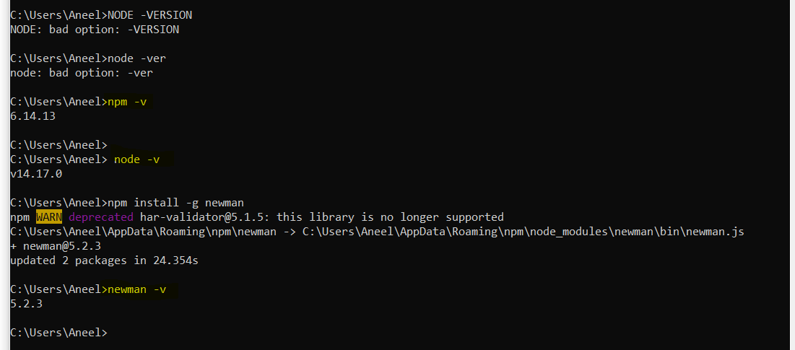

**Click on cmd from the Folder**

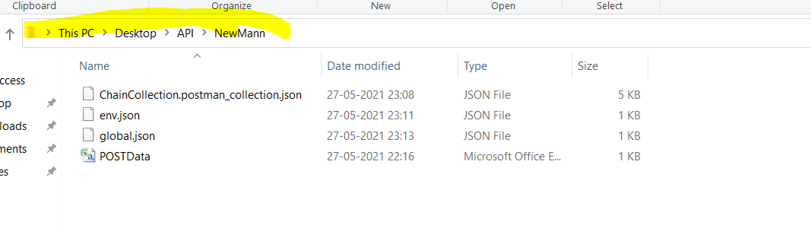

**To run New Man**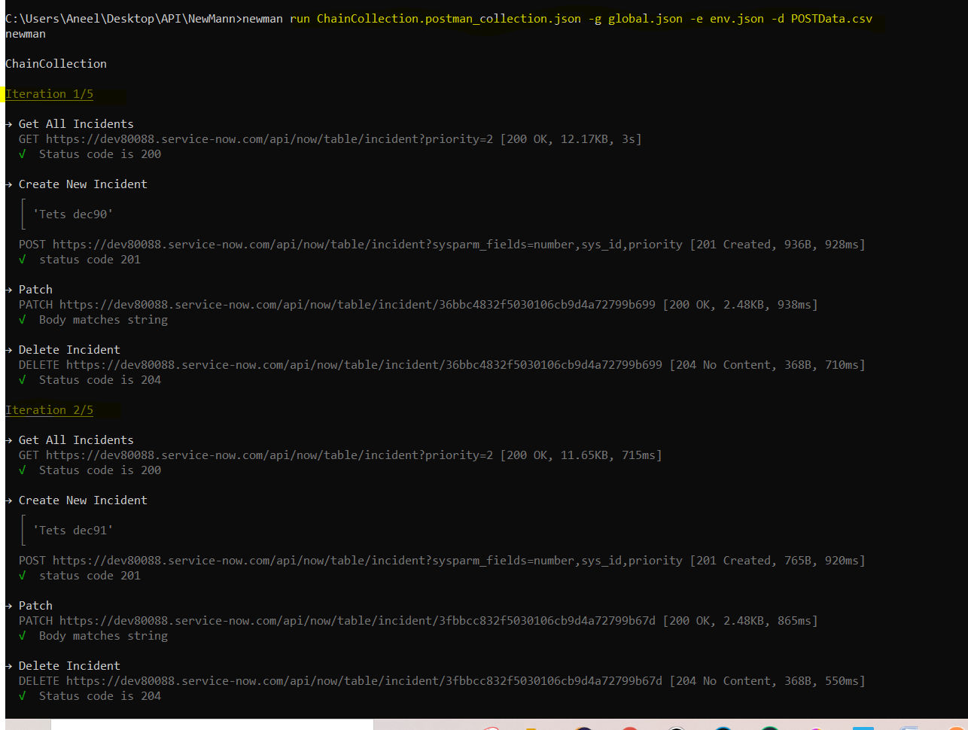 **C:\Users\Aneel\Desktop\API\NewMann>newman**

**run ChainCollection.postman_collection.json -g global.json -e env.json -d POSTData.csv**

**( Collection folder global var env var DataFile )**

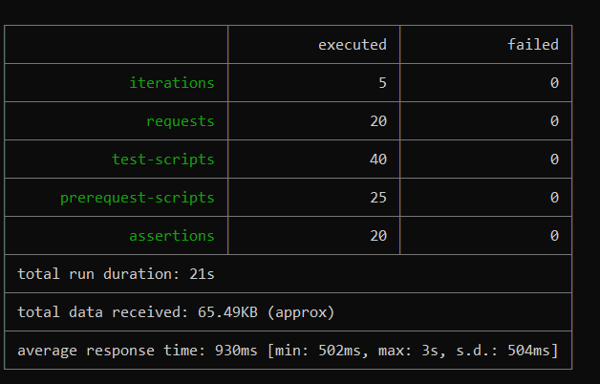 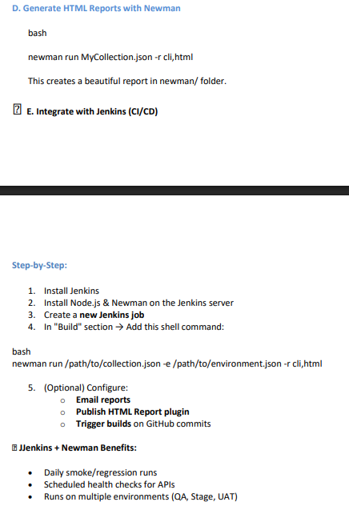

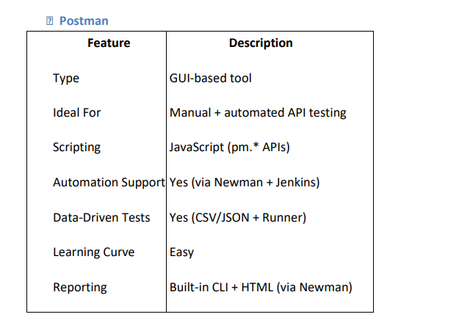

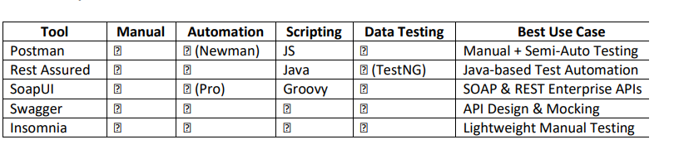

**Get All JIRA Issues**

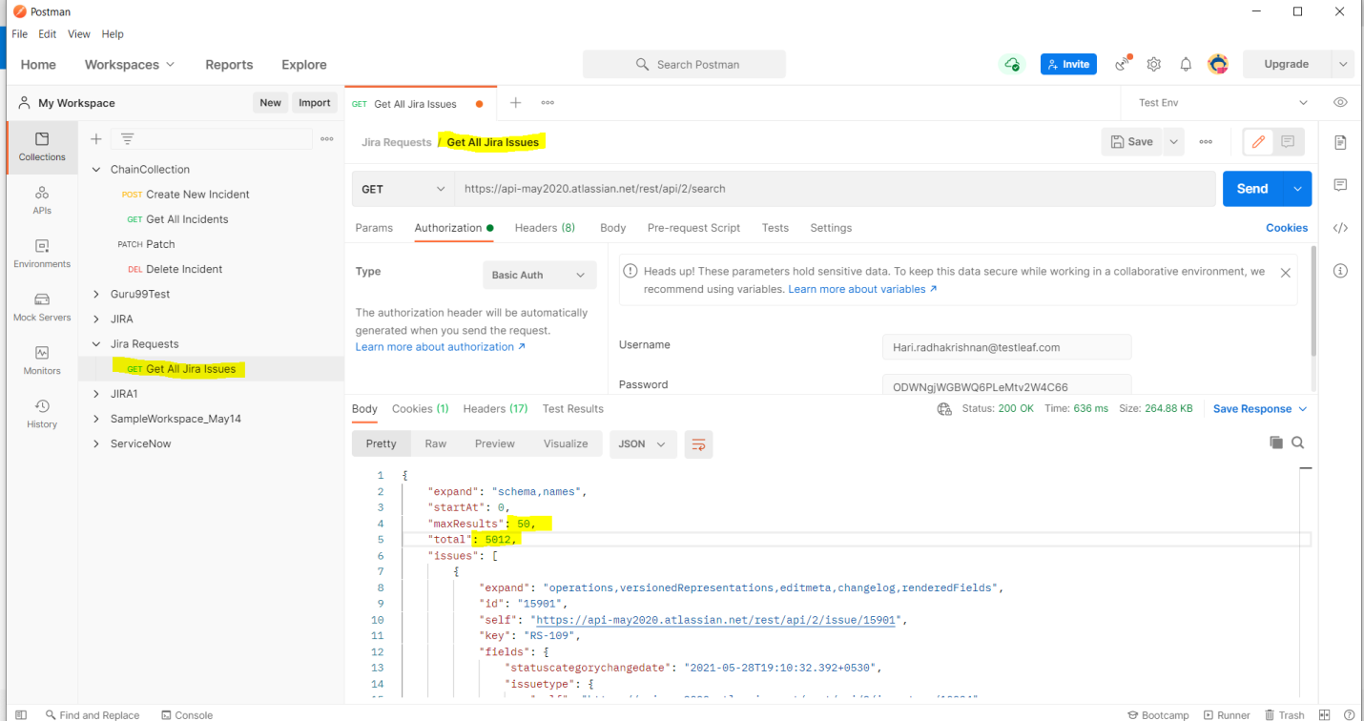

**Find Issues created in last 24 Hours and print the same in console ::**

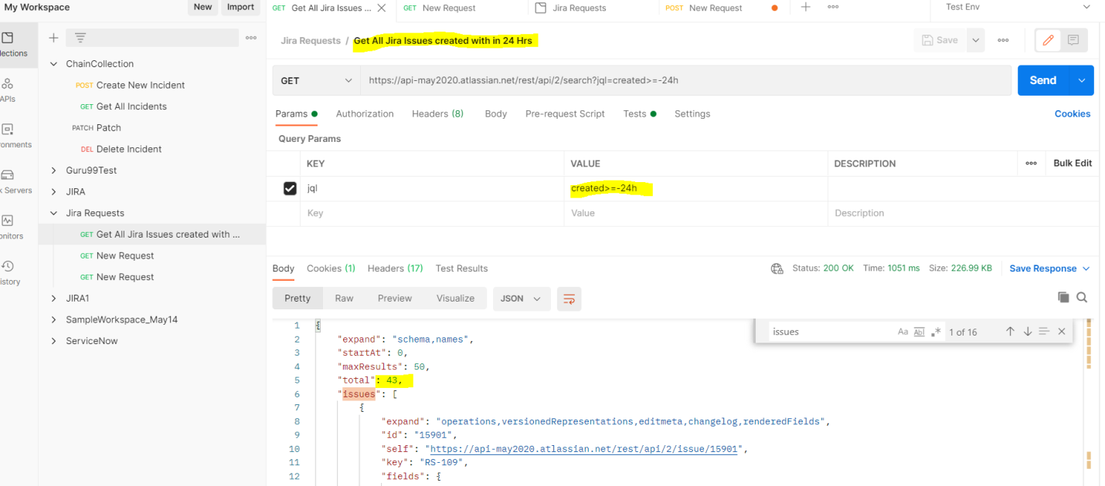

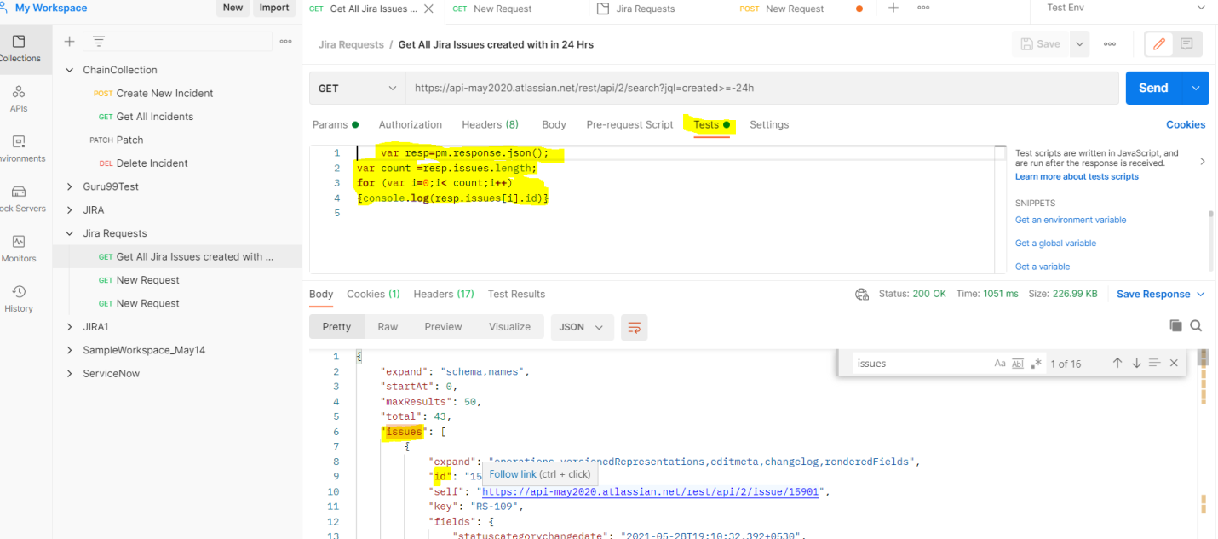

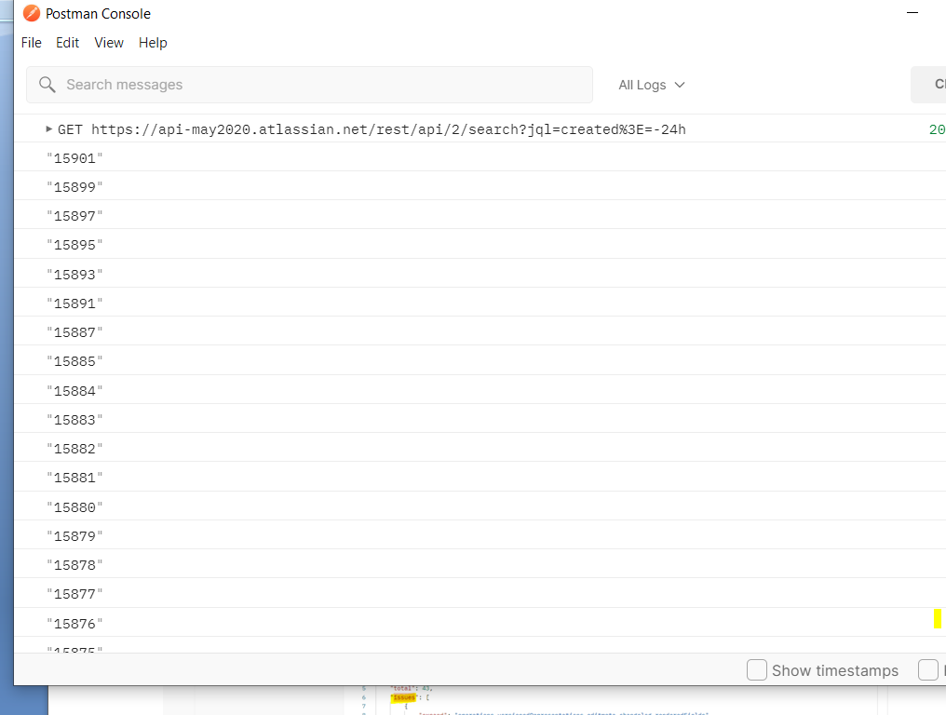

**What is Postman?**

**Ans - Postman is a powerful collaboration platform for API development, testing, and automation. It simplifies the process of developing APIs by providing:**

**� A user-friendly interface to send requests and view responses**

**� Support for multiple request types: GET, POST, PUT, DELETE, etc.**

**� Automation features like test scripts, environment variables, and collection runners**

**� Integrations with CI/CD tools (Newman, Jenkins, GitHub, etc.)**

**🛠️ Where it's used: API testing (manual and automation) Backend validation Regression suite for services Mocking and simulating APIs Data-driven testing .**

**Use of pm ::**

Postman allows you to write JavaScript-based tests using the pm (Postman) object after a request is sent. This helps validate API responses automatically.

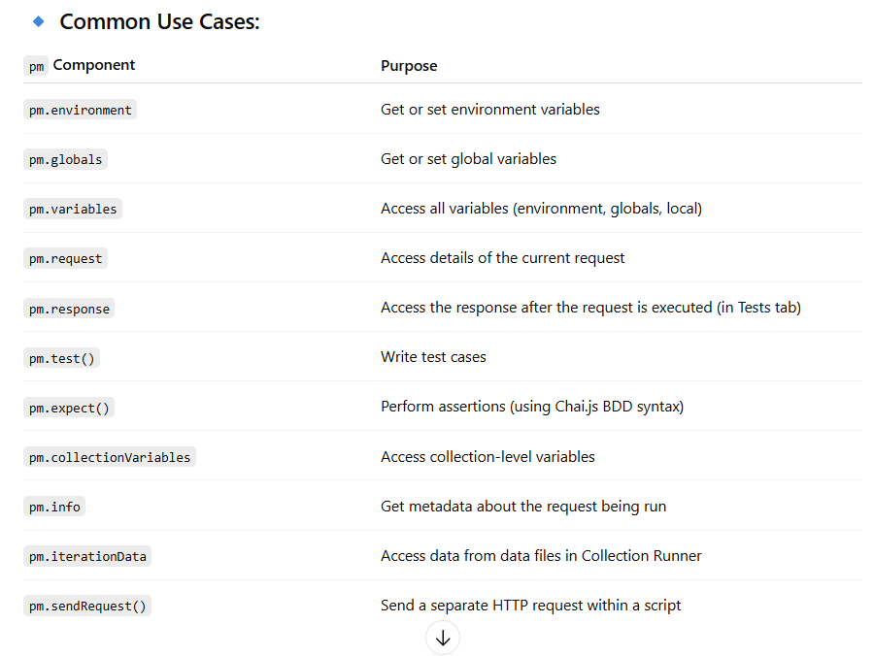

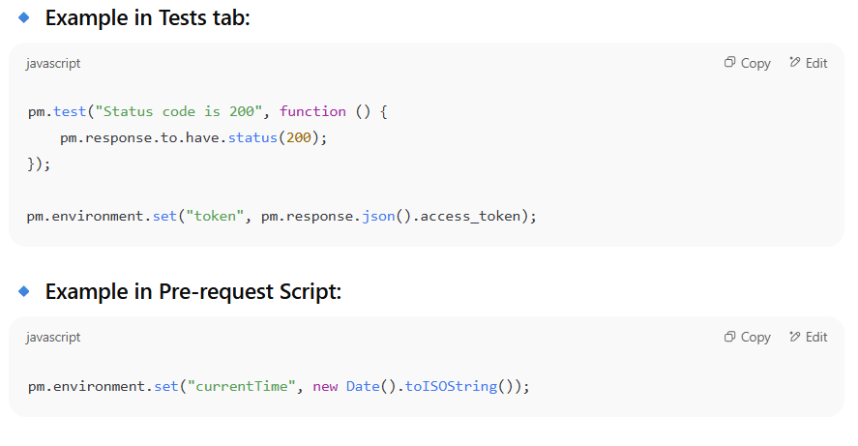

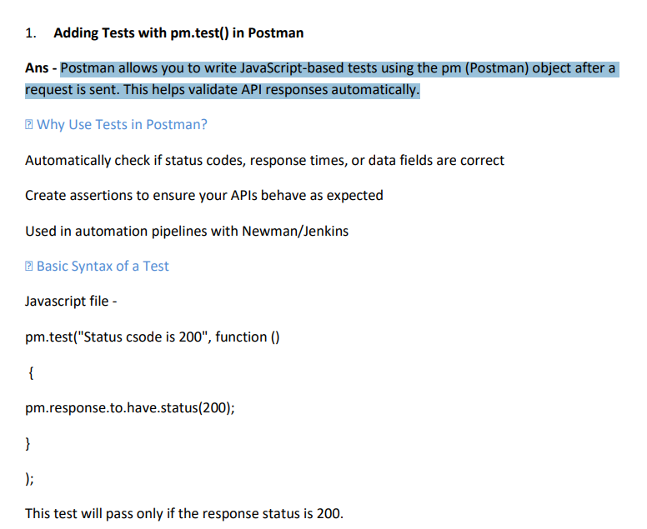

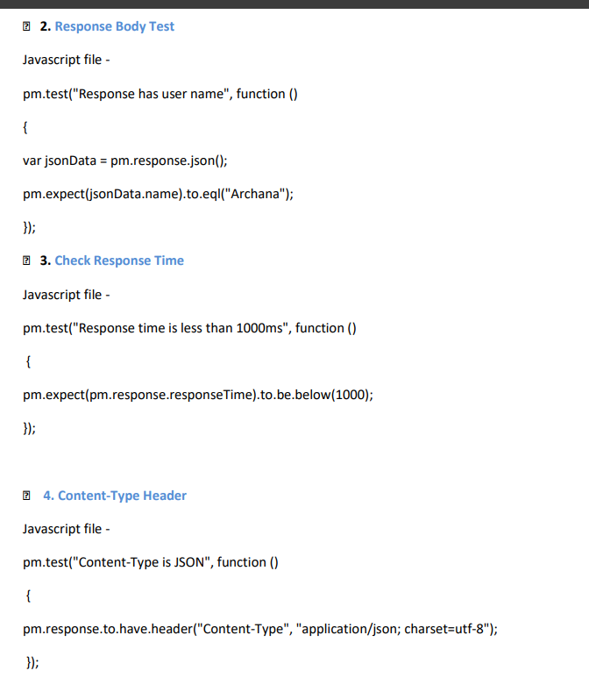

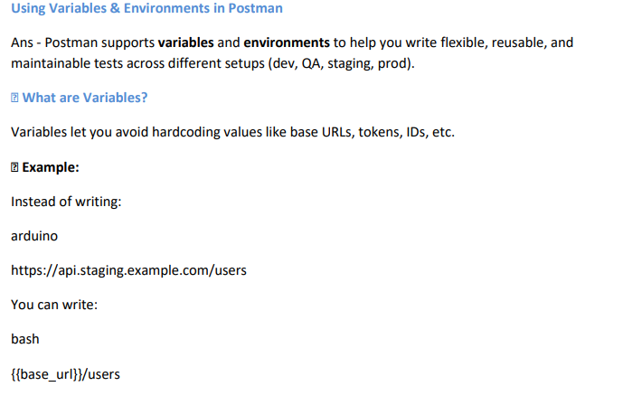

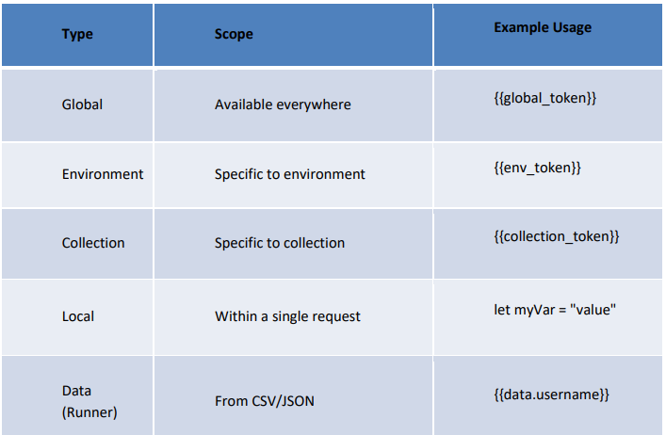

**Use environments to switch between DEV, QA, STAGE, PROD Use pm.variables.get("var_name") to access any variable in tests Keep tokens and secrets out of public/global environments**

**Rest Assured ::**

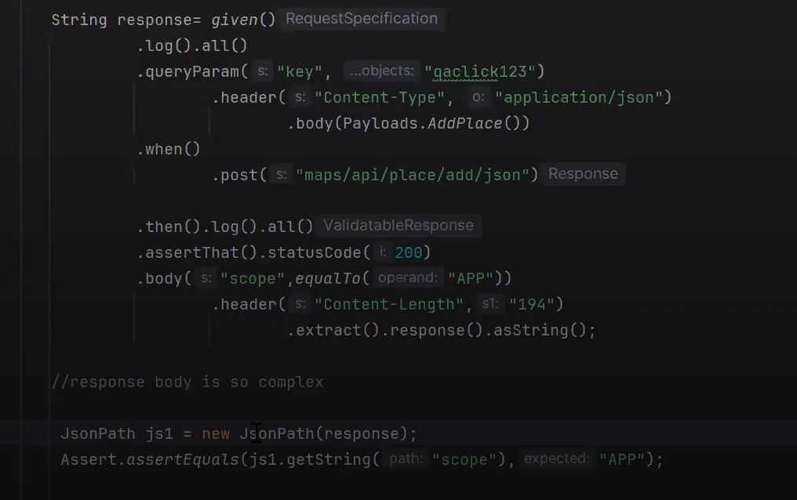

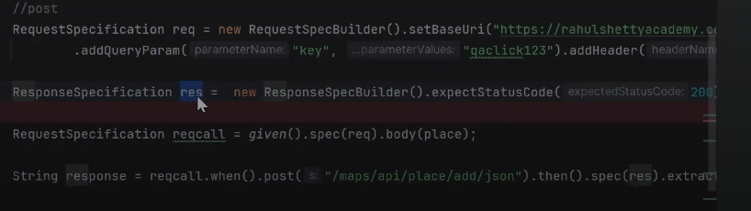

**Request specification builder**

**Response Spec builder**

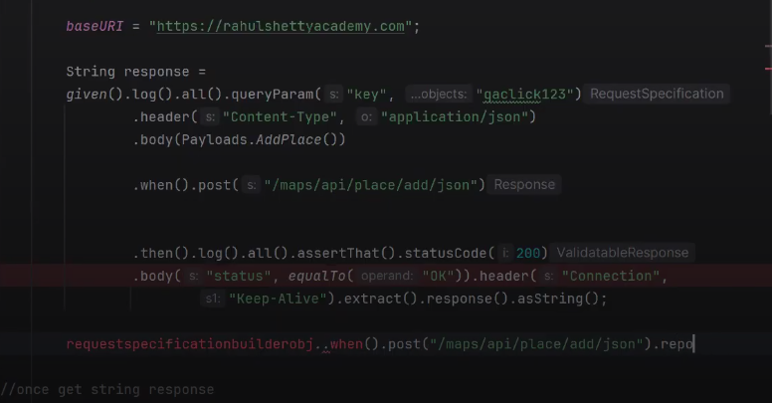

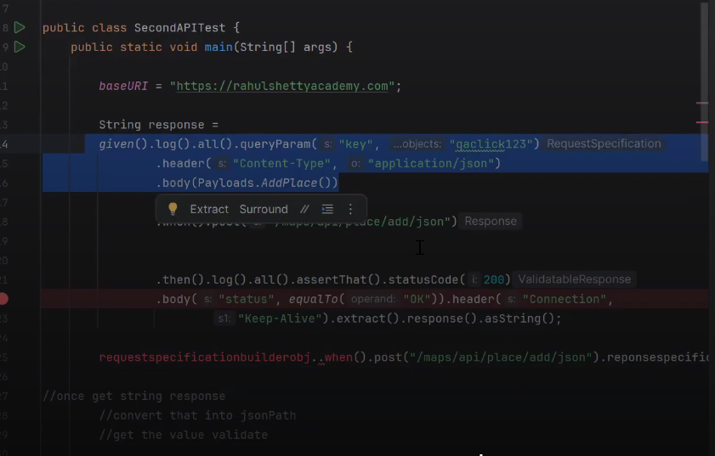

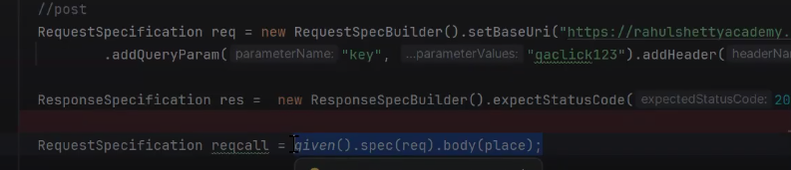

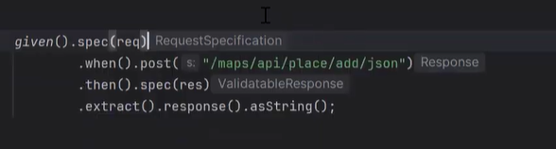

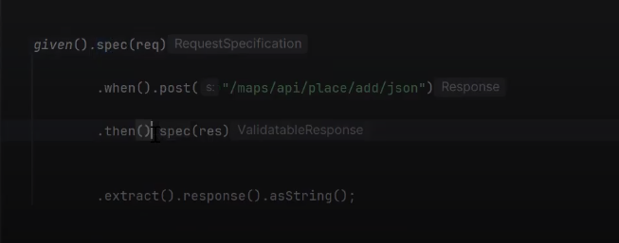

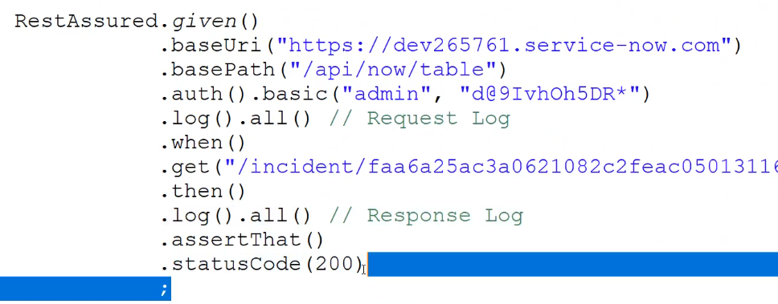

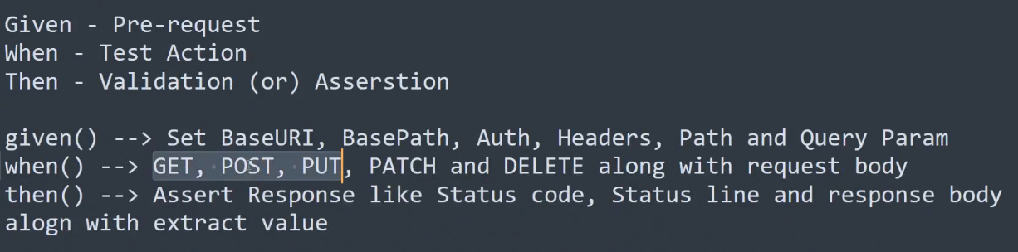

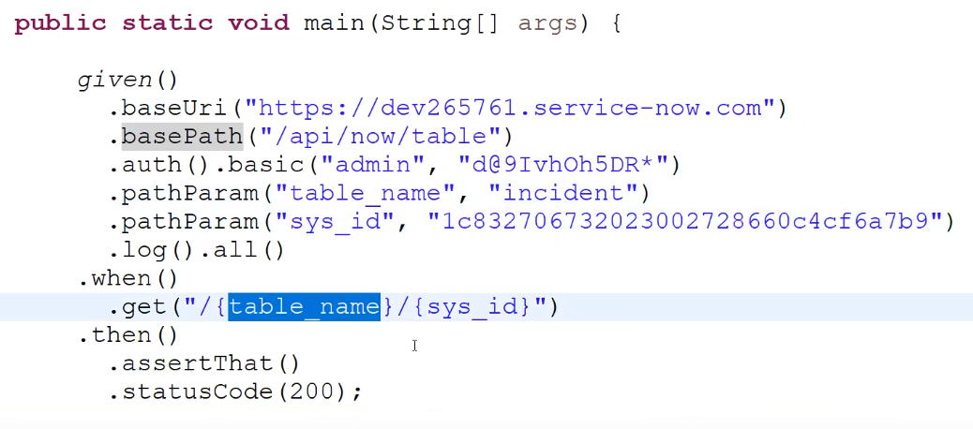

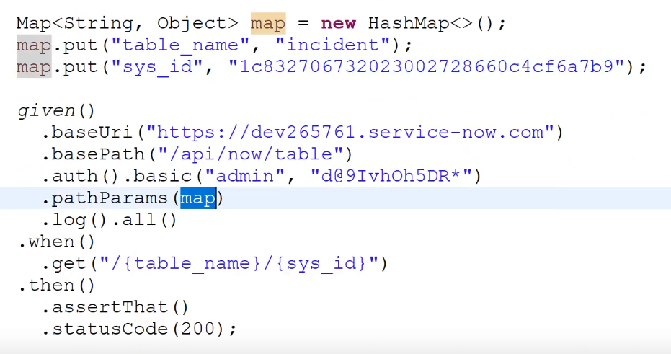

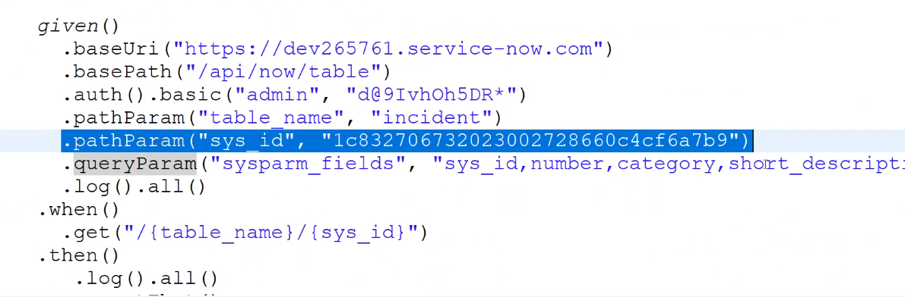

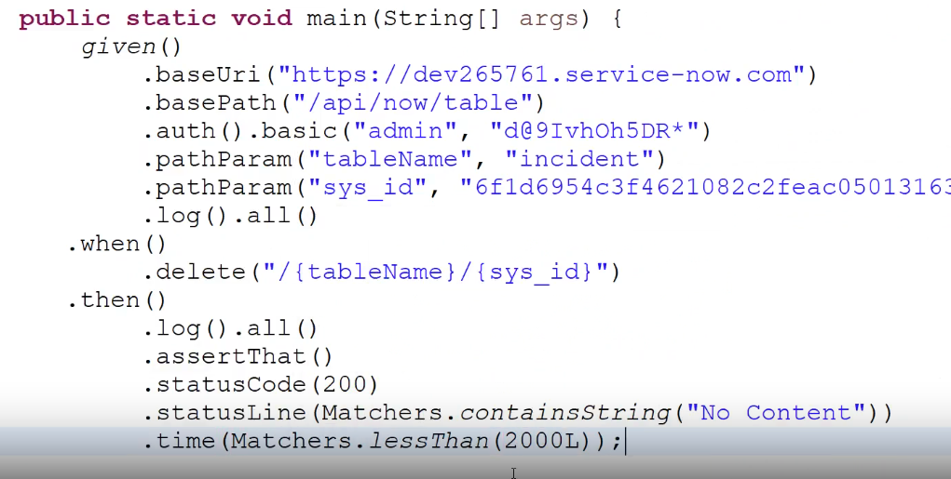

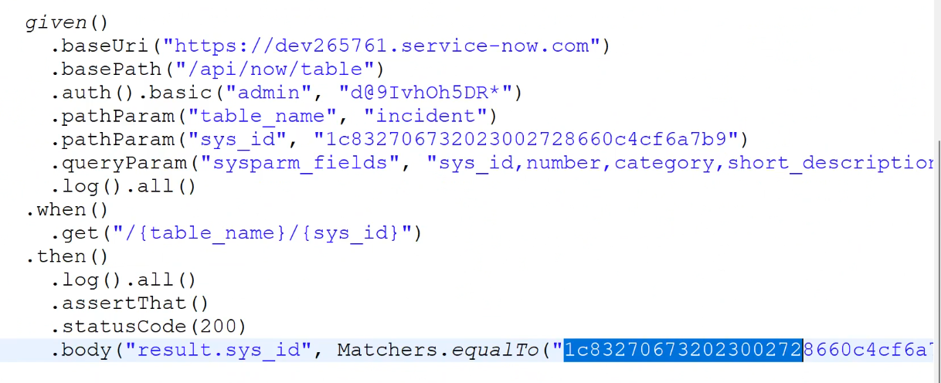

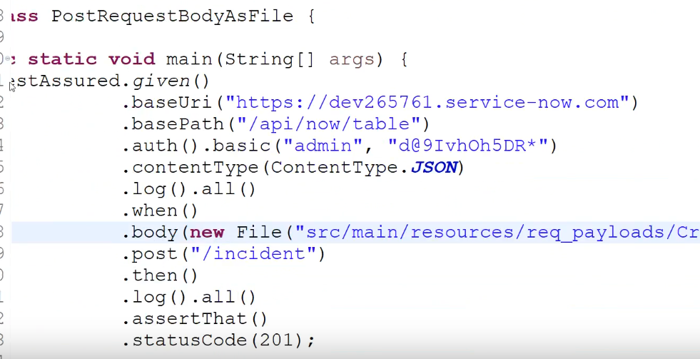

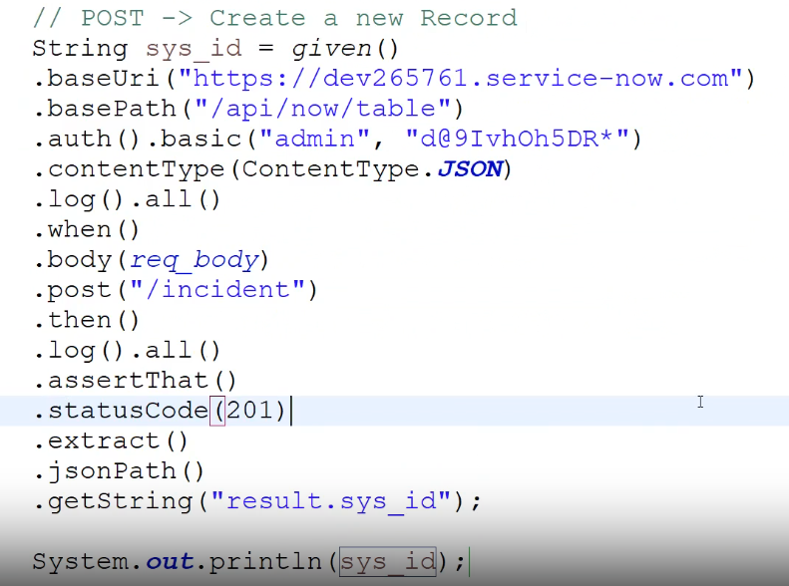

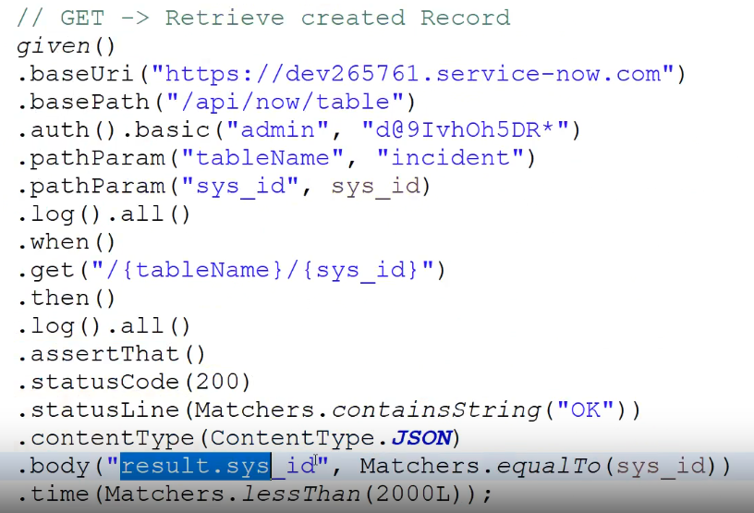

1. How do you perform a GET request using REST Assured?
2. How to pass query parameters in REST Assured?
3. How do you send a POST request with a JSON body?
4. How do you validate a list in the response and extract a value from it?
5. How do you create a reusable request specification?
6. How do you chain multiple API calls?
7. How do you test file upload/download with REST Assured?
8. How do you build a dynamic payload in REST Assured?
9. How do you retry a failed API call automatically (exponential backoff or polling)?
10. How do you compare JSON response from REST Assured with an expected JSON file?
11. How do you handle parameterized JSON payloads using POJO classes and Jackson?
12. How do you extract nested values like data[0].user.profile.email from a JSON array response?
13. How do you write a test to validate pagination logic across multiple pages?
14. How do you mock an endpoint locally using WireMock for REST Assured testing?
15. How to test an asynchronous API call?
16. How to trigger 403 Forbidden in API tests?
17. How to perform JSON Schema validation in API tests?
18. How do you implement dynamic logging in your REST Assured framework?
19. How would you test a secured REST API that uses OAuth2 for authorization using REST Assured?
20. How do you write parameterized tests using REST Assured and TestNG?
21. Can you tell the disadvantages of RESTful web services?
22. What is the concept of statelessness in REST?
23. What are the features of RESTful Web Services?
24. How do you add REST Assured to a project?
25. How do you send GET requests using REST Assured?
26. How do you validate a response using REST Assured?
27. What is JSONPath in REST Assured?
28. How do you extract data using JSONPath with REST Assured?
29. How do you send POST requests using REST Assured?
30. How do you send PUT and DELETE requests with REST Assured?
31. What are Request Specifications in REST Assured?
32. How do you authenticate using REST Assured?
33. What is BDD in REST Assured?
34. How do you perform query parameter validation in REST Assured?
35. What is Response Specification in REST Assured?
36. How do you use Response Specification in REST Assured?
37. How do you handle timeouts in REST Assured?
38. What is the "RootPath" feature in REST Assured?
39. How do you handle SSL in REST Assured?
40. What is "log()" in REST Assured?
41. How do you set headers in REST Assured?
42. What is the difference between "given()", "when()", and "then()" in REST Assured?
43. What is BDD in REST Assured? (Duplicate question)
44. How can you effectively manage dynamic values, such as timestamps, when validating responses using REST Assured?
45. How can you validate a numeric response using REST Assured?
46. How does REST Assured handle Unicode characters when testing APIs?
47. Describe how to perform HEAD requests using REST Assured?
48. Describe how to extract response time information from a response using REST Assured?